Accra, Ghana, 10-12 November 2009

West Africa Regional Sanitation and Hygiene Symposium

What it takes to make sanitation effective

Wurie Mamadu Tamba Barrie and Foday Ahmed Sillah [ Sierra Leone]

Policy and regulation set has been flouted by sanitary personnel through the receipt of bribe from defaulters of sanitary laws, with loop holes for excuses with minimal fine if follow to the latter. The attitude of good sanitary and hygiene practice has been lack across the board, couple with the incapacity of relevant equipment to effectively enforce and supervised the sanitary and hygiene situations in the country with simple communication skills. Access to deposit site within community to enhanced good sanitary practice personally and collectively and the environmental and community setting are grossly affecting the sanitation and hygiene situation in Africa as compared to the western countries. Survey Data on Sanitation Assessment Survey 2008 done by Action For Social Rights in complimenting the International Year of Sanitation 2008. It is reveled in the research that 83% did not have community dust bin to deposit waste from household and 77.8% did not pay for waste collection, 38.9% deposit waste in the stream, 33.3 extract defecation through pit duging and machines respectively while 16.7 through stream and bush respectively, 66.7% are 18yrs to 30yrs and 33.3 % are 31yrs to 45yrs. While 55.6% are women and 44.4 are male involved. However 77.8% observed hygiene rules and principles (Source: AfSoR). The international year for sanitation bring wide sensitization on the improvement of sanitary behavior.

Introduction Of Research Paper

This paper is seek to highlights lapses and provides critical analysis, data and profound sustaining and mental change solution for effective sanitation in the sub region West Africa that can be replicated elsewhere with similar situation. Let me reiterate that the millennium development goals number one {eradicating extreme poverty and hunger}, two {archiving universal primary education}, four and five {reducing child mortality and improving maternal health} provide a connection to effective sanitation and hygiene practice and settings to achieve all the other millennium development goals by 2015.

This paper looks at policy review, attitudinal and mental change, environmental settings, sanitational diversity, proper tracking and filing system etc as key components in designing and implementing hygiene and sanitation proper in West Africa {Sierra Leone}

Overview Of Water And Sanitation In Sierra Leone

With an average rainfall of 2000 mm, Sierra Leone is endowed with abundant water resources; however ten years of war reversed the gins made during the water and sanitation decade of the 1980s. Only two out of the forty two water treatment plants constructed in the 1970s are operational while less than seventy percent of wells and gravity scheme are operational.

Unsafe disposal of excreta and other waste, lack of awareness of the dangers of these in spreading diseases and poor hygiene practice are common. Facilities for safe disposal of excreta are almost non-existence in rural area and woefully inadequate in most urban communities. A recent study sows that tree out of four household’s share a single pit latrine in most urban communities.

Poor sanitation has an effect on health status of the people and on the education and development. At present only twenty two percent of the population have access to safe drinking water and fourteen percent to sanitation facilities. {Nationally}.

Sierra Leone is still remains at the bottom of the Human Development Index {177/177} with the highest maternal and under five mortality rate in the world. Malaria, respiratory and diarrhoeal diseases account for more than 75% of the country under five deaths and malnutrition is also an underlying cause of 57% of child death, all these diseases are closely linked with water and sanitation practices. {Critical Analysis}. Just 47% of the population of Sierra Leone {5 Million Sierra Leone Population census 2004} have access to improve drinking water source, whilst just 30% have of Sierra Leonean currently have access to adequate sanitation facilities {practice or not practice?}

Sanitation and hygiene teaching had been done in primary school under physical and health education and in secondary and high school under home economic that is mostly done by women and in tertiary and vocational level under food and nutrition or beverage production. In these three stages that sanitation and personal hygiene education are passed, the subject is restricted only to those who pursue such subject in tertiary and vocational level which happens to dominated by few women at the end of their school year. The education system in Sierra Leone was dominated by men because of gender discrimination and traditional and religious believes. The country was divided into two which are Protectorate and Colonial, the protectorate are those in the rural setting and the colonial are those in the urban settings as a result of the divide most of women that attained sanitation and hygiene education came from the Krio {those that stay with the British} as compared to those from the provinces. the protectorate are dominated by Muslims, that did not believe in girl child education, while the colonial are Christian and most schools and opportunity are centered in the urban {City}.

The essence and usefulness of sanitation and hygiene to the protectorate is leh we go was en dress fine {wash an put on nice dress} and put watta 4me na ya {rencing of once hands when dem fit} to majority of Sierra Leone no matter the status as in guinea and Liberia. It is clear from this, that the sanitation of the environment {Air, Water} is not hygienic for human living especially young babies and regnant women and children under fie years.

Categorising Sanitation

Personal Sanitation:
It is believed by Sierra Leone specifically that sanitation and hygiene only limited to themselves {taking birth and dress neatly} and their rooms not the compound or back yard, finger nails or after using the toilet. Personal hygiene is the premise to enhanced effective sanitary practices.

Community Sanitation
The attitudes of good sanitary and hygiene has been lacking across the board as result of traditional believes and less education {Official to layman-illiterate, {couple with incapacity of relevant equipment to enforce and supervised the sanitary and hygiene situation and behaviour in the country with simple communication and educational skills. access to deposit site within community to enhanced good community sanitary practice personally and collectively and the environmental and community setting are grossly affecting the sanitary and hygiene situation in Africa as compared to western countries.

Extends Sanitation
Proper sanitary and hygiene practice can be properly demonstrated in the school compound, and private clinic or hospital in Africa with reference to Sierra Leone

Combating Sanitation

Religious Stakeholders
are potentially instrument in passing sensitive and sustaining sanitary messages that can e stick to all {from official to the layman} by quoting and reciting verse of the importance of good sanitary practices irrespective of status in society.

Local Chieves
without discrimination or otherwise are obey and respected in rural setting {Concentrated}and the laws are followed by their subject and justice is quick, they had the potential of less community insanitary behaviour by introducing sanitary laws and enforcing sanitary law as compared in city {cosmopolitan}

Local Council
The sole responsibility of local councillor is to bring development to it ward and community and to provides basic and essential services like water, health etc.

Natural Leaders
These are individuals within the respective communities that have the potential to persuade, motivate, mobilise others to do anything without laws or money. Identifying and enhanced their capacity

Sanitation Diversities and Needs

The uniqueness of sanitation is it diversities and needs in various setting urban {Freetown}
It observed that needs of the urban communities and quite different with the needs of the rural communities

Urban
- Latrine-very expensive
- Water- very expensive {shortage]
- Health- very expensive {available}
- Highly populated
- High ton of wastage

Rural
- Latrine-less expensive
- Water-less expensive {available}
- Health- very expensive {less available}
- Less concentrated
- Low waste
Community diversity and needs can be handle in the following ways to make sanitation effectives. The construction of houses has greatly influenced the sanitary behaviour of individuals and community.

Data on sanitation Assessment Survey 2008 done by Action For Social rights in compliment the international year of sanitation 2008. it is revealed in the survey that 83% did not have community dust bin to deposit waste in stream, 33.3% extract defecation through pit dugging and septic tanks or machines respectively, while 16.7% trough streams and bushes respectively, 66.7% are 18years to 30years and 33.3% are 31years and 45years while 55.6% female and 44.4% are involved. However observed hygiene rules and principles.

Policy Health and Sanitation In Sierra Leone Of October 2006 and March 2007

Human Resources Health Policy In Sierra Leone for the Ministry of Health and Sanitation 2006, October.

The Minister of Health and Sanitation during the Sierra Leone Peoples party tenure in office, October 2006, draw up policy This HRH policy document addresses the production and utilization of Human Resources (HR) within the Ministry of Health and Sanitation in Sierra Leone. It also responds to the contemporary challenges and developments including the exodus of human resources and advancement in technology.
Sierra Leone is facing a major crisis in responding to the heavy Burden of Disease and this exerts a lot of strain on the already overwhelmed health system. Following the development of the draft Health Human Resource Plan in August 2004, feasible strategies for strengthening the human resource base and its management were identified as critical to responding to implementation strategies. One of the recommendations in the human resources plan was to develop a policy for human resources for health and Sanitation.

This policy intends to regulate and direct planning, production, management, utilization and monitoring of HR within the health sector.

Therefore, on behalf of the Government of Sierra Leone I call upon all regulatory bodies, health service providers, educators, managers, all stakeholders and partners concerned to play a pivotal role in the equitable implementation of this policy. The Ministry in partnership with all stakeholders is committed to implementing this policy for the benefit of the people of Sierra Leone.

Sierra Leone adopted the Primary Health Care (PHC) strategy for health service delivery. The primary objective is to improve the health status of the Sierra Leone nation through the provision of quality services that are equitable and client focused, leading to a healthy, productive and prosperous society. The health sector strategy has been reoriented and refocused to meet the national health challenges as stated in the Poverty Reduction Strategy Paper (SL-PRSP, 2005) and to embrace the Millennium Development Goals (MDGs). These goals aim at eradicating extreme poverty and hunger, reducing child mortality, improving maternal health, and combating HIV/AIDS, malaria and other diseases among others.

This policy acknowledges the on going public sector reforms and Local Government decentralization initiative relative to human resources as well as public sector standing orders in place which regulate public service personnel of which health workers are part. The means with which these health- related goals will be reached include human resources as a critical input. Furthermore, importance of adequate quality human resources for health and sanitation is a national outcry as recognized in most national and global documents.

The Ministry's Skills Inventory of 2004 and the draft human resources development plan of the Health Workforce of Sierra Leone of 2004 indicate that the country has produced highly qualified professionals and technical cadres totaling to 3,740. Whilst the health sector has made these achievements, it continues to be faced with increasing challenges of a high disease burden, increasing poverty, deteriorating social welfare indicators, inadequate human resources, poor skills mix, de-motivated workforce and a high attrition rate. This has been exacerbated by the exodus of health workers.

One of the recommendations in the human resources plan is the need for human resources for Health and Sanitation policy, which could guide the Ministry of Health and Sanitation to effectively plan, manage and utilize its valuable human resources. Thus the ministry could strategically and effectively respond to current health and sanitation challenges, which are exacerbated by the high disease burden. Furthermore, the Ministry will be able to strategically plan for its Human Resource for Health (HRH) so as to timely develop and implement strategies to address future challenges and needs as they arise.

This policy document does not contain course admission criteria for various pre-service programmes obtained in Sierra Leone. This policy is within the context of the draft National Health policy

VISION

By the year 2015, the Ministry of Health and Sanitation shall have in place adequate, well-managed, efficient and motivated human resources for health and social welfare capable of providing equitable access and distribution of services leading to a healthy and productive Sierra Leone.

MISSION STATEMENT

The Ministry is committed to developing a competent, dedicated, productive and client centred workforce through improved planning, management, development and utilization of human resources to deliver quality service to the population.

VALUES

This policy is based on the following values:
- Quality and cost effectiveness in human resource development based on client needs and set norms and standards;
- Professional conduct and performance standards oriented towards the client;
- Efficiency and effectiveness in delivery of quality health care services;
- Transparency and fairness in all principles and practices of human resources management and development;
- Equality of access to managerial and leadership positions based on merit and relevant qualifications;
- Decentralized implementation of the HR policy and strategy in accordance with the national health decentralization strategy; and
- Broad involvement and participation of all relevant stakeholders.

GOAL :

The goal of the policy is to ensure right quality, quantity, skill mix, and equitable distribution of health and sanitation personnel are available to meet health care needs in an environment that promotes effective and safe practice.

OBJECTIVES

The objectives of this policy are to:

1. Provide a focused and detailed policy direction on issues of HRH management including planning, production, motivation that will ensure quality service delivery;
2. Provide policy direction on HRH education and training of the required competences/cadres based on service delivery requirements in optimal quantities and quality;
3. Promote research into HRH interventions to provide evidence base for the improvement of service delivery; and
4. Form a basis for the review of the implementation of the human resources strategic plan to address the contemporary challenges affecting HRH within the decentralized system.

Water Supply and Sanitation Policy for Sierra Leone March 2007

Institutional Set-up

Institutional Framework of the Water Sector
The following institutions operate in the water sector in Sierra Leone.

Ministry of Energy and Power
The ministry is responsible for the Water Energy and Power Sectors. Together with the Ministry of Health and Sanitation, it is responsible for Water Supply and Sanitation. It is therefore responsible for formulating policies and plans, their co-ordination, monitoring and evaluation to achieve the government’s development objectives in the water and sanitation sector.

Guma Valley Water Company
It is a parastatal established in 1961 by an Act of Parliament, and is responsible for the water supply of the city of Freetown and its environs. It operates under the Ministry of Energy and Power. It has power to control water abstraction and pollution in the catchments upstream its water sources. It is also expected to be self-financing.

Water Supply Division of MEP
This division covers urban and rural areas outside the areas served by the GVWC. It operations are guided by the Water Supply and Control Act of 1963. Hence it has power to control water abstraction and pollution in the catchments behind its water supply sources.

Sierra Leone Water Company
With the growth in urban and rural settlement and the transfer of the Water Supply Division from the Ministry of Works, to the Ministry of Energy and Power, it became clear that a new organization was required to meet the needs of the growing population. The Sierra Leone Water Company (SALWACO) was therefore established in 2001 to be responsible for urban water supplies in the whole of Sierra Leone outside the jurisdiction of the Guma Valley Water Co. It is also under the Ministry of Energy and Power. Like the GVWC, it has power to control water abstraction and pollution in the catchments from which it takes water for its supply areas. The water supply systems under its control are expected to be self-financing.

Land and Water Development Division
This is under the Ministry of Agriculture, Forestry and Food Security. Its functions include improving the conservation and effective use of land and water resources and provide agro-climatic data for sustained agricultural production; carrying out land evaluation for classification of inland valley swamps and other ecologies for suitability in irrigated rice production; developing a national irrigation and drainage programme to reduce the dependency on rain fed agriculture and collecting data on surface and groundwater resources.

The National Power Authority
This is responsible for the planning, development, utilization and conservation of the power resources of the country including that of hydropower. It is under the Ministry of Energy and Power.

Environmental Health and Sanitation Department
This department is under the Ministry of Health and Sanitation, and it is responsible for both urban and rural health and sanitation matters. Its activities cover water supply in rural and urban areas, sanitation and waste management in rural and urban areas, housing, vector control, food hygiene and safety and enforcement of environmental sanitation standards.

Department of Environment
This is under the Ministry of Lands, Country Planning and the Environment. It is responsible for co-coordinating all the environmentally related activities of Government Ministries and local authorities and act as the focal point of all national and international environmental matters relating to Sierra Leone. The impact of the use of environmental resources (land, minerals, forests, wild life, etc.) and their mitigation on water resources is an important aspect of the department’s functions.

National Privatization Commission
An Act of Parliament established this. It is under the Ministry of Finance. It is required to manage parastatal organizations to such a stage that they become attractive for divestiture entirely to the private sector or where the private sector can become a partner under various arrangements with government to take over public sector organizations in the production and service sectors of the economy. The commission must guide GVWC in its efforts to be self-financing with private sector involvement.

Ministry of Local Government and Community Development
This Ministry has been given the role to champion the government policy of decentralization and devolution of power to the grassroots under the Local Government Act of 2004. It is expected to build the capacity of District Councils and Town Councils to assume their new responsibilities in providing government services including water supply and sanitation in the rural areas. Among the functions that have been devolved to the Local Councils is that of water supply and sanitation presently assigned to SALWACO under the Ministry of Energy and Power. It will also coordinate the policies and programmes of the various ministries, departments and agencies as they relate to the water and sanitation sector.

Ministry of Planning and Economic Development
In view of the role of water in domestic, agricultural, industrial, commercial, energy use and the environment, economic planning and development must be integrated with water management. In the area of water resources development, it has responsibility for the formulation of national development objectives, strategies and implementation. It mobilizes both internal and external funds for projects including those of the water sector.

Ministry of Finance
The Ministry is responsible for mobilizing government revenue, and marshalling other activities to finance government budgets including raising internal and external loans and their repayment.

Development Partners Non Governmental and Governmental
These consist of governmental and non-governmental organizations. The non governmental ones work directly with communities to provide water supply and sanitation facilities. They include CARE, Action Aid, Water Aid, World Vision, OXFAN, Pan International, etc.

The governmental ones include EU, UNICEF, GTZ, World Bank, Danida, and JICA.
The involvement of the agencies in the regions as of 2003 is presented in

Sierra Leone Challenge
One of Sierra Leone major challenges over the next six years is the millennium development goals target of 66% coverage of improved sanitation facilities {practice} the requires some 300.000.00 latrines to be available by 2015 in the rural communities and intense sensitisation in Urban communities. Poor drainage system

Achievements/Improvement / Scale Up

In 1995 to 2006 out of 20% only 12% are using and improved sanitary facilities {Area out of Slum} in urban communities and 11% in the rural communities {Including Urban Area}. In 2009, 47% have access to an improved sanitation facility and 30% in rural communities

The community led total sanitation roll out intervention ascribe and used target by organisations through out Africa {West Africa} are proven to be effective especially in the rural or provincial communities wit in Sierra Leone as 169 communities/village has been declared open defecation free and 754 community triggered project has been conducted by various organisation in 13 district since January to June 2009.

Water Supply and Institutional Latrines Construction

62 out of 200 proposed boreholes has been completed
132 will be finished by April 2009
3 latrines have been supported by UNICEF in Freetown, Makeni an Kenema teachers training college

Improved PHU Water and Sanitation Access

Since March 2009, UNICEF has supported the construction of latrine and well/hand pumps at peripheral health units in the following district
- Moyamba 5 latrines and 5 wells/hand pumps
- Kenema 10 latrines and 10 wells/hand pumps
- Port Loko 15 latrines and 20 well/hand pumps
- Pujehun 10 and 10 well/hand pumps

From January to June 2009 within eight district 96.9% of community led total sanitation intervention areas has been declared open defecation free. North 44.7%; South 17.8%; East 34.4%

77.8% observed hygiene rules and sanitation principles
99.7% community triggering project has been done so far in eleven districts
{note: all these does not yet covered all the chiefdoms within a district}

Best Practices

- The involvement and awarding natural leaders
- Open testimonies
- Community involvement in CLTS
- Community monitoring open defecation site
- Bye law adherence
- Formation of WASH consortium
- Strengthen community NGO relation
- Increase self esteem and community cohesion
- Use of local material for toilet construction
- Kline Salone Project
- Policy Formulations on Human Resource and Water Supply and Sanitation
- Internal revenue collection by the Local Councils and the National Revenue Authorities for the maintenance and public services delivery through the introduction of local tax, Goods and Service tax, licences etc.

Learning Points

- Demonstration of political will and fulfilment of hygiene and sanitation programs and activities, with no political interference
- Review of sanitation laws with advance outlook
- Prioritising sanitation needs for communities as opposed to urban communities
- Broaden or revamp hygiene and sanitation education in schools and tertiary institutions
- Provision of equipment and materials for monitoring community and compound sanitation habit, with proper motivation to discourage bribery and corruption
- Inclusion community involvement and sanitation of behaviour and mental change
- Provide guidance not direction
- People centred project

Critical Analysis

- It as been demonstrated that with the availability of community dust bin equipment and capacity for sanitary supervisor, involvement of community stakeholders and natural leaders, enhancing girl child awareness, research, soap in every toilet hand washing will be done,
- It is clear despite the odd in 2005-2006. The international year of sanitation through the WAS intervention has raised the awareness and some level of good practices {which can be closely monitor}
- Because of the divide during the colonial era of protectorate and colony the education system was restricted
- Combination of religious and traditional believes send women at the back, despite their urge involvement in sanitary situation
- The provision of job creation project that do not address sanitation education also increase the risk of sanitary diseases
- The total involvement or religious leaders and parent {educated or illiterate} are essential to achieve 66% and reduce poverty.
- regional action plan and policy will enhance the implementations and bring healthy competition among counties
- the application of the human resource health policy, is not visible as on the 10 September 2009, the minister of state of the federal republic of Nigeria and through the ministry of foreign affairs sign a memorandum of understanding to send one hundred and thirty two professional volunteers to aid Sierra Leone {under the technical Aid Corp- TAC} mainly on health and education. This is to demonstrate that the human resource attached to the ministry of Health and sanitation is inadequate.

Table 1. Style: WEDC – The Threes Spotlights To Effective Sanitation
ITEMS | Issue/Situation | Area Of Concentration | Management
Prioritising Health: Hygiene and Sanitation | Many countries in West Africa if not Africa, lacks proper health facilities both human,infasrturue | Health sectors especially on hygiene and sanitation needs to be prioritise in government agenda, non governmental organisations and religious bodies on education with life skills incorporated | The local council through an established firm devoid from political linage should undertake and manage the program with supervision from the local councils and cavity society organisations for effective delivery
Proper Mapping, Data Tracking and Filing System | Mapping and data collection with modern filing system are big challenge in some West Africa Counties. National data’s are absent on hygiene and sanitation practice or adherence. NGOs or UN specialise agencies have sanitation data’s | Frequent sanitation research and sport, electronic filing and analysis which shows an indication of progress or retrogression should be done by government and published | Apart from the monitoring and evaluation units that most ministries have and information and research units needs to be establish for such purpose and manage by bodies responsible for such purpose
Regional Hygiene And Sanitation Policy and Action Plan | Regional action plan or policy on sanitation is not in existence and regional document, programs, activities or convention has been proven fruitful. The Regional Policy and Action Plan { RePAAP} will co-habit countries in West Africa to synergies their plans | The regional policy and action plan should/would concentrate on tangible benchmarks and mobilisation of resources and capacity building in the implementation of sanitation and hygiene programs with healthy competition | A regional assessment and monitoring team comprises of Government Officials, United Nations Specialise Agency NGOs, INGOs

[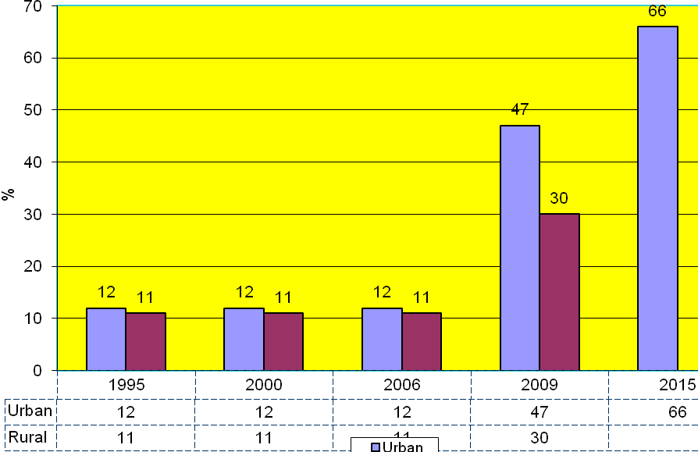 ]

Figure 1. WEDC – Sierras Leone Sanitation Stands

Source: WEDC – UNICEF/AfSoR

[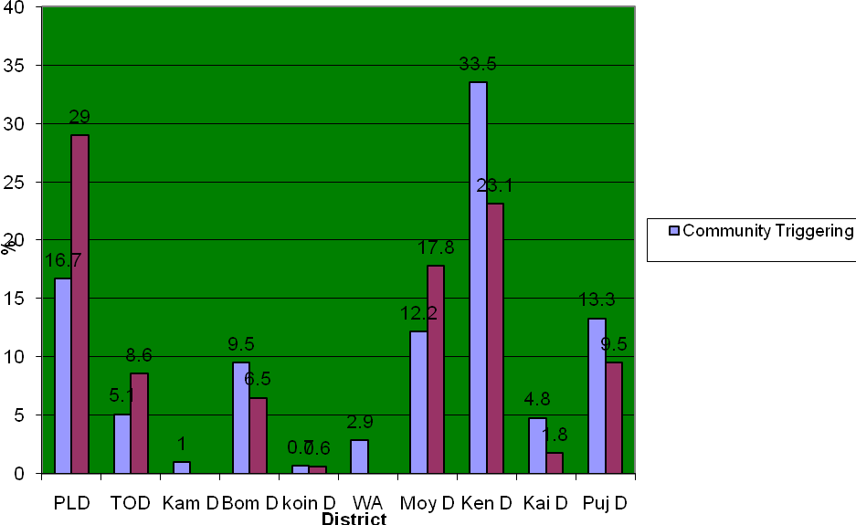] |  | [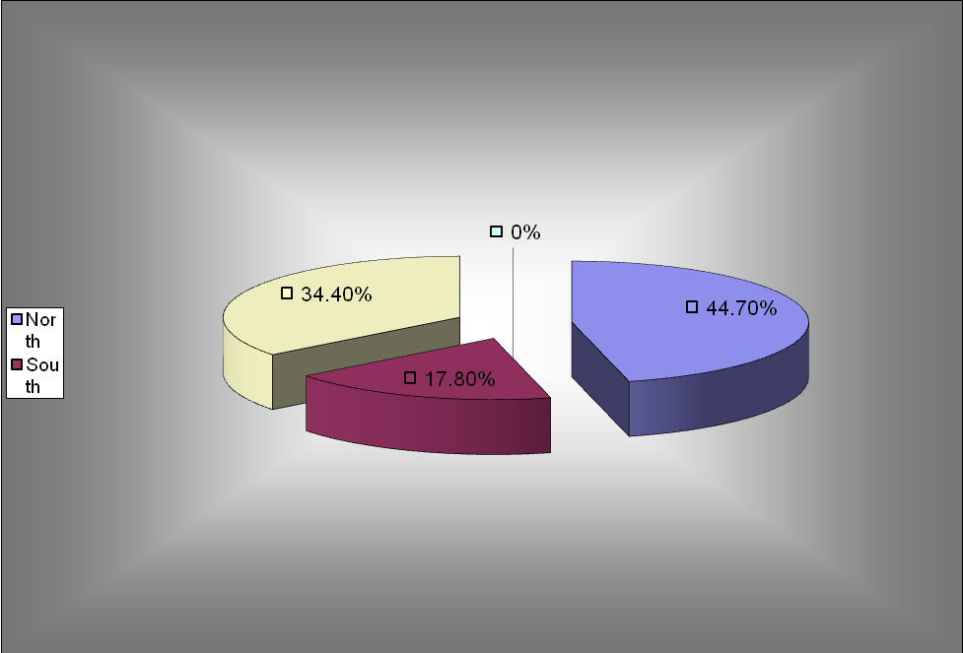 ]
Figure 2. WEDC – Community Triggering and Open Defecation Free |  | Figure 3. WEDC – Open Defecation Free Provinces

[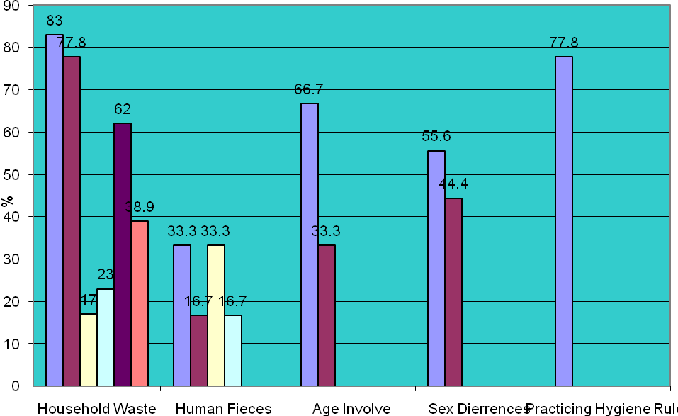
Figure 4. WEDC – Sanitation Assessment Survey 200

Acknowledgements
I, Wurie Mamadu Tama Barrie and Foday Ahmed Sillah Executive Director and Assistant Program Officer of Action For Social Rights wishes to express our thanks and appreciation by acknowledging the contribution of the following individuals and organisation for providing the relevant information an fact in making these research paper a success. Emily Bamford UNICEF; Arnold Cole UNICEF and the CORD Sierra Leone
References
UNICEF-Quarterly WASH Report Sierra Leone January to June 2009.

United Nations Economic for Africa- Sierra Leone Water Supply and Sanitation Policy Final
Action For Social Rights Sanitation Assessment Survey 2008
UNICEF-A HANDBOOK FOR SCHOOL SANITATION AND HYGIENE EDUCATION
Human Resources for Health Policy in Sierra Leone for the Ministry of Health and Sanitation
Action For Social Rights International Year of Sanitation Report 2008

Note/s
Please note that sanitation can only be achieved when the six key words are integrated in our programs and activity.

ODF
Please note that the ODF free does not represent the 149 chiefdoms in the twelve district but only 11 districts and selected villages within the 149 chiefdoms {not entirely}

Human Waste Extraction
33.3% Machine
33.3 Manual
16.7 Streams
16.7 Bush

Waste Household
17% have access to dust bin as opposed to 83%
23% pay for collection of waste as oppose 77.8
62% unknown where their waste s deposited as opposed 38.9% known

- Men that it believed because of stereotyping and gender roles did no involve actively in household work but man involved in extraction of human faeces either by septic tanks or pit dugging that increase diarrhoeal
- Because of the domestic nature or attribute of women, women involve greatly in risky sanitation behaviour than men, which unknowingly transmit the bacteria or faeces to her children or other members of her household including herself
- Clearly indicated African elder {aged} are not involved in waste deposit, has minimise the risk for them getting sanitary related diseases.
- The job creation project with the aim of reducing unemployment among young people has p0laced in a high risk category to get sanitary illnesses

Keywords
communication/education, community driven/practicing the young, policy review, attitudinal and mental change, eniromental settings, increase funding
Contact Details

Name of Principal Author Wurie Mamadu Tamba Barrie  Address C/o NMDHR-14 Earl Street, Off Circular Road Freetown Sierra Leone West Africa  Tel: +232 78 397 357 +232 77 542 577  Fax: Nil  Email: exedirector_afsor@yahoo.com  www: Nil | Name of Second Author Foday Ahmed Sillah  Address C/o NMDHR-14 Earl Street Off Circular Road Freetown Sierra Leone West Africa  Tel: +232 77 835 654  Fax: Nil  Email: a.socialrights@yahoo.com  www: Nil

