Joel G. Murray
Fall 2008

Rainwater Harvesting in Ethiopia and Kenya, Africa

Introduction

With support from the Bill and Melinda Gate Foundation (BMGF), EnterpriseWorks/VITA (EWV) plans to undertake desk studies in 20 countries/regions to consolidate the information and lessons learned from former and current rainwater harvesting programs, with a view to disseminating the information widely and to support the design of a pilot project. The pilot project will test whether domestic rainwater harvesting (DRWH) has the potential to be an affordable and sustainable option for the poor with limited access to groundwater when supported through a market-based approach. The market-based approach includes developing a sustainable supply chain to support the delivery of DRWH goods and services, stimulating demand for such services by leveraging consumer preferences, and applying sustainable business models and with user fees that ensure full cost recovery. This approach has been successful in other sectors and BMGF would like to determine whether and how it can be successful with DRWH.


Literature Review
Abstract
World-wide pressure on water resources is increasing due to population growth, groundwater mining and climate change. Domestic and agricultural water usage is a significant component of water demand. Rainwater harvesting (RWH) has been found to be a viable alternative to meet this growing demand. The use of Geographic Information Systems (GIS) data, specifically rainfall and population density, is generally a low cost method that can be used to identify sites that are suitable for RWH. When supported with a market based approach, RWH has the potential to be an affordable and sustainable option for the poor with limited access to groundwater.
Keywords: Africa, Ethiopia, Geographic Information Systems (GIS), Kenya, Rainwater Harvesting (RHW)
Introduction
The Federal Democratic Republic of Ethiopia is located in East Africa. Ethiopia is one of the oldest countries in the world and Africa's second-most populous nation. Ethiopia’s climate is considered tropical monsoon with wide topographic-induced variation. The countries population, according to the CIA World Factbook, is approximately 82,544,840 persons. The capital city of Addis Ababa is located near the geographic center of the country and with a population of 3,627,934 as of 2007, is the world's largest city in a landlocked country.
The Republic of Kenya is also located in East Africa. The country is named after Mount Kenya, the second highest mountain peak on the continent. Kenya’s climate is hot and humid along the coast, temperate inland and very dry in the north and northeast parts of the country. The countries population, according to the CIA World Factbook, is approximately 37,953,840 persons. The capital city of Nairobi, located in south-central Kenya, is the most populous city in East Africa, with an estimated urban population of between 3 and 4 million.
Rainwater harvesting (RWH) is the gathering, or accumulating and storing of rainwater. Traditionally, rainwater harvesting has been practiced in arid and semi-arid areas, and has provided drinking water, domestic water, water for livestock, water for irrigation and a way to replenish ground water levels. Due to aging infrastructure and low income status many families in both Ethiopia and Kenya are finding that access to potable water is becoming increasingly more difficult. Geographic Information Systems (GIS) can be used to identify areas in both countries where domestic rainwater harvesting (DRWH) has the potential to be an affordable and sustainable option for the poor with limited access to groundwater when supported through a market-based approach. The market-based approach includes developing a sustainable supply chain to support the delivery of DRWH goods and services, stimulating demand for such services by leveraging consumer preferences, and applying sustainable business models with user fees that ensure full cost recovery.

Description / Discussion
A number of studies have been conducted to examine the possibility of using RWH technologies for both domestic and agricultural use. The overall potential market for RWH is governed by factors relating to rainfall and population. A high level estimation of market potential will be possible by overlaying the population density and rainfall amount and distribution throughout the year. This will provide an idea of the overall potential market.
In 2006 (Mati et al.) the United Nations Environment Programme conducted a study to determine if RWH technologies can be mapped at continental and country scales, given that RWH is a site-specific activity. The project utilized a number of GIS data sets including rainfall, land use, land slope, and population density to identify four major commonly adaptable RWH technologies:
• Rooftop rainwater harvesting
• Surface runoff collection from open surfaces into pans/ponds
• Flood flow storages and sand/sub-surface dams
• In-situ water harvesting
One of the main constraints faced in the continent-wide mapping of RWH potential in Africa was lack of high resolution input data, as most available data were of scales 1:5,000,000, which is too small for most of the factors associated with RWH. The study concluded that spatial data could be used to demonstrate that Africa has a huge untapped potential for rainwater harvesting.
A similar study was undertaken in 2002 (Nega and Kimeu) by the Regional Land Management Unit in cooperation with the Swedish International Development Cooperation Agency. This study focused on the actual cost of installing collection facilities to capture rainwater for domestic purposes in Ethiopia and Kenya. In many areas there is little or no likelihood of a piped water supply becoming available; therefore, roof-water harvesting is a feasible way of improving water quality and availability. Unfortunately, a major limitation to the expansion of RWH has been the lack of suitable roofs and storage facilities. The study concluded that RWH has the potential to reduce the enormous burden of collecting and transporting water while at the same time providing a cleaner supply. As iron-sheet roofs replace grass thatch roofs and through the construction of underground tanks with low-cost linings, the potential for RWH for domestic supply has greatly increased.
The potential for RWH for both domestic and agricultural use has been examined in other areas of Africa as well. Mbilinyi et al. (2007) utilized a GIS-based decision support system (DSS) using remote sensing and limited field survey to identify potential sites in Tanzania for RWH technologies. Input into the DSS included maps of rainfall, slope, soil texture, soil depth, drainage and land use/cover. Outputs from the model were maps showing potential sites of water storage systems (ndiva), stone terraces, bench terraces and borders. Results from testing and validation of the developed DSS indicate that the tool can be used to reliably predict potential sites for RWH technologies in semi-arid areas.
Two studies in South Africa have also identified the potential for RWH to improve water supply. Kahinda et al. (2007) explored the use of DRWH as an alternative for South Africa to meet the Millennium Development Goals of halving, by 2015, the proportion of people without sustainable access to safe drinking water and basic sanitation. Their study determined that DRWH has the potential to improve rural water supply in rural South Africa but only an integrated system approach will likely guarantee its success. Kahinda et al. (2008) also developed a method to create RWH suitability maps in South Africa based on a combination of physical, ecological and socio-economic factors. ArcView Model Builder enabled a weighted overlay of the datasets, which was used to create the suitability model, comprising the physical, ecological and vulnerability sub-models from which the physical, the ecological and the vulnerability maps were derived respectively. The study concluded that the suitability maps produced do not have the required resolution to query details of known areas, but provide at the country scale valuable information for implementing a strategy that guides the sustainable wide scale adoption of RWH in South Africa.

Conclusion
RWH is not only a potential water source for citizens of developing countries but for developed countries as well. The city of Tokyo, Japan has begun to utilize rainwater and reclaimed wastewater for urban water use (Furumai, 2008). There are currently 850 facilities for RWH in Tokyo and both rainwater and recycled water have been utilized for various purposes such as washing, watercooling, toilet flushing, waterway restoration and creation of recreational waterfront. This study shows that past and current practices and the concept of sustainable water use in Tokyo will be worthy of consideration in the urban water management of future mega cities in Asia.
Germany has also utilized RWH for domestic use (Nolde, 2006). Currently, about 50,000 professional rainwater plants are being installed every year which collect rainwater from the roof which is filtered, stored and primarily used for toilet flushing, garden watering and household laundry. A novel approach in Germany is the use of the more polluted rainwater draining from streets and courtyard surfaces for treatment and reuse as service water. This form of RWH could be considered a viable option for densely populated urban areas. It also contributes to the reduction of drinking water consumption and wastewater production while minimizing pollutant entry into surface waters.
As global freshwater resources are being increasingly polluted and depleted, threatening sustainable development and human and ecosystem health the use of RWH will undoubtedly increase. GIS models have proven that RWH is a viable option to improve water supply not only in developing countries, but also developed ones. Through the use of a market-based approach, a sustainable supply chain to support the delivery of RWH goods and services can be promoted.

References
CIA – The World Factbook. Accessed 22 Nov. 2008. https://www.cia.gov/library/publications/the-world-factbook/.
Furumai H. 2008. Rainwater and reclaimed wastewater for sustainable urban water use. Physics and Chemistry of the Earth 33: 340-346.
Kahinda J.M., Lillie E.S.B., Taigbenu A.E., Taute M., Boroto R.J. 2008. Developing suitability maps for rainwater harvesting in South Africa. Physics and Chemistry of the Earth 33: 788-799.
Kahinda J.M., Taigbenu A.E., Boroto J.R. 2007. Domestic rainwater harvesting to improve water supply in rural South Africa. Physics and Chemistry of the Earth 32: 1050-1057.
Mati B., De Bock T., Malesu M., Khaka E., Oduor A., Nyabenge M., Oduor V. 2006. Mapping the potentials for Rainwater Harvesting technologies in Africa: A GIS overview on development domains for the continent and ten selected countries. Technical Manual No. 6 Nairobi, Kenya: World Agroforestry Centre (ICRAF), Netherlands Ministry of Foreign Affairs. 116 p. + x p.; includes bibliography.
Mbilinyi B.P., Tumbo S.D., Mahoo H.F., Mkiramwinyi F.O. 2007. GIS-based decision support system for identifying potential sites for rainwater harvesting. Physics and Chemistry of the Earth 32: 1074-1081.
Nega H, Kimeu PM. 2002. Low-cost methods of rainwater storage: Results from field trials in Ethiopia and Kenya. RELMA Technical Report Series 28 Nairobi, Kenya: Regional Land Management Unit (RELMA), Swedish International Development Cooperation Agency (Sida). 58 p. + viii p.; includes bibliography.

GIS Plan and Preliminary Analysis
Problem Statement
Global freshwater resources are being increasingly polluted and depleted, threatening sustainable development and human and ecosystem health. Viable alternatives to groundwater mining are needed to provide the general populous with access to sustainable water resources. Rainwater harvesting (RWH) can provide this alternative as a low cost means to capture and store water for both domestic and agricultural use. This pilot project in Ethiopia and Kenya, Africa will determine if data is available to accurately map and identify RWH potential in the region.
Ultimately, EnterrpiseWorks/VITA would like to determine the potential market for domestic rainwater harvesting (DRWH) systems in 20 countries/regions. The countries/regions include: four regions in India (Rajasthan, Karnataka, Tamil Nadu and the North East Hill Country), Sri Lanka, China, Thailand, Cambodia, Vietnam, Laos, Bangladesh, Papua New Guinea, Australia, Germany, Hawaii, Brazil, Uganda, Ethiopia, Kenya, Tanzania, and South Africa.

Justification

The overall potential market for DRWH is governed by factors relating to rainfall and population. A high level estimation of the market potential will be possible by overlaying the population density and rainfall amount and distribution throughout the year. This will provide an idea of the overall potential market. We would like to identify some other criteria that could be used as filters to give a better estimation of the actual potential market. Places where there is a lack of alternative water sources, as seen on some of the small low lying islands, make rainwater collection the only option for fresh water. Factors that relate to the relative competitiveness of DRWH systems with alternative sources of water could also provide an indication of the actual potential market. These factors would include the cost of water from other sources, the distance that it must be transported, the quality of water from the alternative source and the time required to fetch the water (travel time and time in queues). The cost of a DRWH system will certainly influence the market size as will the purchasing power of the households. If socio-economic data is available we could further segment population by socio-economic category (SEC). The cost of the system will be less if the roof is suitable for use as a catchment surface, therefore the percentage of homes with a hard roofs will influence the actual market size.

Methods
Data Availability
I conducted an exhaustive internet search for global precipitation, population and elevation data. Although I discovered numerous data of varying quality the most robust data sets, utilized for the RWH analysis, were the following:
Global Population Data:
Gridded Population of the World, version 3 (GPWv3)
Global Precipitation Data:
WORLDCLIM, version 1.4
Global Elevation Data:
Shuttle Radar Topography Mission (SRTM)
Database Structure
All data were projected to Africa Albers Equal Area Conic, WGS84. Data analysis was conducted using ESRI ArcGIS software (version 9.2). Figure 1 displays the database structure which consists of two folders for Ethiopia and Kenya respectively. All map documents are stored in the upper-level NR505 folder.
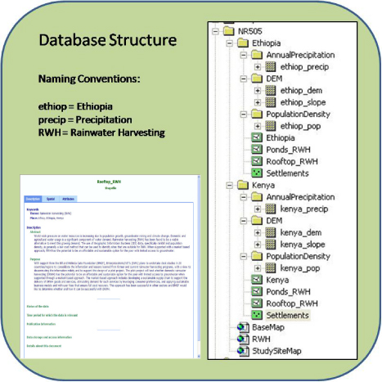
Figure 1: RWH Database Structure.
Study Area
The areas of interest for my individual research project were the countries of Ethiopia and Kenya. Both countries are located in eastern portion of the continent on 'the horn' of Africa (Figure 2).
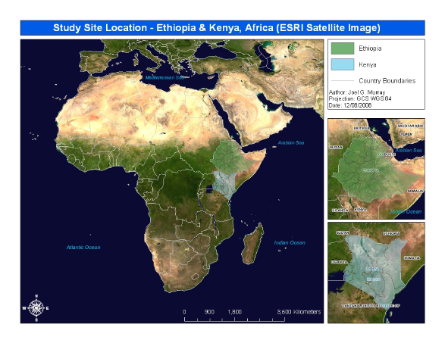Figure 2: Location map showing Ethiopia and Kenya, Africa.
Base Maps
The figures below (Figure 3 & 4) display the data that were used to map RWH potential in Ethiopia and Kenya. These include global precipitation, population and elevation (slope) data.
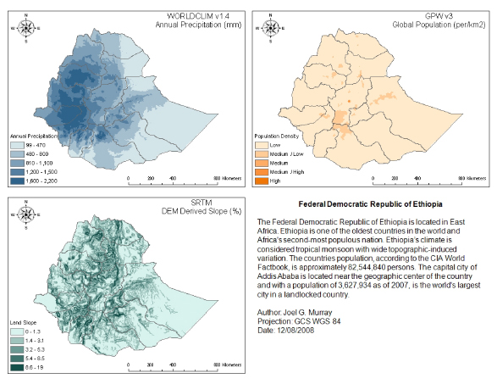Figure 3: Base Maps for Ethiopia RWH Analysis.
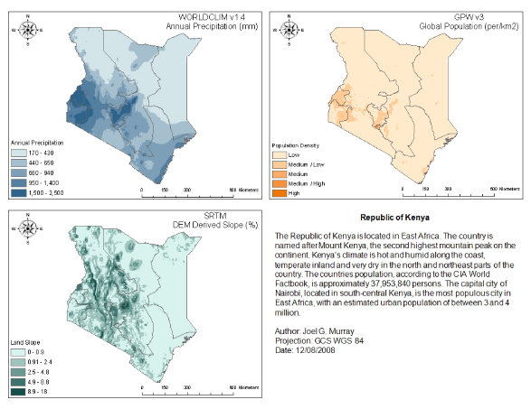Figure 4: Base Maps for Kenya RWH Analysis.

Results
GIS Analysis Flowcharts
Figure 5 illustrates the analysis steps used to create the RWH potential maps for Ethiopia and Kenya. The Rooftop RWH model requires precipitation and population data and can be limited to areas where settlements exist. The Ponds/Pans RWH model requires precipitation and elevation (slope) data. Criteria were obtained from the World Agroforestry Centre (ICRAF), Technical Manual No. 6.
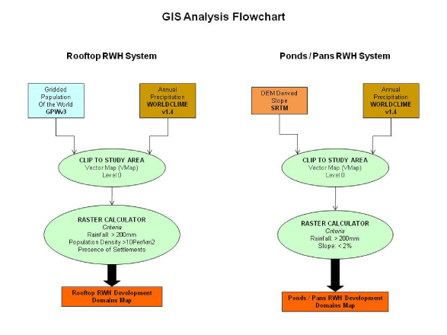Figure 5: RWH Analysis Flowchart.
RWH Maps
The figures below (Figure 6 & 7) display the RWH potential maps. Preliminary results indicate that over 95% of Ethiopia is suitable for Rooftop RWH, but only 57% is suitable for Ponds/Pans RWH. Kenya is over 80% suitable for both Rooftop and Ponds/Pans RWH.
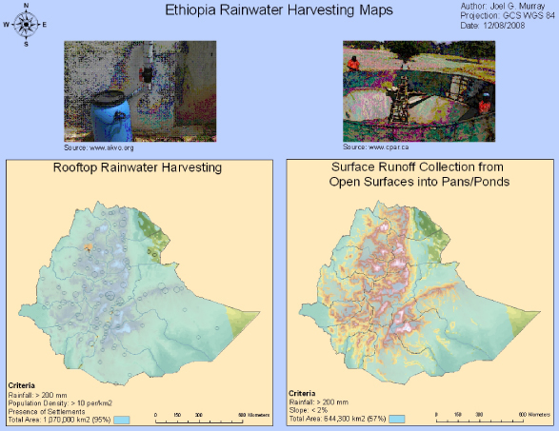Figure 6: Ethiopia RWH Maps.
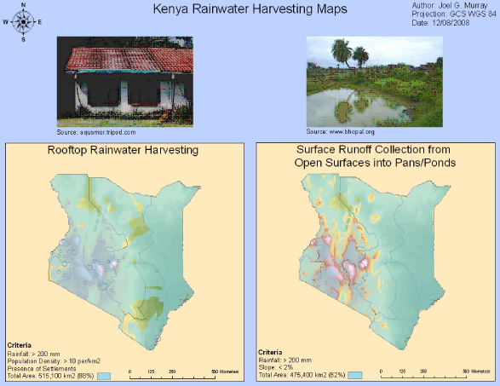Figure 7: Kenya RWH Maps.

Conclusions
Although RWH potential maps for Ethiopia and Kenya look promising the models are extremely simplistic and a review of model criteria should be considered. Other data sets such as land use and rooftop type as well as RWH system installation costs can be added as model parameters to improve accuracy. NDVI and higher resolution temporal data such as monthly precipitation grids can also be used to examine seasonality effects.
Overall, this project has successfully shown that GIS is a cost effective method to identify RWH as a viable option to improve water supply in both Ethiopia and Kenya. Furthermore, through the use of a market-based approach, a sustainable supply chain to support the delivery of RWH goods and services can be promoted.

