Accra, Ghana, 10-12 November 2009

West Africa Regional Sanitation and Hygiene Symposium

How behaviour change approaches helped improve hygiene and sanitation practices in Northern Ghana

Sumaila S. Saaka, Ghana & Lonna Shafritz, Washington, DC

The USAID Hygiene Improvement Project (HIP) supported West Africa Water Initiative (WAWI) field partners in Ghana (as well as in Niger and Mali) to strengthen their behaviour change approaches from March 2007 through October 2008. This photo essay presents the process of engagement of Ghanaian WAWI partners with behaviour change and their adoption of successful hygiene promotion strategies. Some field-level behaviour change activities and results will be presented. Specific examples include the adoption of Community-Led Total Sanitation (led by UNICEF and WaterAid), and the negotiation of more effective hand washing (led by UNICEF) and household water treatment practices (led by World Vision).

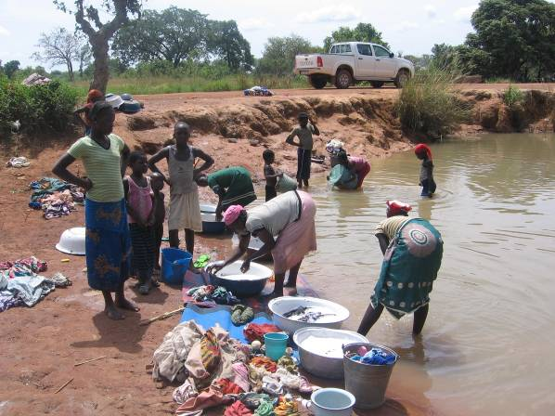
1. Diarrhoea contributes significantly to under-five mortality in Ghana, partly due to unsafe drinking water, unimproved sanitation and poor hygiene. In Northern Ghana, the West Africa Water Initiative (WAWI) field partners and other stakeholders have achieved remarkable success providing improved water sources and sanitation facilities (latrines) in intervention communities. Nevertheless, the water that many have access to is generally not safe to drink. Here we see women of Bawdo Village in West Mamprusi District washing in a stream—a source of drinking water for their community during the rainy season (June-December), which is contaminated by this and other daily activities such as open defecation. [Photographer: Sumaila Saaka/HIP Consultant].

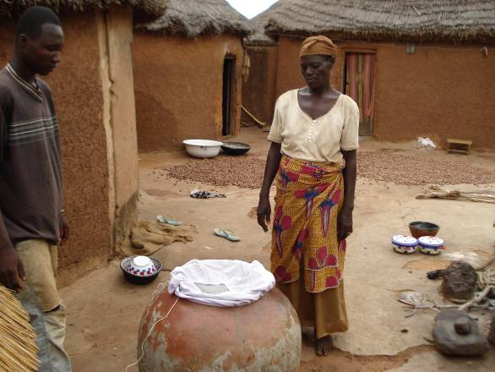
2. Thus, promoting safe household water treatment and storage as one of the key hygiene practices is critical to reducing diarrhoea and other water-related diseases. Women are primary audience for hygiene behaviour change interventions because they are gatekeepers for the health of their families and communities. In this photo, a woman in Kanshegu Village, assisted by a community-based hygiene volunteer, explains how the cloth water filter (covering the opening of a water storage pot) has been helpful in reducing the incidence of guinea worm in her community. She indicated that the filter was given to her by guinea worm eradication volunteers during a health education session, which included a demonstration on how to use the filter. She recollected the importance of always using the filter material with the same side up, thus preventing cyclops (intermediate hosts of guinea worm) and debris previously caught in the filter from re-contaminating the water. Although the main focus of the HIP hygiene behaviour change support was to prevent or reduce diarrhoea, the behavioural analysis approach introduced was also used by WAWI partners/collaborators to address other priority water and sanitation related diseases such as guinea worm.
[Photographer: Sumaila Saaka/HIP Consultant]

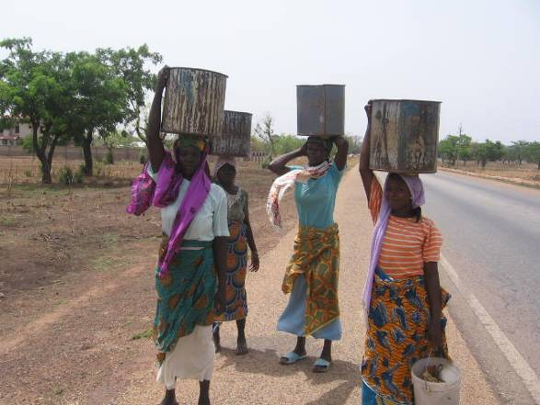
3. Many peri-urban and rural communities do not have access to sufficient water throughout the year. This is a major barrier to adoption of safe personal hygiene practices, particularly regular handwashing with soap or ash before food preparation and after dealing with faeces, to prevent diarrhoeal diseases among children. In this photo, women in the peri-urban town of Tamale are carrying water in open containers from the source (an open well about 9 kilometres away) for household use—cooking, hand washing, drinking, washing of utensils, washing of clothing and bathing [Photographer: Sumaila Saaka/HIP Consultant].

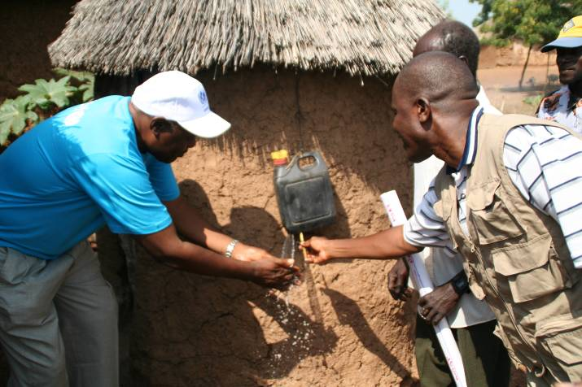
4. WAWI partner and collaborator WASH promoters have been taught how to construct tippy taps (a low-cost water-saving hand washing device) during training sessions. In turn, the trainees were expected to also train community-based WASH volunteers in their intervention areas. WAWI partners have also worked with the communities and households to use tippy taps to wash their hands with soap at critical times. Tippy taps not only help keep stored water clean, but limit the amount of water used to wash hands. This picture shows a demonstration of how to use a tippy tap to wash hands (note the soap on top of the lid) during the visit by USAID/ARD/WAWI staff to Gbandu Village. This tippy tap with soap hangs outside a USAID/UNICEF-supported household latrine, which was made by the father of the household. The mother supervises the filling of water. The soap, which is bought by the mother or caregiver, is usually kept in the hand-washing station of household. [Photographer: Sharon Murray/USAID]

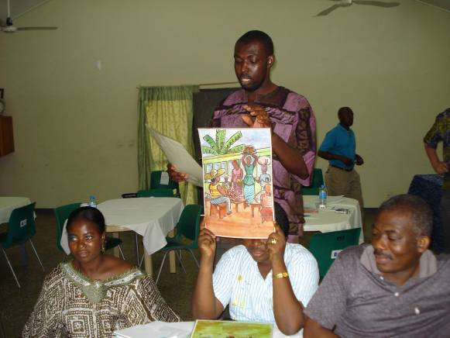
5. Improved water, sanitation and hygiene practices (WASH) can only be achieved through sustained behavioural change at the household and community levels. Thus, HIP support included technical assistance from a full-time Tamale-based Behaviour Change Specialist as well as two workshops on behaviour change, both funded by USAID/ARD/WAWI, with technical support from HIP. In this photo participants in a training-of-trainers workshop on behaviour change held in Tamale are providing opinions on WASH behaviours. The trainers being trained were from the various WAWI field partner and collaborator organizations. WAWI collaborates with local NGOs and government agencies (Community Water and Sanitation Agency, Environmental Health and Sanitation Unit of the Ministry of Local Government and Rural Development, and District Assemblies). The participants remarked that they really appreciated the cross-organization training approach as it gave them an opportunity to meet and exchange experiences with others doing similar work.
[Photographer: Sumaila Saaka/HIP Consultant]

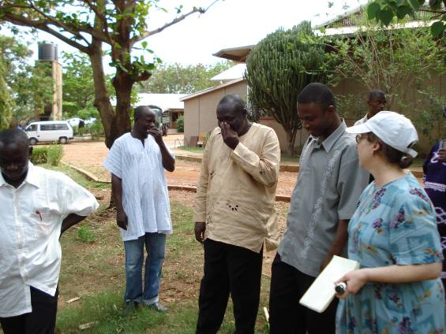
6. …For example, practical training in negotiation of improved practices and effective facilitation skills are fundamental for the success of water, sanitation and hygiene promotion. Here, the WAWI partner/collaborator field staff practice the first Community-Led Total Sanitation (CLTS) ignition skill—a walk of shame to locate sites of open defecation—during a HIP-assisted training session. They are holding their noses due to the "imaginary" smell from the feces areas they have located. The training facilitator, Ms. Lonna Shafritz (extreme right) observes their reactions and provides further guidance. Good facilitation at the household and community levels is very crucial for hygiene and sanitation behavioural change.
[Photographer: Sumaila Saaka/HIP Consultant]

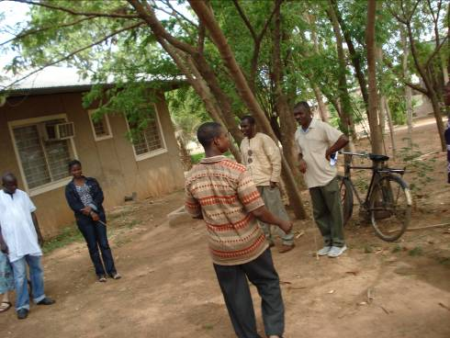
7. Once the sites of open defecation are identified, the next step in CLTS is to have the community members create a map of their community. Here, a WAWI Workshop participant is acting as a facilitator to encourage the other WAWI partner/collaborator field staff to create a map of a community to identify where the open defecation areas are located. [Photographer: Sumaila Saaka/HIP Consultant]

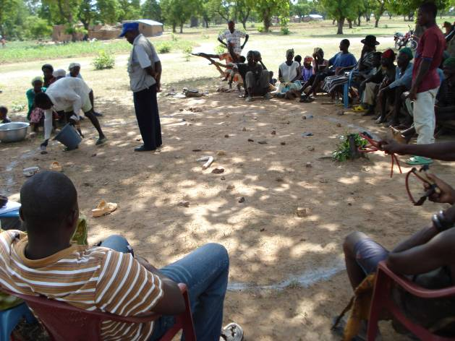
8. Some communities have accepted the challenge to stop open defecation in order to improve their health. This picture shows the beginning of community mapping in Atowoo-Tinganoore Village in Bolgatanga Municipality. Men, women and children of Atowoo-Tinganoore draw their community map, using stones as households, and ashes to represent the defecation areas. The facilitator in this picture is a district environmental health officer, who was trained in CLTS during a WaterAid workshop, with technical assistance from HIP. [Photographer: Sumaila Saaka/HIP Consultant]

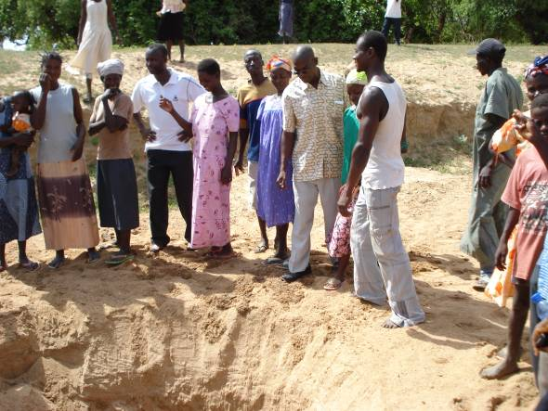
9. The CLTS walk of shame and community mapping activities illustrate to community members the fact that their water sources are likely contaminated by their proximity to open defecation sites. Based on their new concern about effects of open defecation, the community of Atowoo-Tinganoore drew up a community action plan and started some activities. In this picture some villagers from Atowoo-Tinganoore are looking at their main source of water during the dry season and wondering how safe it is from the runoff from open defecation. [Photographer: Sumaila Saaka/HIP Consultant]

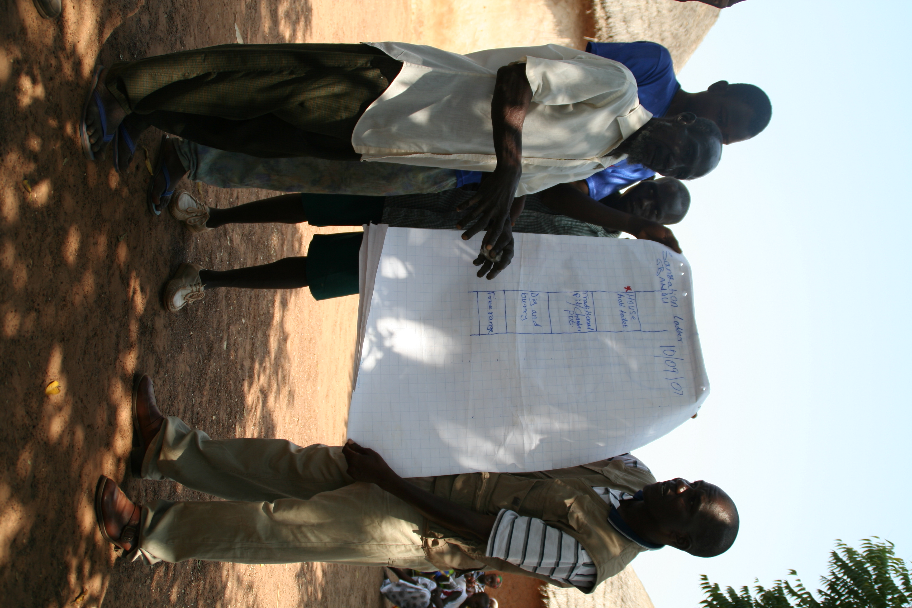
10. Community-based WASH volunteers in project sites have developed their own community WASH action plans. This is usually the output of training they receive from WAWI partner WASH program officers and district environmental health officers, supported mainly by UNICEF and WaterAid/Ghana. In this picture Gbandu community hygiene and sanitation volunteers present their village sanitation ladder (a diagram that takes people from open defecation to other unimproved and improved sanitation options) to USAID/ARD/WAWI program managers and funding partners during their visit to the village. A member of the hygiene and sanitation volunteers team (extreme right with hands stretched) explained that they have reached the stage of building their own household latrines using local skills and materials (marked red picture). [Photographer: Sharon Murray/USAID]

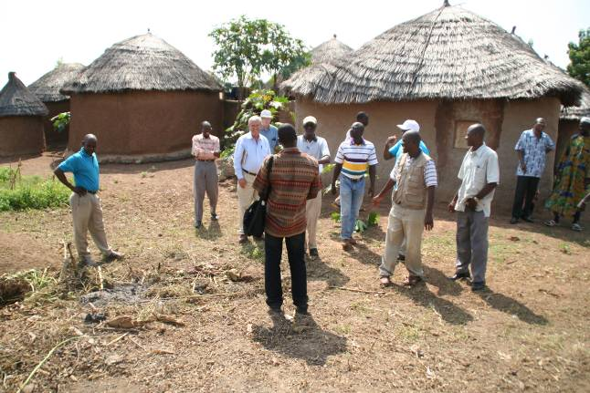
11. …However, WASH behavioural change in Northern Ghana has gone beyond individuals and communities. WAWI program managers and funding partners also have personally witnessed the results of improved behaviour change capacity and activities in project areas. These include increased community, household and individual participation in sanitation and hygiene behaviour change planning design and implementation; more people building household latrines; and more people washing their hands. As a result, the partners have resolved to increase funding for behaviour change activities as well as to mainstream it into their interventions. Here the USAID/ARD/WAWI team shares ideas with UNICEF partner/collaborator staff at Gbandu Village in Tolon-Kumbungu District. [Photographer: Sharon Murray/USAID]

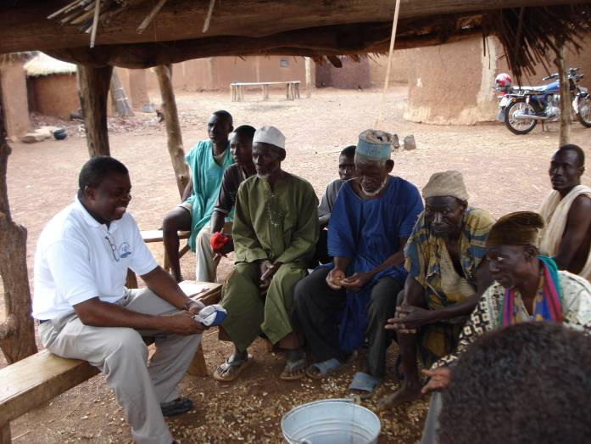
12. As a result of their behaviour change training, WAWI field partners have improved their behaviour change activities around water, sanitation and hygiene practices. This picture shows Emmanuel Asare-Boateng (extreme left), formerly of World Vision Ghana (WVG), discussing progress and next steps on hygiene and sanitation activities with village leaders. Here we see the chief of Kanshegu village near Savelugu (extreme right with towel) and his elders sharing their thoughts. WVG has been working here for a number of years, mainly in water supply and sanitation. [Photographer: Sumaila Saaka/HIP Consultant]

Acknowledgements
The authors would like to extend thanks to Orlando Hernandez, Sandy Callier, and Patricia Mantey from the USAID Hygiene Improvement Project; Merri Weinger, John Borrazzo and Sharon Murray from USAID; Hammond Murray-Rust, from ARD; as well WAWI partners including UNICEF, World Vision and WaterAid in Ghana and their field partners for sharing their work, on which many of the pictures are based.

Keywords
behaviour change, Community led Total Sanitation (CLTS), handwashing with soap, household water treatment, tippy tap, WAWI

Contact details
Name of Principal Author: Sumaila S. Saaka  Address: P.O. Box 452  Bolgatanga  Upper East Region  Ghana  Tel: +233 208488375  Fax:  Email: ssaaka2003@yahoo.com  www: | Name of Second Author: Lonna B. Shafritz  Address: AED  1825 Connecticut Avenue, NW, Washington, DC 20009-5721 USA  Tel: 1-202-884-8784  Fax: 1-202-884-8454  Email: lshafrit@aed.org  www: www.aed.org

