Support input by IRC, Jo Smet Version-5: April 2009
Quality Assurance by Brenda Achiro

GUIDELINES FOR BUILDERS/MASONS ON ARBORLOO AND FOSSA ALTERNA
Key source: ‘Toilets that make compost’, Peter Morgan www.ecosanres.org/toilets_that_make_compost.htm

Introduction Arborloo (Tree Latrine)

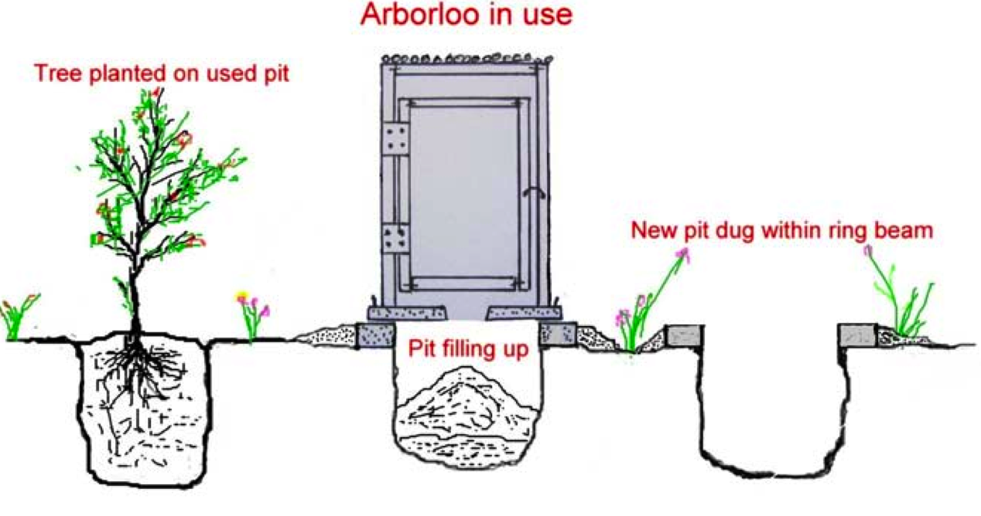
An Arborloo is a ‘Tree Latrine’. It is a shallow composting latrine. The magic comes when you add soil, ash and hopefully leaves into the pit as well as excreta. These extra ingredients accelerate the composting process and make what goes on below ground level rather different from the standard pit toilet. In a period of 9-12 months the pit fills up. Then a new pit has to be dug. The latrine house, the concrete slab and the ring beam or brick collar move all to the new pit. A new Arborloo is then ready for use. The old latrine is covered with soil and a tree is planted. There is no need to touch the partly decomposed faeces! So it is safe! Any tree will grow on the rich compost; fruit trees, bananas and papayas are very suitable and commonly planted. But also trees used for timber can be planted. Every year the household has a new tree, which gives fruits or timber for the family and excess fruits can be sold for extra income. Apart from having a growing orchard of trees, the Arborloo has more advantages. Because the pit is shallow, it is a sound solution for (i) high groundwater tables, (ii) rocky soils; and (iii) sandy (loose) soils. And because the latrine collar is placed above ground level, the slab is some 30-40 cm above the ground, and that may be sufficient to avoid seasonal flooding/overflowing in flood-prone areas.

Introduction Fossa Alterna (Twin Composting Latrine)

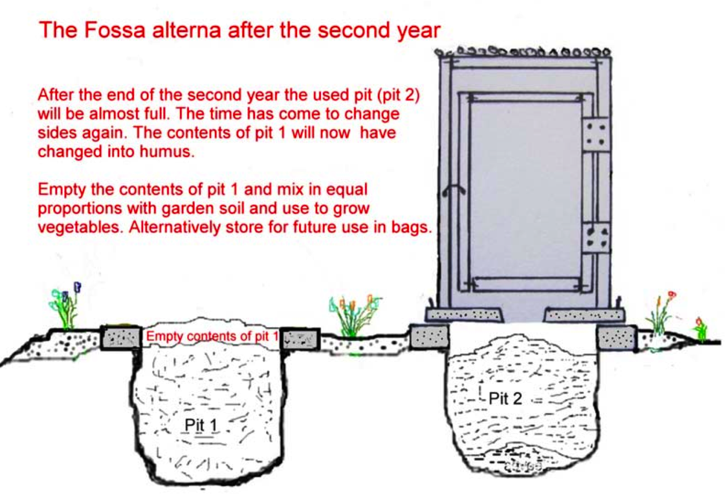
A Fossa Alterna or Twin Composting Latrine and its composting process are based on the same principle as for the Arborloo: a shallow composting latrine. But has a more permanent structure. Where you do not have sufficient space to dig a new pit and shift the latrine every year, the double (alternating) pit option is the solution. If the first pit is full after 12 months of use, one transfers latrine house and slab to the second pit. Then when the second pit is about to be full, the first pit will be emptied. The safe manure (also called humanure) can be used in the garden. It can also be sold to farmers (provided they are interested). The Fossa Alterna is therefore a more permanent structure. Because the pit is shallow, it is a sound solution for (i) high groundwater tables, (ii) rocky soils; and (iii) sandy (loose) soils. Does the name ‘Fossa Alterna’ sound strange, you can give this option a good local name? Composting latrine, or ‘Manure latrine’?

The latrine components
The latrine house:
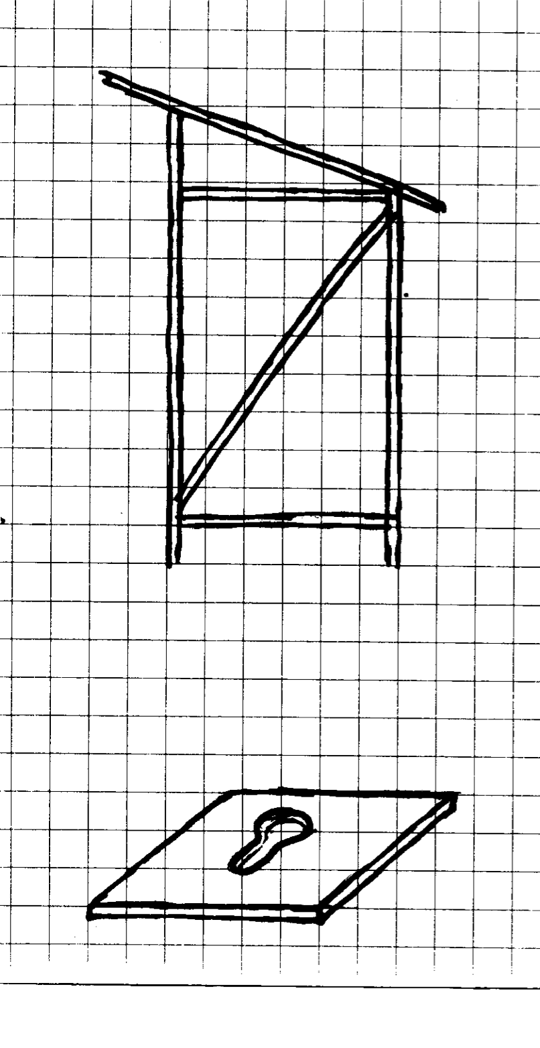
Can be made of any material that is available.
For instance, from poles and grass; from poles and mud; from poles or timber and papyrus stalks; all timber; poles and corrugated iron sheets; masonry; ferro-cement etc. The choice of building materials has a direct effect on the cost!

The slab or floor:
Must be made of reinforced ‘concrete’; the concrete is made of coarse (river or builders) sand and cement with iron wire reinforcement

The ring beam or collar
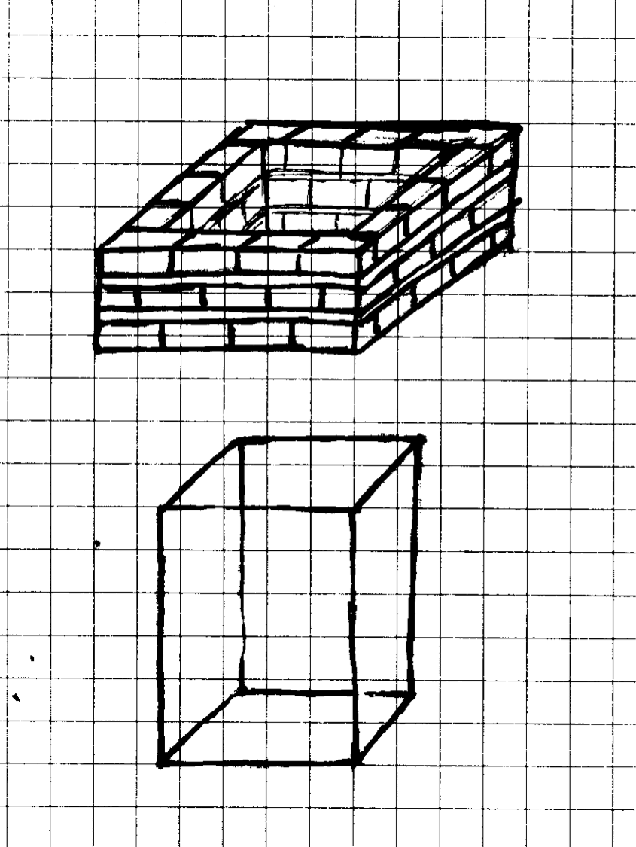
Can be made of reinforced ‘concrete’ then it called a ring beam; a ‘collar’ is made of burnt bricks with mortar, sun-dried bricks with termite hill soil, or stones/ rocks/pebbles/large gravel kept together with cement mortar or termite hill soil.

The pit
Does not need any lining provided the soil is not too coarse (e.g. very coarse sand or fine gravel) and tends to collapse, and the pit is shallow.

Steps in constructing an Arborloo or Fossa Alterna
Step 1: Locate the building site of the EcoSan latrine
- Stay at least 5 m away from the kitchen (for pit latrines officially 30m from home)
- Stay at least 10 m away from any dug well (if present) (for pit latrines officially 30m)
- If groundwater level is high (less than 1m), build latrine at higher ground level
Step 2: Prepare building site of the latrine
- If the collar option is chosen, level the ground (do not dig the pit yet!)
- If the ring beam option is chosen, raise the ground level some 10cm and ram the fresh soil. Level the raised surface.
Step 3: Make the concrete slab
- Can be circular or square (dimensions depending on pit size – see later in text)
- Can be cast in a timber frame or in a brick frame (or even metal frame)
- Accurately level the ground where you will cast the slab
- Always put plastic or paper on the ground before casting to avoid slab sticking to ground
- Best to apply some used engine oil to timber/brick frame and hole mould
Step 4: Make collar or ring beam at the site
Step 5: Dig latrine hole to required depth
Step 6: Place concrete slab on concrete ring beam or brick collar
Step 7: Build superstructure (latrine house)
Step 8: Empty a full sack of dry leaves to the pit

The pit

The pit size
The size or volume of the pit is important as the period of use of latrine should be at least 9-12 months for the Arborloo and at least 12 months for the Fossa Alterna. The 12 months are needed to make the compost safe so that no pathogens survive that could create a health risk. But making the latrine last for more than 12 months does not make sense. Only the construction cost will go up steeply.

An individual may produce some 60 litres of dry faeces per year (small kids less and perhaps adults more). The dry soil, ash and leaves added to the pit may add another 60 litres per person per year. We add another 20% volume as a ‘safety’ buffer (the factor 1.2 in the calculations below).
So the total required volume for a family of five people is estimated at:
5 x (60+60) x 1.2 = 720 litres
For a family of 10 people:
10 x (60+60) x 1.2 = 1,440 litres
For a school latrine used by 60 students, the calculation has to take into account that perhaps not more than one out of three pupils will use the latrine for defecation, and only five days a week and 40 weeks a year (some 12 weeks school holidays); so the total required volume is estimated at:
(60:3) x (60+60) x (5/7) x (40/52) x 1.2 = 1,582 litres

Furthermore, the pit dimensions are depending on – these are important rules:
- The groundwater level; have bottom of pit always above the highest groundwater level. Faeces decomposes differently in water, giving bad smells, attracting flies and mosquitoes etc. This means if the groundwater reaches 0.5 m below ground level and you need a pit of 1.0 m deep, then you have to raise your pit by building a higher collar (pit walls) on which you put your slab; or find another higher location for the latrine.
- The soil texture – 1;
if too hard (rocky) to dig, then you need to build the pit partly or fully above the ground.
- The soil texture – 2
if soil is very loose (sandy), then the pit can not be too deep (for instance not more than 70-80 cm), and a round pit is stronger than a square or rectangular pit
- The construction costs of ‘concrete’ slab
if width & length or diameter (circular slab) are more than 1.1 m (pit size 1.0m) then more reinforcement is needed (at least two iron wires), and then cost may become high
- The use of a concrete ring beam, stone collar or brick collar
the height of a concrete ring beam may be around 10-12 cm. That of a stone/rock/boulder collar some 15 cm, and that of a brick collar some 35-40 cm. These beam and collars are placed above the ground level. In use, the pit will be filled up to a level of some 35 cm below the slab. For the brick collar that is up to the original ground level, for the ring beam and rock collar that is some 20-25 cm below ground level. This 25 cm needs to be added to the pit depth as it is not effective pit depth (not to be filled up).
The pit dimensions for Fossa Alterna (12 months -use) are given in table below. The most recommended choices are made green. The slab sizes are 10 cm larger/wider - to have 5 cm overlap on brickwork.
Users per latrine | Pit volume [litres] | Depth  [m] | Circle diam. [m] | Square  [m] | Rectangular Width [m] | Rectangular length [m]
School: 60 | 1,582 | 1.0 | 1.40 | 1.25 | 0.70 | 2.25
School: 60 | 1,582 | 1.25 | 1.30 | 1.15 | 0.70 | 1.80
School: 60 | 1,582 | 1.50 | 1.15 | 1.05 | 0.70 | 1.50
HH: 10 | 1,440 | 1.0 | 1.35 | 1.20 | 1.00 | 1.45
 | 1,440 | 1.25 | 1.20 | 1.05 | 1.00 | 1.15
 | 1,440 | 1.50 | 1.10 | 1.00 | 1.00 | 0.95
HH: 5 | 720 | 0.8 | 1.10 | 0.95 | 1.00 | 0.90
Remark: possible depth depends also on groundwater table and soil texture- see above

The pit dimensions for Arborloo (12 months -use) are given in the table below. The most recommended choices are made green. The slab sizes are 10 cm larger/wider - to have 5 cm overlap on brickwork.
Users per latrine | Pit volume [litres] | Depth  [m] | Circle diam. [m] of pit | Square  [m] of pit | Rectangular Width [m] | Rectangular length [m]
School: 60 | 1,582 | 1.0 | 1.40 | 1.25 | Not applicable | n.a.
School: 60 | 1,582 | 1.25 | 1.30 | 1.15 | n.a. | n.a.
School: 60 | 1,582 | 1.50 | 1.15 | 1.05 | n.a. | n.a.
HH: 10 | 1,440 | 1.0 | 1.35 | 1.20 | n.a. | n.a.
 | 1,440 | 1.25 | 1.20 | 1.05 | n.a. | n.a.
 | 1,440 | 1.50 | 1.10 | 1.00 | n.a. | n.a.
HH: 5 | 720 | 0.8 | 1.10 | 0.95 | n.a. | n.a.
Remark: possible depth depends also on groundwater table and soil texture- see above

The pit dimensions for Arborloo (9 months -use) are given in the table below. The most recommended choices are made green. The slab sizes are 10 cm larger/wider - to have 5 cm overlap on brickwork.
Users per latrine | Pit volume [litres] | Depth  [m] | Circle diam. [m] | Square  [m] | Rectangular Width [m] | Rectangular length [m]
School: 60 | 1,187 | 1.0 | 1.25 | 1.10 | Not applicable | n.a.
 |  | 1.25 | 1.10 | 1.00 | n.a. | n.a.
 |  | 1.50 | 1.00 | 0.90 | n.a. | n.a.
HH: 10 | 1,080 | 0.9 | 1.25 | 1.10 | n.a. | n.a.
 |  | 1.00 | 1.15 | 1.05 | n.a. | n.a.
 |  | 1.25 | 1.05 | 0.95 | n.a. | n.a.
HH: 5 | 540 | 0.60 | 1.10 | 0.95 | n.a. | n.a.
Remark: possible depth depends also on groundwater table and soil texture- see above

The Pit shape
Circular Square Rectangular

Circular shape is strongest. This is best solution in loose soils and high groundwater tables, as shape gives most stable pit walls. Circular shape can withstand higher soil forces. | Square shape is OK in more stable soils with deeper/low groundwater tables. | Rectangular shape is sound for higher pit volumes and where soils are more stable (or with lining). The latrine house will be built above part of the pit. The part outside the latrine house could be used for emptying the pit.

The slab

The shape and mould

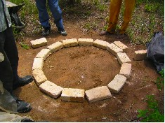

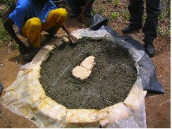

The mould and slab casting
The circular slab has a diameter of the pit size plus 10 cm, to allow for 5 cm overlap at all sides.  Thickness of the slab is 40 mm provided coarse river sand and fresh cement is being used. If quality of sand and/or cement is poor, 45-50mm to be at safe side (worst ‘business’ scenario is a slab collapsing with someone ending in the pit, even if the pit is quite shallow and dry!) | The square slab has a size of the width plus 10 cm, to allow for 5 cm overlap at all sides.  Thickness of the slab is 40 mm provided coarse river sand and fresh cement is being used. If quality of sand and/or cement is poor, 45-50mm to be at safe side (worst ‘business’ scenario is a slab collapsing and the user ending in the pit!)

The mould can be made of bricks of 40 mm height (for slab of 40 mm thickness; if slab is thicker use bricks with height accordingly. Making a circular timber or metal mould is attractive and worthwhile if expected number of slabs to be produced is high. | The square mould can be made of bricks or timber of 40mm x 40mm. The rectangular corners can be fixed as above.  Put a sheet of plastic or paper at the bottom to prevent that slab sticks to ground.
Squatting hole
To avoid soiling and urine splashing on the slab, the squatting hole should have an appropriate shape. The hole should also not too big as small kids may fear to fall in the ‘dark’ hole. A common shape is the key-hole; it provides sufficient space for urination. It is basically a circle and an ellipse. The diameter of the circle is 15cm and the ellipse is 20cm, see figure next  The mould for the squatting hole can be made of an empty paint tin or a small bucket, or a pan; and a smaller round object (diameter some 10cm).  For more permanent moulds, one could use a timber, metal or masonry shaped mould. Always apply some used engine oil to the mould to prevent the concrete sticking to the mould. | 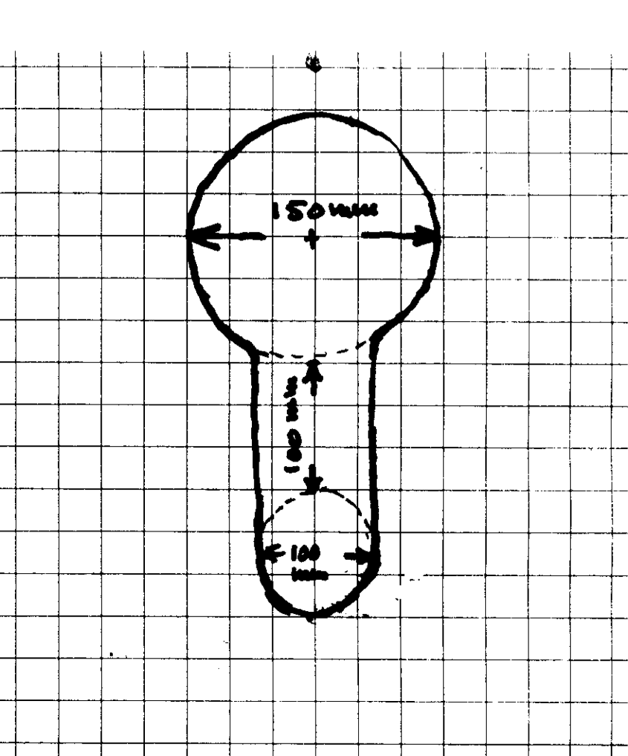
Concrete mixture
Some general advice:
- Use coarse sand, river sand, also called builders sand. If sand is fine, the concrete will not be strong!
- Use clean sand. Always wash the sand and remove silt, organic material etc.
- Use fresh cement; old cement has lost much of its strength; old cement tends to granulate and then mixing with sand is also not optimal
- Do not use gravel; the thickness of the slab (40-50mm) is too small for such large aggregates
- Mix sand and cement thoroughly by turning it many times until the product has a uniform grey colour
- Add water slowly and mix continuously
- Do not add too much water, usually not more than half the volume of cement used
- The final product should be a stiff mixture
- When casting the slab, first put a bottom layer of ‘concrete’ of 10-15 mm, then put the reinforcement, and then add concrete to fill the mould; level off and smoothen with a wooden float
- After casting, at least 10 days are needed for curing. Keep the slab always wet and have it covered with gunny (jute) bags or grass or banana leaves to protect it from the direct sunlight!
- Concrete will reach its maximum strength 28 days after casting.

A good mixture is 1:3, that is one volume of cement to three volumes of sand. For a slab of 40mm thick and a size 1.00m x 1.00m, 30 litres of washed coarse sand and 8-10 litres of fresh cement would do. Just try it and adjust if needed. As ‘seeing is believing’, have the finished/cured slabs loaded with some 160 kg (= two adults) to test the strength of the slab!

The ring beam or collar of burnt bricks, sun-dried bricks or rocks/pebbles/gravel

The circular brick collar | The circular concrete beam
- Mark a circle on the ground with the diameter required for the pit  - Lay burnt or sun-dried bricks around the circle  - Make a good mortar of ant hill soil and water (for the Fossa Alterna, with a permanent collar, also cement mortar can be used) (the Arborloo collar will be dismantled when shifting)  - Add the ant hill or cement mortar between and above the bricks  - Add another two courses of burnt bricks in the same way (joints of layer 1 and 2 not above each other!)  - Add extra mortar above course three to get levelled surface  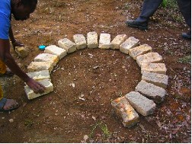  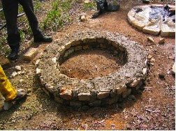  For the Arborloo, instead of burnt or sun-dried bricks, rocks or pebbles mixed with a rich anthill mortar can be used.  Make sure the shape of the ring beam is correctly shaped with a width of some 15 cm. | - Level off some ground and lay plastic sheet over the ground  - Take some bricks of 10-12 cm high  - Lay the bricks so that the outer and inner circles will make a ring beam of 15 cm in between them; the beam is 15cm all around  - Fill the spaces opened up between the inner bricks with wet sand  - Put plastic sheet inside to prevent concrete sticking to the bricks  - Put concrete mixture (1:3, see above) on the bottom of the mould (fill some 2-3cm)  - Take a length of wire of 3-4mm diameter and place it on the concrete bed, half way between inner and outer bricks  - Then add remainder of the concrete mix  - Level off with a wooden float  - Ram hard down the wooden float  - Steel handles can be added if required  - Cure concrete ring beam by covering and keeping it with for at least 10 days  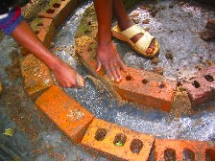  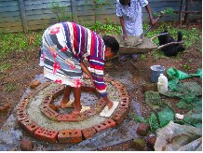  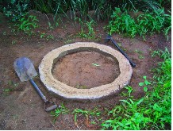

The square brick collar | The square concrete beam
The construction is similar as for the circular brick collar, only the shape is different. Make sure the inner dimensions are the same as these of the pit to be dug.  Below a picture of a square brick collar with cement mortar. Remark: instead of cement mortar, termite hill soil might be used.  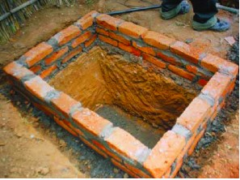  Below a picture of a fully lined pit needed when soil is very loose or when a masonry latrine house will be built on top.  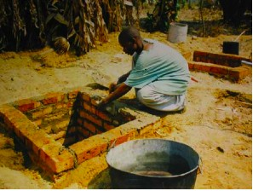  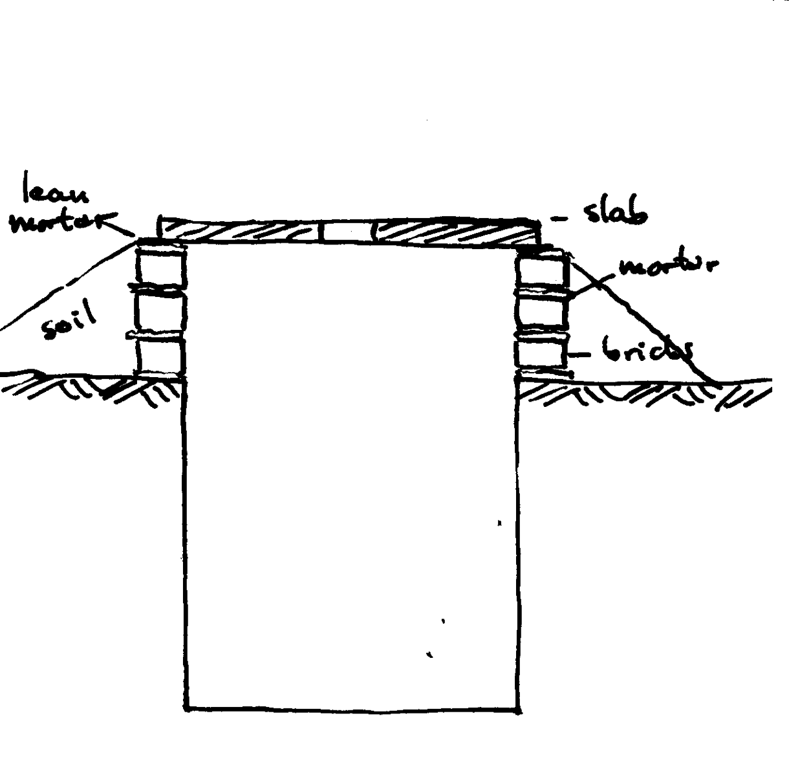 | The construction is similar as for the ring beam, only the shape is different. Make sure that the width is some 15cm and the height some 10-12 cm, and do not forget the reinforcement wire.  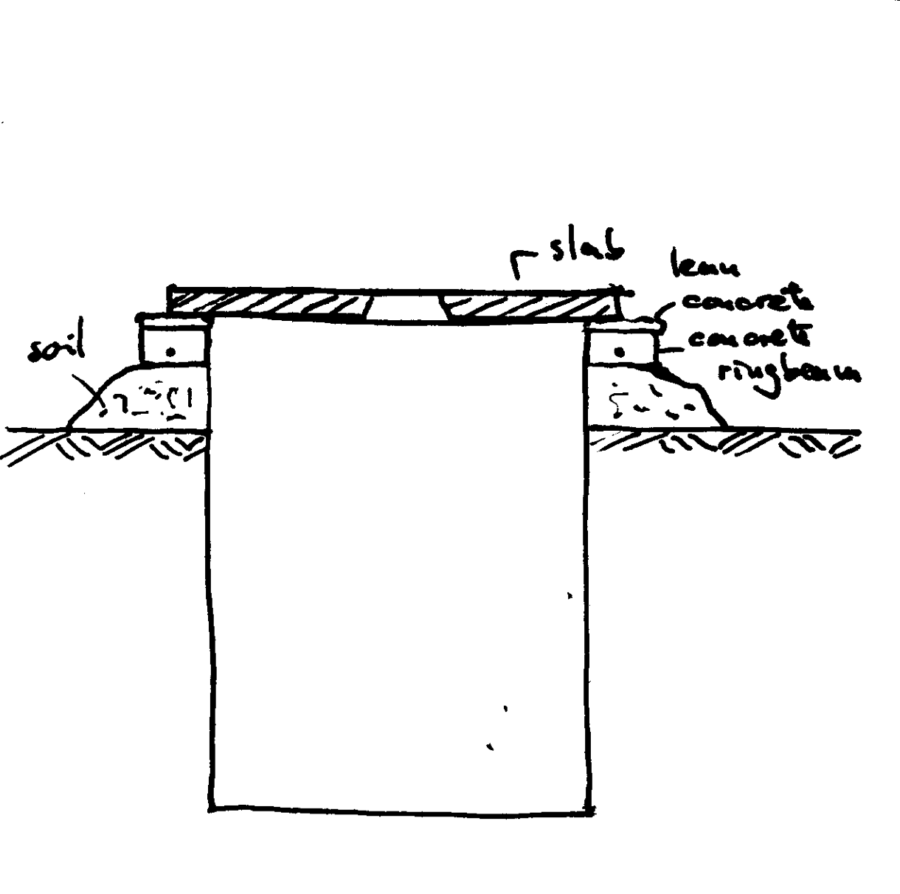

Fossa Alterna design of rectangular pits

Rectangular pits of Fossa Alterna are suitable for schools and larger households; see also table with dimensions. School pits require a high pit volumes. Therefore check to what depth you can dig before you reach the ground water; if 1.50m is possible, fine. Stability of the soil is less an issue as the pits will be fully lined. If max. depth is only 1.00m then the surface area of the pit will be larger and the length greater. For schools latrines that may require a permanent superstructure of bricks, the pit needs to be lined up to the bottom to avoid pit collapsing.
To save construction cost, pit and superstructure walls may be shared. That means that pits needs to be narrow (width of 70cm) and long enough to have an external opening for emptying (length > 1.50m). That length of the pit, however, demands for extra attention during operation as fresh compost needs to be levelled regularly over the entire pit surface. The drawing below shows a four-stance Fossa Alterna for schools. The superstructure is built over the walls and the concrete beam. The rear of the pit is closed with a removable light concrete slab (with metal wire hooks), sealed with termite hill soil. A beam crossing all pits makes building of the superstructure/house possible (dimension house 1.00mx1.50m). The beam should be at least 120mmx120mm with 2 iron reinforcement bars of at least 10mm diameter place low.
A front wall may replace doors (always problematic) and private still enough privacy.
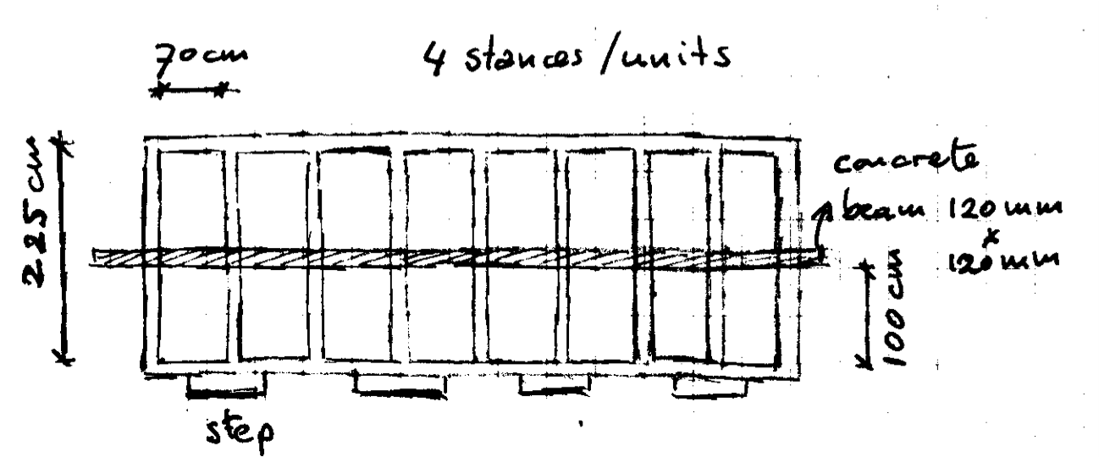
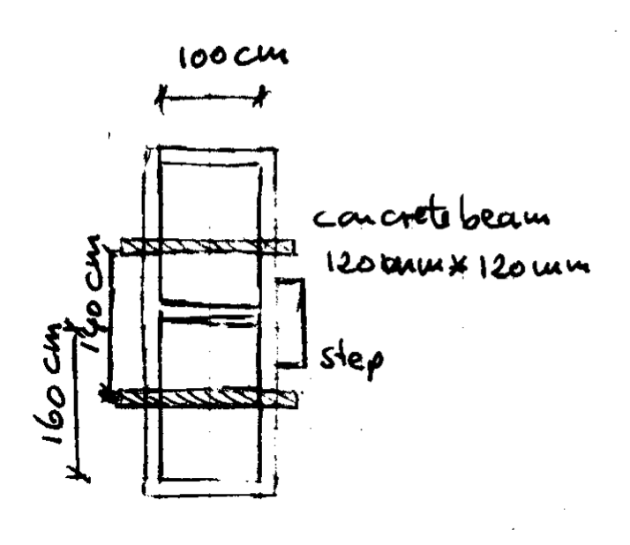
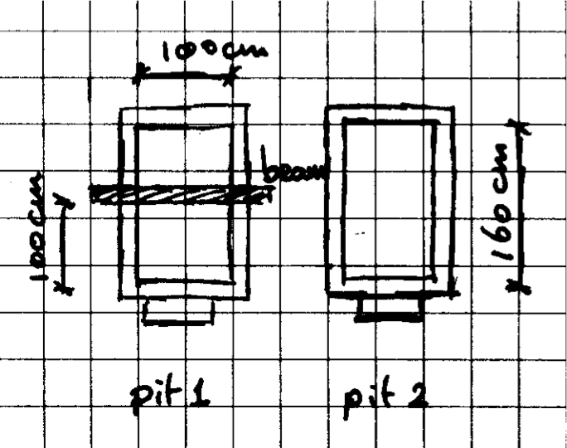
For larger households the Fossa Alterna may be built adjacent (see below) that allows a permanent superstructure (over two beams), or apart (see below). In the latter case the transferable superstructure is also partly build on the beam, and a light slab covers the rear hole for emptying. Spreading /levelling of the excreta/compost (also from the rear hole) in the pit is needed to have a proper functioning of the Fossa.
The latrine house or superstructure

The options and implications
- Poles and grass, papyrus, palm leaves or banana leaves  Cheap and easy to transfer or replace. Make sure that the poles are put in the ground outside the ring beam or square collar by digging/boring small diameter holes (not making pit to cave in)  - Timber or metal frame with grass, papyrus, palm leaves or banana leaves  Advantage is that the ‘house’ can easily be transferred to new Arborloo or Fossa Alterna. More expensive because of cost of timber or metal frame  - Fully made of timber: More expensive and heavier but still transferable  - Poles and mud: cheap though heavier and not easily transferable  - Fully made of burnt bricks: Heavy and expensive. This requires a full lining of pit otherwise the pit will collapse quickly!  - Roofing material: any in principle, that is, corrugated sheet (expensive but durable), papyrus (cheap if available), grass (cheap), palm or banana leaves (cheap); however, corrugated sheet are durable. | 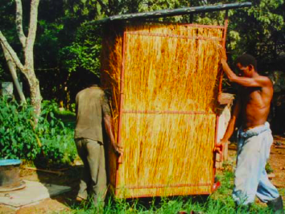  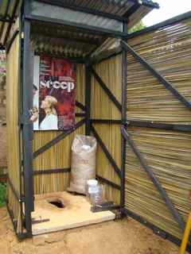

Urinals for boys and girls – see Guidelines for Builders/Masons on Urinals

