

Project Document

WATER FOR ASIAN CITIES PROGRAMME

A Regional Programme Promoting Pro-poor Investments in Water and Sanitation To Support Millennium Declaration Goals

United Nations Human Settlements Programme (UN-HABITAT)

Nairobi, January 2003

UNITED NATIONS HUMAN SETTLEMENTS PROGRAMME (UN-HABITAT)

PROJECT DOCUMENT

Project Title : Water for Asian Cities Programme
Project No :
Duration : 36 Months
Start Date : January 2003
Primary Location : Asian Region (Five Countries: one in each sub-region)

Executing Agency : UN-HABITAT/Water for Asian Cities Programme

Collaborating Agency : Asian Development Bank and National Governments of
participating Countries

Date of Grant Agreement: December 2002

Contribution of the Government of the Netherlands US$ 3,135,750
Contribution from UN-HABITAT (in kind) US$ 859,000
Contribution of participating Governments (in kind) US$ 590,000
Grand Total US$ 4,584,750

Project Summary

The Water for Asian Cities Programme will focus on four key areas which include (a) Urban Water demand management (b) Integrated urban environmental sanitation (c) Pro-poor urban water governance and (d) Community-based water and sanitation services. The programme will also make targeted interventions to address issues of urban sustain ability, poverty reduction, environmental protection and integrated water resources management.

In order to create the enabling environment for pro-poor investments in Water Supply and Sanitation the programme will be implemented on two parallel tracks (a) Capacity Building Activities and (b) Investment Promotion Activities. The Capacity-building activities will be pursued with the two main objectives of (a) mobilization of political will through advocacy and exchange of information and (b) enhancing regional, country and city-level capacities for water and sanitation management.

Investment Promotion Activities will promote urban poor targeted new investments in the water and sanitation sector in the region by conducting sector studies for identifying investment constraints and opportunities in selected cities, establishing pro-poor governance framework through consultations with multi-stakeholders and facilitation of necessary policy and institutional adjustments and development of investment proposals.

Proposed by: Andre Dzikus, Project officer & HSO Date: _________________
Infrastructure Branch

Cleared by: Kalyan Ray, Coordinator, WAC Programme Date: _________________
& Chief, Infrastructure Branch

Cleared by: Daniel Biau, Ag. Deputy Executive Director Date: _________________

Approved by: A. Tibaijuka, Executive Director Date: _________________

A. BACKGROUND AND CONTEXT

Introduction

Almost all of the world's major cities will go in to the 21st Century facing a water crisis. The explosive growth of urban centres over the past 25 years or so, which continues unabated, is rapidly depleting previously bountiful fresh water resources. The urban water challenge is taking an ominous dimension in vast tracts of Africa, the Middle East and Central Asia, where the situation is most precarious. Rapid urbanization, growing populations and development are overwhelming traditional water management practices.

Water scarcity is also a potential source of social and political conflicts. Rapid population growth in urban areas has led to degraded environments and increasing competition for resources. The world's cities not only face the challenge of supplying safe water and adequate sanitation facilities to its residents, but must also ensure that the available water is not wasted or contaminated. An integrated approach to urban water management is essential for the social, economic and environmental sustainability of cities.

Building on the experience from other regions: Managing Water for African Cities

The Water for African Cities Programme was launched by UN-HABITAT in 1999 as a direct response to the Cape Town Resolution (1997) adopted by African Ministers addressing the urban water challenge facing the continent. Initially started as a project titled: Managing Water for African Cities, this was the first comprehensive initiative to support African countries to effectively manage the growing urban water crisis and protect the continents threatened water resources from the increasing volume of land-based pollution from the cities.

The programme was started with a core funding support from the United Nations Foundation for International Partnerships (UNFIP/UNF). A growing number of multilateral and bilateral external support agencies including UNDP/UNV, The World Bank, Governments of Sweden, the Netherlands, Finland and Germany have since extended their support, increasing the scope and outreach of the Programme.

The Programme focuses on three inter-linked priorities:

- Introducing effective urban water management strategies in African cities. Demand management and other related measures are being implemented in seven participating cities through pilot demonstrations;

- Protecting freshwater resources from the growing volumes of urban wastes. The programme is assisting the participating cities to strengthen capacity for monitoring of freshwater pollution from urban wastes and to take mitigating measures;

- Enhancing regional capacity for urban water management through information sharing, enhancing public awareness, training and education.

The Programme is being implemented in a phased manner, as follows:

- A Start-up phase (January to June 1999), devoted to in-country consultations and discussions with external partners to firm up implementation arrangements, which has been concluded.
- An implementation phase (October 1999 to December 2002), for (a) execution of demonstration activities in seven participating cities and (b) region-wide activities including information exchange, awareness raising, training and education.

- A dissemination phase for sharing of Programme results and implementation experience with other African countries, towards the end of the Programme.

The regional activities of the Programme are primarily aimed at extending its outreach and benefits to other cities on the continent which are not directly participating in demonstration Programmes but could gain from sharing of information and experience of good practices. Regional activities also promote synergy among the seven demonstration cities and the optimal use of Programme resources.

The Programme governance structure follows a three-tiered pattern, as follows:

- A UN-HABITAT core professional team, supported by UNEP expertise, directs and supervises Programme implementation from the Headquarters on a continuing basis.
- City managers from the seven participating cities meet on a biannual basis to review progress of Programme activities and agree on future Programme priorities over the next six months.
- A High-level Advisory Group, comprising responsible Ministers from the seven participating countries, meet periodically to provide oversight and policy guidance in Programme implementation.

Achievements to Date

- Acceptance of Water Demand Management principles and practices

The most notable success of the Programme has been the wide acceptance of water demand management as the cheapest form of augmenting supply at both utility and national policy-making levels. In many utilities, however, a detailed sensitization process had to be gone through by the Programme. At national policy level, the willingness to invest in WDM measures was increasingly evident (for example, W.B funds allocated in Dakar long term Programme, also through the mobilization of internal resources for leakage control Programme, as in Addis Ababa and Lusaka). Water restructuring secretariats and water regulators in several countries have begun the process to incorporate WDM principles and practices in the regulatory framework (e.g. in Zambia, the national regulators will use the Lusaka WDM strategy as a model for developing a national WDM strategy; in Ghana, the Water restructuring secretariat is currently introducing WDM in the regulatory framework and in the national water policy).

- Application of IWRM principles at local level

The introduction of catchment management strategy at local level has been one of the most impressive achievements of the Programme so far. Specific catchment management strategies have been developed for the River Densu River Basin in the Accra-Tema region, Klip River basin in Johannesburg and the Nairobi River basin in Kenya. The strategy relies on active community involvement and participation in the catchment management. The implementation of a catchment management strategy is also providing a unique platform to bring together diverse stakeholders from the urban, water and environment sectors and community groups into action-planning, monitoring and implementation of local environment management of water resources. The community groups are also proving effective lobbies for bargaining with local authorities with a diversity of issues such as local environmental 'management, protecting their livelihoods, promoting investment etc.

- Promoting new investments for water in African cities

From the very beginning, the Programme has leveraged its limited resources to attract new investments in the water sector in African cities. Partnership with the World Bank has catalyzed new investment in water demand management in Dakar, Senegal, which is being further expanded in the second phase. Similar investments have been stimulated by the Programme in Ghana in partnership with DANIDA and in Ethiopia in consortium with a group of international donors. The Ministerial Advisory Group overseeing the programme implementation has actively supported this effort.

- Raising Public Awareness on urban water issues

To achieve this, the Programme had to direct its effort initially to promote a customer responsive culture in the utilities and then to establish capacity within the utilities to organize public awareness raising campaigns. The initial sensitization process proved time consuming but yielded excellent results. In many utilities, new public relations units had to be established and the human resources capacity developed. In Addis Ababa, for example, the Addis Ababa Water and Sewerage Authority has conducted a very successful, city-wide, public awareness campaign following Programme support over a period of one year to establish its capacity for conducting public awareness campaigns. The impact of the public awareness campaign has since been evaluated with positive results.

- Introducing Water Education in African Cities

Early on, the Programme developed a comprehensive strategy for public awareness raising which focused not only on achieving short term results through public awareness campaigns, but also longer term approaches through water education targeting- school children and youth. The Programme fund was successfully leveraged to raise additional funds for educational activities. The school water education Programme, which is now fully established in the participating countries, is complementing public awareness campaigns in creating a new water-use ethic in African societies.

- Training and capacity-building of utility managers

Another notable achievement of the Programme has been the sensitization of city and utility managers on the need for institutionalizing skill development in IWRM in the urban context. Following intensive consultations with city managers and external experts, a comprehensive training and capacity building proposal was developed by the Programme, which has now been fully funded by the Dutch Government. The Programme is institutionalizing staff training in the utilities and is currently helping to develop regional and city level capacity for training in IWRM with the help of IHE, Delft.

- Developing a global consensus on urban water issues

The Programme's hard-won experience with urban water management issues and its continuing advocacy efforts have successfully raised urban water issues on the international agenda. The Programme experience was widely disseminated at the Stockholm Water Symposium (August 2001) and at the Bonn International Conference on Freshwater (December 2001). The Programme experience in African cities and the lessons learnt are planned to be widely disseminated in. a Seminar in Johannesburg during the World Summit for Sustainable Development in late August this year.

Formulation of the Water for Asian Cities Program: Initial Consultations

The Water for African Cities Programme, which has just been wrapped up, has raised considerable interest in other regions as well. Several countries in Asia have evinced interest to participate in a similar regional programme for Asia. At the Asian Mayors' Summit held in Fukuoka, Japan, in 2001, this interest took a concrete shape through a formal request to UN-HABITAT to commence a Water for Asian Cities Programme. UN-HABITAT conducted a questionnaire survey among several Asian cities to carry out a needs assessment, specifically in the Asian context. The Survey revealed specific interests in the following areas: demonstration of best practices through pilot projects in integrated urban water resource management, training and capacity building, advocacy, information exchange and water education. It was also noted that while the priorities addressed by the African Cities Programme, namely, demand management and pollution control were equally relevant in the Asian region, there was strong interest from the Asian countries to include in such a programme the following additional action priorities: (a) urban poverty alleviation through community-based urban water services; (b) priority attention to urban environmental sanitation; (c) improving urban water governance.

Based on further consultations with the bilateral and multilateral donor agencies active in the water sector in Asian countries, it was decided to organize a region-wide, stakeholders' consultation to identify action priorities and to develop an implementation strategy for the proposed regional initiative. The Asian Development Bank expressed interest to support the consultation and the Government of India in the Ministry of Urban Development offered to host the Consultation in New Delhi.

The New Delhi Consultation

The Water for Asian Cities Consultation organized by UN-HABITAT in cooperation with the Asian Development Bank and held in New Delhi from 10 to 11 April 2002 was attended by more than 100 participants from 16 Asian countries and 12 external support agencies. The participants shared their experience in the water and sanitation sector, analyzed the key problems and issues currently faced by the sector in the countries of the region and identified a clear set of action priorities that could be addressed by the proposed regional initiative. The Consultation also made specific recommendations with regard to the implementation strategy and partnership arrangements for the proposed programme. Full recommendations of the New Delhi Consultation are available in the Report of Consultation attached to this document.

The following section gives a brief overview of the key issues and priorities in the region as identified by the New Delhi Consultation.

The Asian Context:
Key Issues and Priorities identified by the New Delhi Consultation

Information gaps on urban service coverage

Asia is facing a major challenge in the water and sanitation sector. Eighty percent of the global population without access to improved sanitation, and almost two-thirds without access to improved water supply, live in Asia. The need for these basic services in Asia outstrips that of Africa, Latin America, and the Caribbean taken together.

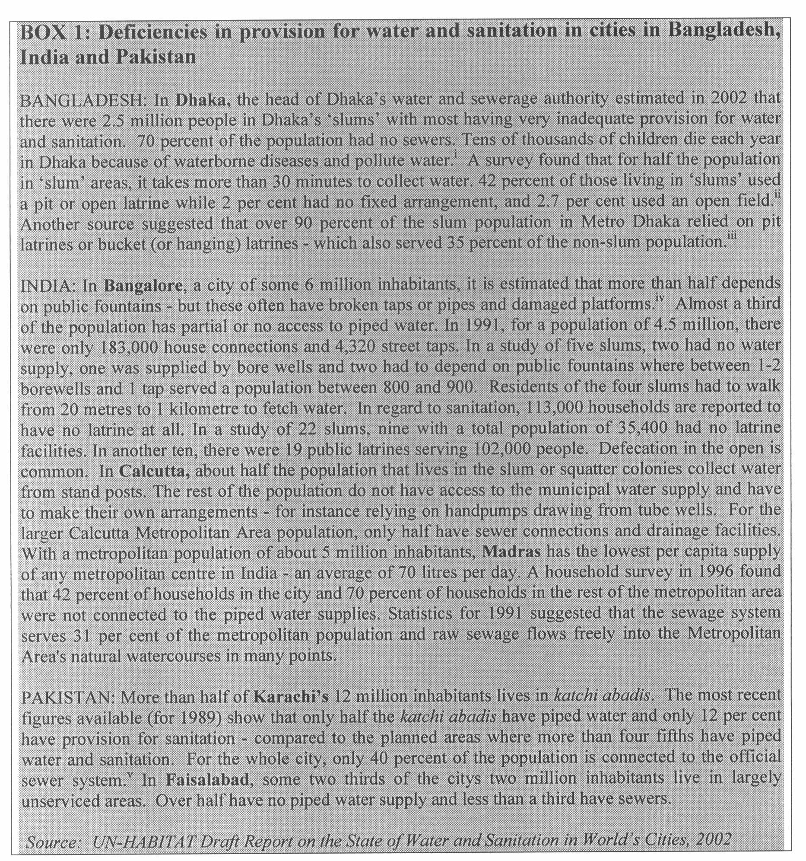

To meet the Millennium Declaration Goal of halving the proportion of people without access to improved services by 2015, an additional 1.5 billion people in Asia will need access to adequate sanitation facilities, while an additional 980 million will need access to safe water. In urban areas, the corresponding figures are 675 million and 619 million respectively. Emphasis on urban water and sanitation has also been placed in the Millennium Declaration by setting a target of improving the living condition of at least 100 million slum dwellers by 2020.

The aggregated regional statistics, however, mask many important facts, for example, the wide diversity of the region with some countries already enjoying near universal access to water and sanitation while, at the other extreme, some countries have been able to realize service coverage much lower than the regional average. The statistics also do not bring out the infra-urban differentials in service coverage, with more than half of the population of many cities, living in slums and squatter settlements, remain outside the reach of municipal services (see Box 1).

Coverage figures also give little indication of the quality of service provided by municipalities or utilities. In many Asian cities water supply is limited only to a few hours a day which not only restricts water availability but also poses serious health threats due to infiltration of pollution into the system. Intermittent, unreliable supplies and large volumes of unaccounted-for water are also an indication of poor demand management and inefficient operation and maintenance.

Millennium Declaration Goals and the Need for Effective Monitoring

Systematic and sustained tracking and review of progress towards the water and sanitation related Millennium Declaration Goals for Asian cities would be an important means of achieving the targets set in the Millennium Declaration. Monitoring of trends, achievements and shortfalls in the urban water and sanitation sector, bringing out interurban differentials and gender disaggregated data will help in developing policies and programmes at national and city-level targeted to improving the services for the urban poor. Such monitoring exercise will also help international cooperation to be targeted to pro-poor interventions in a more effective manner.

Demand Management as a Priority Action

Greater attention is also needed to manage the spiraling urban water demand on to a sustainable track. Experience from both within and outside the region shows that a modest investment in demand management and in measures to improve the efficiency of the existing delivery system could postpone large investments in supply expansion by several years. Sharing of this experience could benefit many countries in the region.

The need to move away from a narrow supply-fix approach is just as compelling in poor as in affluent settings. However, many of the insights, priorities and tools that have come to be associated with demand management are inappropriate to low income settings -they derive from a conservation perspective, and ignore the health, economic and a grassroots perspectives that tend to be critical in deprived urban areas.

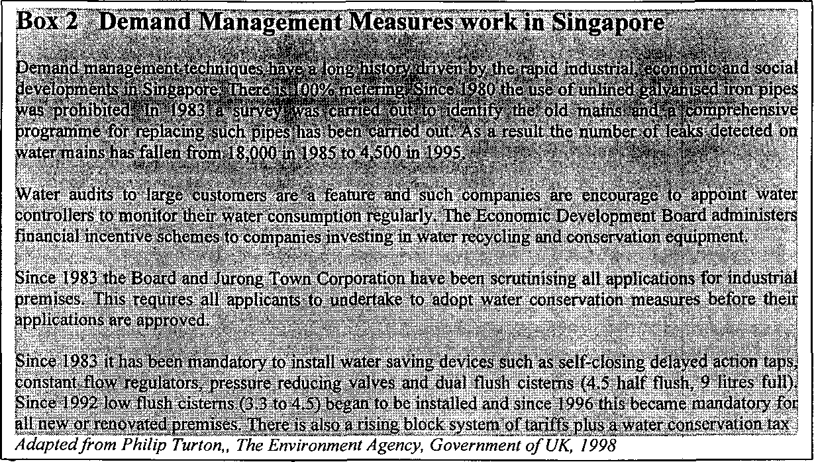

Thus, a comprehensive approach to demand management should focus on reducing unaccounted for water; discouraging wastage through pricing, technical and regulatory measures; and in low-income areas, promoting greater involvement of local residents' in driving water provision. This will call for a range of administrative and institutional measures and building capacity in water service provider and regulatory bodies.

Increased focus on Sanitation & Hygiene

It is now realized that sanitation and hygiene promotion need priority in its own right. The proven success in reducing water and waste-related disease through campaigns of school sanitation & hygiene have been clearly demonstrated in the Asian region. Hygiene planning and action need a focal point to be successful and educational institutions have proved to be a suitable focus. The programme needs to develop an effective methodology to promote sanitation more vigorously. Sanitation and hygiene campaigns have demonstrated their effectiveness as a tool to reduce ill health and childhood diahorrea and initiatives such as the "WASH" Campaign (see Box 3) have gained momentum and received a high-level of political support.

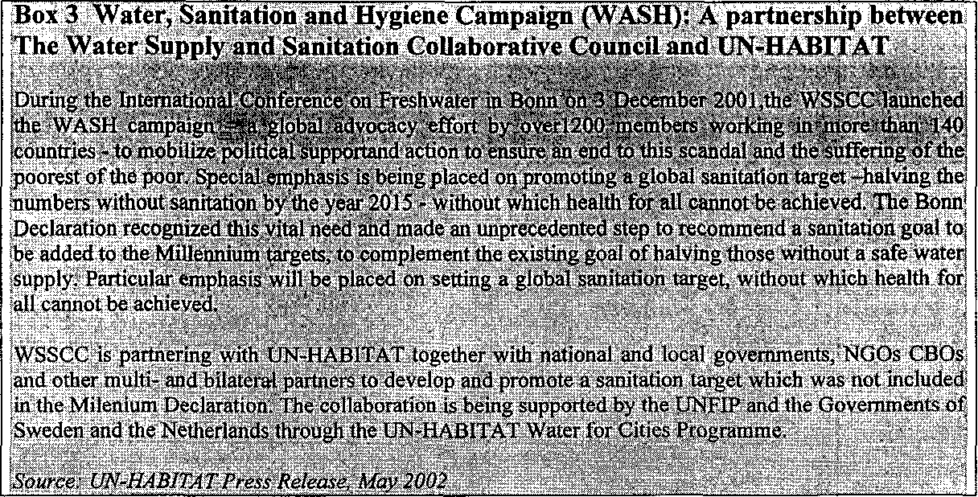

Attention needs also to be given to community-preferred technological options and service levels which can be maintained and managed by communities with a sense of ownership, essential for successful sanitation solutions.

Need for pro-poor governance

The urban poor, mostly living in peri-urban settlements should, unquestionably, receive the highest priority in the matter of future investments and institutional capacity building for the delivery and management of urban basic services. Key issues to be addressed in this context are: housing rights (including security of tenure), realistic pricing of services, reliability and level of service and choice of technology. All these issues affect the affordability and willingness to pay by communities which, in turn, impact on investment and sustainability.

Policy makers need to be aware that infrastructure investments, unless properly directed, does not necessarily lead to better services for the urban poor. The social and environmental health implications of new investments in infrastructure need to be evaluated in each case to assess their impact on the urban poor. A clearly articulated infrastructure investment policy for urban basic services could go a long way to safeguard the interest of the urban poor.

Few local governments, however, have a clearly defined urban development policy, not to speak of a policy for basic services in informal settlements. The "Illegal status" of many low-income settlements excludes them from the provision of services. Many local authorities do not have provision in the planning process for the peri-urban poor. The urban poor are thus forced to rely on private sector operators and a thriving informal water market (commonly known as small-scale water providers which include both private operators and NGO/CBO run entities) exists in most Asian cities. The urban poor rely almost exclusively on this sector for meeting its water needs, however, there is a major information gap on the operation of this sector (Asian Development Bank has recently started a study of this sector, result of which is yet to be available). There is an urgent necessity to regulate the services of the small-scale service providers to ensure that the urban poor can be assured of safe water at a price they can afford.

Community participation in the water and sanitation sector has, however, seen remarkable progress in several countries within the region in recent years. However, most innovative initiatives have come from communities and NGOs rather than from local authorities. The challenge in this area is to evaluate these experiences and disseminate them widely for possible replication in other cities. Also stable partnerships with local authorities are essential for the sustainability and up-scaling of these initiatives to city-wide level.

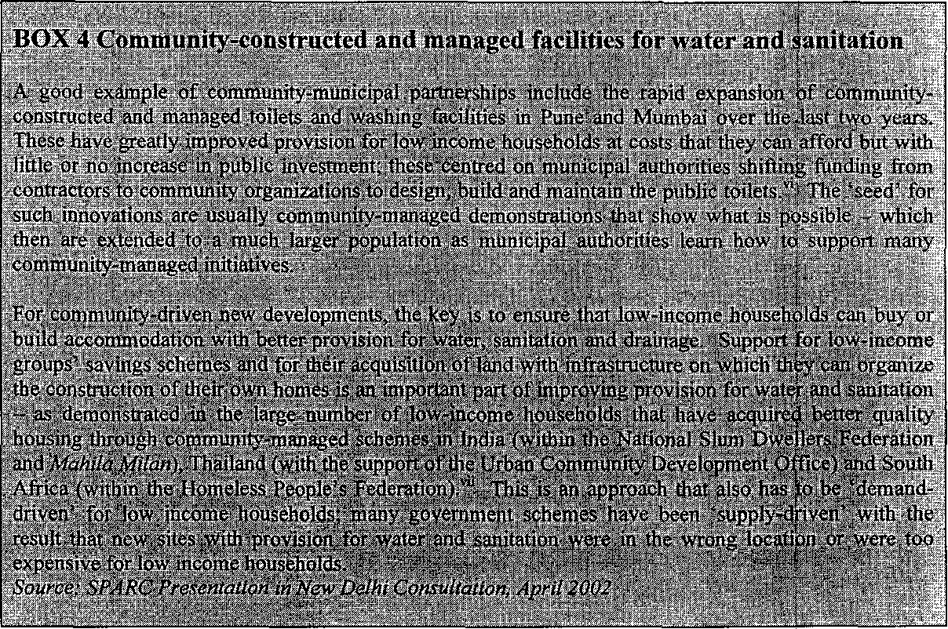

To improve governance in the water sector at the local level, the community and city residents in general, can play a key role in the monitoring of resource allocation and ensuring that local authorities and utilities are open and transparent in their operations and free with information. The concept of community-friendly local authorities and utilities who have a "Consumer service focus" is becoming a new challenge which can greatly improve service delivery efficiency. For example, encouraging communities to report leakage or illegal connections, develops trust and understanding between the service provider and consumer.

Examples of community-municipal partnerships include the rapid expansion of community-constructed and managed toilets and washing facilities in Pune, Mumbai and Bangalore in India over the past two years. These have greatly improved provision for low-income households at costs that they can afford but with little or no increase in public investment; these were mainly centred on municipal authorities shifting funding from contractors to community organizations to design, build and maintain the public toilets. The 'seed' for such innovations are usually community-managed demonstrations that show what is possible - which then are extended to a much larger population as municipal authorities learn how to support many community-managed initiatives.

Income generation for the urban poor linked to water and sanitation services

The urban poor in peri-urban settlements are often de-facto managers of the local environment. The major motivation for local environmental initiatives, however, comes from the income-generating possibilities that such activities offer to poor households. Communities in many Asian cities have demonstrated that given the necessary support, they can contribute significantly to the management of local water supply, Sanitation and solid waste disposal.

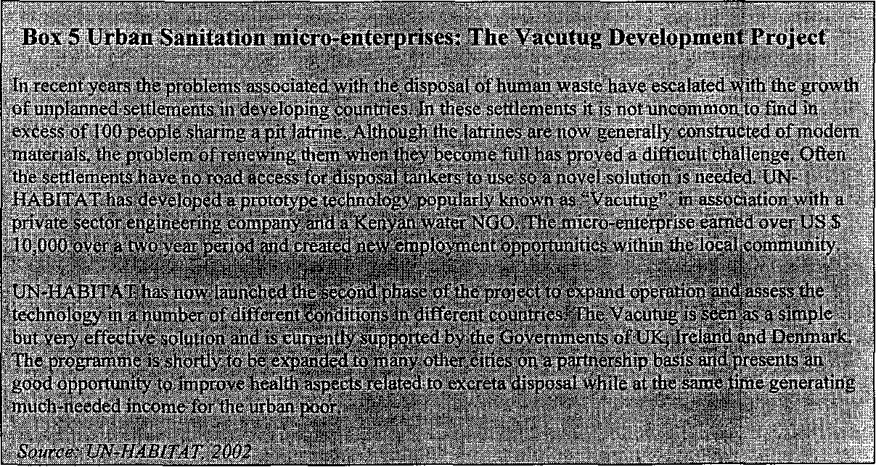

Such activities not only reduce the burden of local authorities but also helps to keep the local neighbourhood environment clean and provide significant opportunities for additional income and employment generation to the urban poor. Local authorities can play an important role here through institutional support in providing training, technology and markets to promote such local initiatives.

Thematic Focus and Cross-cutting elements of the Programme

The overriding thrust of the Water for Asian Cities Programme is to enhance capacity at city, country and regional levels and to create an enabling environment for new flows of investments in the urban water and sanitation sector with a view to meet the water and sanitation related Millennium Declaration Goals in Asian cities.

Thematic Focus of the Programme

The four key thematic thrust areas of the programme will be:

- Promoting urban water demand management: The programme will focus on all aspects of demand management: economic, social, technical, legal, administrative and institutional. Priority will be given to reduction of unaccounted for water; pricing and public-private partnerships; equity in distribution of services; regulation and reallocation of resources.
- Promoting integrated urban environmental sanitation: Priorities will include the development of appropriate technological options; promoting public, private, NGO partnerships for scaling up sanitation provision; innovative financing mechanisms for mobilization of local funds for sanitation services.
- Income generation for the urban poor through community-based water and sanitation services: The focus here will be to develop and implement strategies for the provision of water and sanitation services that will maximize the income and employment earning opportunities for the urban poor; special attention will be given to active community involvement and ownership in the provision and management of services
- Pro-poor urban water governance: Priority will be given to promoting institutional and policy frameworks that could focus on the needs of the poor; decentralized, simplified and transparent procedures accessible to the poor; rights-based (including tenurial rights) approach to the provision of water and sanitation; and specific attention and mechanisms to address the needs of the women.

Cross-cutting Themes

The four thematic thrust areas of the Programme should not be seen as mutually free standing priorities but closely interconnected through a number of cross-cutting themes, notably, urban sustainability, poverty reduction, environmental protection and integrated water resources management. The programme will address these cross-cutting priorities through targeted interventions in the water and sanitation sector.

For example, the broader goal of urban sustainability will be addressed by the programme through stakeholder participation in every aspect of programme implementation.

Improving urban water governance will be an important entry point for good urban governance - an essential element of urban sustainability.

Similarly, programme interventions addressing income generation for the urban poor, community empowerment through active participation in water and sanitation services, rights-based approach to water and sanitation and addressing the differentiated needs of men and women - all these will contribute to urban poverty reduction.

The programme interventions will enhance the productivity and quality of urban water resources — two key elements of integrated water resource management — through water demand management and improved environmental sanitation.

Key Elements of Programme Implementation

Within the thematic framework outlined above, the key elements of programme implementation will be as follows:

- Monitoring of progress towards achieving Millennium Goal targets in the water and sanitation sector in Asian cities. Systematic monitoring of progress in terms of achievements, trends and shortfalls in the provision of services for the urban poor and, wherever possible, gender disaggregated information will help keep the spotlight firmly on the MDGs. This will provide the basis for policy adjustments and new and directed investment in the sector.
- Mobilization of political will through advocacy and exchange of information. Mobilizing political commitment will call for engaging policy level functionaries in the programme in a continuous manner. Information exchange will be facilitated through Internet (interactive network and website), newsletters, study visits, staff exchange etc.
- Strengthening regional, country and city level capacities for integrated water and sanitation management. This will require human resource development in a focused manner, strengthening the capacity of existing institutions and establishing a regional network of experts and institutions. Gender mainstreaming will be an important cross-cutting theme of capacity-building at all levels.
- Creating a new ethic among children and community through Water, Sanitation and Hygiene Education. Interventions will include: introducing value-based, water education in schools; establishing water education classrooms in pilot cities; community education, training of trainers etc. Twinning of cities and schools will be part of this initiative.
- Promoting pro-poor investments in the water and sanitation sector. This will call for the establishment of a pro-poor governance framework at the city level through stakeholder consultations; this will facilitate the necessary policy and institutional reforms required for improving water and sanitation services for the urban poor.

B. Strategy for the Use of Resources

Within the emerging strategy framework for the implementation of the Millennium Declaration, the Water for Asian Cities Programme will draw upon the recommendations of the New Delhi Consultations (see accompanying report, pages 7-14) as also the lessons learnt over the past three years from a similar regional programme implemented by UN-HABITAT in Africa. Specifically, advantage will be taken of the relative strengths of the Asia Pacific region, in the fields of human resources and institutional capacity in particular.

Partnership and Collaboration

In programme implementation, emphasis will be placed on partnership and collaboration. Two kinds of partnerships have been identified for programme support:

- Primary partners such as local governments and non-governmental / community based organizations to be supported by the programme;
- Secondary partners supporting the programme, mainly the external support agencies and other programmes active in the region

For both types of partnerships, the terms of engagement will be defined in terms of roles, contributions, responsibilities and strengths that each partner will bring into the programme. In developing partnership arrangements, the following general principles will be considered:

- Development of partnerships will need catalytic support from all prospective partners;
- Focus on action and policy should go together in programme implementation;
- Cooperation should be based on comparative strengths and advantages;
- Use be made of existing institutions and networks for programme implementation.

The programme will commence with a partnership development phase. The focus in this phase will be on developing a framework for collaboration among city level actors as also with external support agencies and other ongoing programmes. The programme governance structure (comprising a donor coordination group and a multi-stakeholders' Forum) will also be established during this phase and in-country consultations will firm up implementation arrangements. Care will be taken that organizations representing the urban poor are included in the programme governance structure It is also intended to put in place a network of city-level stakeholders for monitoring improvements in water and sanitation services in cities within the region (see resolution of New Delhi Consultation in the accompanying report).

The partnership development phase, in reality, commenced with the regional consultation in New Delhi (April 2002) with the participation of 68 country participants from 16 countries in the region, 24 representatives from ten external support agencies (ESAs) and 13 representatives from NGOs, international capacity building institutions and the private sector. Country-specific needs and priorities as well as existing capacities in cities and institutions within the region were presented and discussed at the consultation. The proceedings of the regional consultation are available in the accompanying report of the New Delhi Meeting.

The Partnership Development Phase is expected to be completed within six months (September 2002 - March 2003).

Advocacy, Training and Capacity Building and Education

Improving governance in the water and sanitation sector cannot be accomplished in a vacuum. This calls for a willingness to change on the part of the policymaker, the sector managers as also the individual consumer. Such willingness to change comes from information (knowledge and skills, e.g. about good practices that are working elsewhere), awareness (e.g. the possible results of inaction on the part of the policymaker and at the same time awareness of the responsibility on the part of the consumer) and a change in attitude which education can bring about. The capacity to change through efficiency improvements (including distributive efficiency) is also equally important for which human resource development and institutional reforms and strengthening are essential.

The central emphasis of the Water for Asian Cities Programme will therefore be on Capacity building in the countries and cities in the region with a view to prepare the environment for pro-poor investments in the water and sanitation sector. The Capacity Building phase of the Programme will be implemented over a period of 33 months from January 2003 to September 2005.

Mobilizing political will, media and public awareness

The New Delhi Consultation noted that pro-poor investments in the water and sanitation sector will call for a rapid mobilization of political will and commitment to break away from a business-as-usual approach towards time bound achievements to meet the Millennium Declaration goals. The programme will address this through the establishment of an Asian Ministerial Forum for Water and Sanitation which would meet annually to review progress and speed up policy reforms. The Forum is expected to be hosted by one of the countries in the region and its deliberations will be facilitated by the Programme.

The programme will also interact actively with regional media networks to raise water and sanitation high on the media agenda. Public awareness campaigns will be launched selectively in a five Asian cities (one in each sub-region) in cooperation with its partner programmes. The programme will draw here from the experience of the Water for African Cities programme which has carried out successful campaigns in African cities and the campaigns have been evaluated through public attitude surveys.

Opportunities will also be taken to raise water and sanitation high on the political and media agenda through selected global events, notably through the forthcoming 3rd World Water Forum in Japan (March 2003), where UN-HABITAT has been invited to organize a Special Session on Water and Cities.

Enhancing Human Resources and Institutional Capacity

The training and capacity building activities of the Programme will be implemented in two parallel tracks. In the first track, the programme will seek to enhance the capacity of managers and decision-makers in water utilities, other service provider agencies and regulatory bodies in the five selected cities (one in each sub-region), in integrated urban water and sanitation management. In the second track, it will seek to anchor the enhanced capacity within the region and ensure sustainability of this effort by institutionalizing the training programme through capacity building in the form of a training-of-trainers programme and technical support to existing local training institutes and regional resource centres. An important part of this effort will be directed at establishing an active regional network of national capacity building institutions for urban water and sanitation.

The Programme will develop separate training activities in terms of content, training methodology, duration and implementation for three target groups of professionals:

- Apex-level managers and policy-makers (managing directors and administrative / political heads) in Utilities, regulatory bodies, ministries; training will be of the seminar/exposure/workshop type, focusing on sensitization of this target group, addressing policy, strategy and programme development issues.
- Senior managers (heads of technical and financial departments of utilities and other service provider agencies); training will be of the seminar/exposure/workshop type, and will address project planning, monitoring, co-ordination, evaluation and resource allocation issues.
- Middle level managers (those with operational responsibilities, heads of distribution districts, plant managers etc.); training will be of the workshop/exposure type, addressing project preparation, implementation and management issues in the areas of water demand management and water quality management.

The principal beneficiaries / stakeholders in the training component will be the staff of water service provider agencies (which may be from public/private/community sectors or a combination). In addition, national government officials (including policy makers in the national ministries and in national regulatory agencies) will also participate in the training programme. Other beneficiaries will include bodies or organizations who are responsible for developing and implementing reforms in the water and sanitation sector.

All training activities implemented under this Programme will include appropriate evaluation before and during the life of the programme and a summative evaluation that is both quantitative and qualitative.

Water, Sanitation and Hygiene Education

The New Delhi Consultation considered that water, sanitation and hygiene education in schools and communities would be an investment in the future and could promote a better understanding of water as a key social, economic and environmental resource and should facilitate the emergence of a new water management ethic in Asian cities. Education could complement advocacy and public awareness raising measures of the Programme and, together, could promote an enabling environment for pro-poor governance in the water and sanitation sector. Here again, the Programme could draw upon the experience of the Water for African Cities Programme which has been implementing a water education project in Africa.

A first step in launching of the water education activities would be the development of a broad consensus at political and professional level with regard to the most effective strategy for introduction of water education in Asian cities through an appropriate mix of formal education through schools (e.g. water class rooms, school water audits, water healthcare education etc.) and informal education through community channels. An expert group meeting will be convened for this purpose.

The water education initiative will give special emphasis to capacity building, particularly to training of teachers and facilitators and the development of learning materials. It will be important to coordinate the contributions of school/education authorities and those of water utilities and city managers in introducing water education.

The Programme will establish active partnership with other ongoing water/environmental education programmes in the region, to improve its outreach and cost-effectiveness and to avoid duplication and overlap.

Promoting Pro-poor Investments

New investments in water and sanitation do not always reach the poor. Asian cities abound in examples where supply expansion has led to improved quality of service for the affluent sections of society while the poor continues to remain outside the reach of municipal services. Pro-poor investments (i.e. investments targeted to improve the services for the poor) require, as a pre-requisite, a pro-poor governance framework comprising pro-poor policies and institutions that direct investments and monitor their impact on the poor. Critical to this is the participation of communities in the planning, provision and management of water and sanitation services on the one hand and improving the accountability of service provider agencies at the local level, on the other.

The ultimate objective of the Water for Asian Cities programme is to scale up the flow of pro-poor investments in the water and sanitation sector in Asian cities. This is essential for achieving the Millennium Declaration goals. While the Capacity Building Phase of the Programme will be directed to enhancing the willingness and commitment of the policy makers and creating the necessary institutional and human resource capacity to implement pro-poor policies and programmes, the investment promotion phase of the Programme be directed to creating the enabling environment for pro-poor investments. Both these phases (or tracks) will complement each other with a single objective.

The New Delhi Consultation recommended that five demonstration cities (one in each sub-region) be identified within the region in consultation with the programme partners for intensive pro-poor investment promotion in the water and sanitation sector. These cities will be selected using transparent criteria such as: (a) urgent need for improvement in service provision for the poor; (b) climate and capacity for delivery; and (c) demonstrated commitment to change on the part of local authorities.

The Programme will carry out a rapid appraisal of the sector needs for new investments in water and sanitation to achieve the Millennium Development Goals through country studies (in five countries, one in each of the five sub-regions) and will develop financing strategies for new investment. These country studies will be crucial to develop a credible road map to achieving the MDGs.

The Programme will then concentrate its efforts on establishing a pro-poor governance framework and an action plan in each of the selected cities. The process, which will involve multi-stakeholder consultations, will focus, as a priority, on the needs of the poorest of the poor, so that improvements in their access to water and sanitation services could be realized within 3 to 5 years. This will be a point of departure for this programme, as most development agencies currently work on investment programmes with a longer timeframe. This will call for close consultation and agreement with the Programme's key development partners in the initial stages of programme development.

Some of the key elements of the pro-poor governance framework and related action plans will be: (a) assessment of the effective demand of communities for services; (b) building concrete, project-oriented, partnerships between local governments (or service provider agencies) and community groups (and their coalitions); and (c) developing innovative financing mechanisms for 'unbundling' larger development finance, that could be accessed by the poor communities. Generic toolkits developed by the Programme through its capacity building effort (and also those developed by the Water for African Cities Programme) are expected to be useful in operationalizing the action plans into concrete investment proposals in Asian cities.
C. DEVELOPMENT OBJECTIVE, IMMEDIATE OBJECTIVES, OUTPUTS AND RELATED ACTIVITIES

C.1 Development Objective

The development objective of the Water for Asian Cities Programme is to support the implementation of the water and sanitation related Millennium Declaration Goals (MDGs) in Asian cities, specifically promoting pro-poor governance, water demand management, increased attention to environmental sanitation; and income generation for the poor linked to water supply and sanitation. The programme will seek to achieve this by mobilizing political will, raising awareness through advocacy, information and education; training and capacity building; by promoting new investments in the urban water and sanitation sector; and by systematic monitoring of progress towards MDGs.

C.2 Project Immediate Objectives, related Outputs and Activities

To realize the development objectives outlined above, the programme will focus on the following immediate objectives, related outputs and activities.

C.2.1 Partnership development phase (6 months, September 2002 -March 2003)

Immediate objective I: Establishing a Collaborative Framework for Water and Sanitation Partnerships in the Asia Pacific Region

Output I.1 An Online Interactive Network established for multi-stakeholders' dialogue for exchange of problem-solving experience and good practices in water and sanitation

Related Activities

Activity I.1.1 Develop TOR for interactive network
Activity I.1.2 Identify host organization for network
Activity I.1.4 Develop and sign host agreement
Activity I.1.5 Develop an online network and launch network
Activity I.1.6 Maintain and update network regularly for entire project period

Output I.2 Water for Asian Cities Programme Governance Structure established comprising:

- A Donor coordination Group, to provide policy oversight and direction for programme implementation
- A Multi-stakeholders' Forum, for programme planning, review and sharing of experience of implementation

Related Activities

Activity I.2.1 Carry out consultations with interested donors and stakeholders
Activity I.2.2 Establish donor coordination group and multi-stakeholder forum
Activity I.2.3 Establish a programme of work and facilitate regular meetings

Output I.3 A collaborative framework established for monitoring achievements, trends and shortfalls in achieving MDG targets in water and sanitation in cities the Asia Pacific region (through the development of indicators, benchmarks and a network of city-level stakeholders)

Related Activities

Activity I.3.1 Establish a collaborative framework of partners institutions and review available data and analysis on state of water and sanitation in Asian Cities
Activity I.3.1 Organize an expert-group meeting to develop monitoring strategies
Activity I.3.2 Develop key indicators and benchmarks to monitor MDGs
Activity I.3.3 Collect data from a representative sample of cities
Activity I.3.4 Analyze and present findings on an annual basis and contribute to MDG Monitoring process

Output I.4 Water for Asian Cities Programme officially launched in Johannesburg during WSSD with an exhibition and a media event

Related Activities

Activity I.4.1 Organize an exhibition and media event for wide dissemination of the launch of the Water for Asian Cities programme at WSSD
Activity I.4.2 Signing of MOU and launch of WAC programme at WSSD

C.2.2 Capacity-building Phase (33 months, January 2003 -September 2005)

Immediate Objective II: Mobilization of political will through advocacy and exchange of information.

Output II.1 An Asian Ministerial Forum for water and sanitation established Related Activities

Activity II.1.1 Establish MOU with interested country / city governments
Activity II.1.2 Establish Ministerial Conference of participating country governments
Activity II.1.3 Conduct annual meetings of Ministerial Conference
Activity II.1.4 Implement declarations of Ministerial Conference

Output II.2 A regional media network established for water and sanitation

Related Activities

Activity II.2.1 Develop a regional media strategy
Activity II.2.2 Operationalize a regional media strategy
Activity II.2.3 Maintain regional media activities
Activity II.2.4 Evaluate impact of regional media outreach on public awareness

Output II.3 Information and promotional material developed and a quarterly newsletter launched on water and sanitation

Related Activities

Activity II.3.1 Develop and publish newsletter on a quarterly basis
Activity II.3.2 Distribute newsletter widely
Activity II.3.3 Develop posters and distribute
Activity II.3.4 Develop flyers and brochures and distribute

Output II.4 Public awareness campaigns launched together with cooperating partners in five selected Asian cities

Related Activities

Activity II.4.1 Develop public awareness strategies
Activity II.4.2 Implement public awareness campaigns at local level
Activity II.4.3 Monitor impact of public awareness strategy

Output II.5 Water and Cities Conference organized in Osaka during WWF3

Related Activities

Activity II.5.1 Organise Water and Cities Conference
Activity II.5.2 Conduct conference at WWF3
Activity II.5.3 Monitor impact of conference

Immediate Objective III: Enhancing regional, country and city level capacities for integrated water and sanitation management

Output III.1 Training needs and institutional capability assessed in participating cities

Related Activities

Activity III.1.1 Develop questionnaire
Activity III.1.2 Distribute questionnaire and visit sites
Activity III.1.3 Analyze results and assess training needs
Activity III.1.4 Conduct stakeholders workshop for consensus building on training needs, methodology and target groups
Activity III.1.5 Finalise needs assessment and capacities and summarize in report

Output III.2 Regional and local training facilities and dissemination networks established / upgraded

Related Activities

Activity III.2.1 Develop TOR for regional and local training facilities
Activity III.2.2 Conduct bidding
Activity III.2.3 Identify most suitable regional and local training facilities
Activity III.2.4 Sign agreement with faculties
Activity III.2.5 Establish training network

Output III.3 Development of generic toolkits for integrated water and sanitation management

Related Activities

Activity III.3.1 Develop toolkits
Activity III.3.2 Test tool kits
Activity III.3.3 Modify and finalize toolkits

Output III.4 Pilot testing and demonstration of toolkits in selected cities

Related Activities

Activity III.4.1 Identify pilot cities
Activity III.4.2 Demonstrate the use of toolkits through carefully designed demonstration projects in selected cities
Activity III.4.3 Monitor, evaluate and disseminate information on the toolkits

Output III.5 Training needs assessed in WAC cities including identification of all stakeholders

Related Activities

Activity III.5.1 Assess needs to develop training package
Activity III.5.2 Stakeholder identification
Activity III.5.3 Identify institutional capabilities

Output III.6 Capacity of local and regional training institutions enhanced

Related Activities

Activity III.6.1 Identify institutional requirements
Activity III.6.2 Procure/implement institutional enhancement$
Activity III.6.3 Evaluate impact

Output III.7 Curriculum and training material developed

Related Activities

Activity III.7.1 Develop teacher guides for curriculum
Activity III.7.2 Test teacher guides
Activity III.7.3 Refine and finalize teacher guides
Activity III.7.4 Apply teacher guides

Output III.8 Training of trainers conducted

Related Activities

Activity III.8.1 Develop training programme
Activity III.8.2 Conduct training
Activity III.8.3 Monitor and evaluate impact

Output 111.9 A comprehensive training programme for water sector decision-makers, regulators and senior and middle level city managers conducted

Related Activities

Activity III.9.1 Develop training programme
Activity III.9.2 Conduct training
Activity III.9.3 Monitor and evaluate impact

Immediate Objective IV: Creating a new water-wise and sanitation -friendly ethic amongst children and communities through Water, Sanitation and Hygiene Education

Output IV.1 Expert group meeting held to develop strategy for water education in Asian Cities

Related Activities

Activity IV.1.1 Develop strategy for water education
Activity IV.1.2 Conduct expert group meeting and refine strategy
Activity IV.1.3 Finalise water education strategy

Output IV.2 Water classrooms established in participating cities

Related Activities

Activity IV.2.1 Develop guidelines and resource material for water classroom
Activity IV.2.2 Identify ideal host for classroom
Activity IV.2.3 Establish classroom
Activity IV.2.4 Maintain and run classroom
Activity IV.2.5 Monitor sustainability and impact

Output IV.3 Exchange programme and twinning arrangements implemented with selected schools in participating cities

Related Activities

Activity IV.3.1 Develop framework for twinning and exchange programme
Activity IV.3.2 Identify schools for twinning and countries for exchange programmes
Activity IV.3.3 Conduct twinning and exchange visits
Activity IV.3.4 Monitor impact

Output IV.4 School curricula developed on water education in participating countries

Related Activities

Activity IV.4.1 Develop school curricula
Activity IV.4.2 Test school curricula
Activity IV.4.3 Revise and finalize school curricula
Activity IV.4.4 Apply school curricula

Output IV.5 Training of trainers organized for the introduction of water education through primary and secondary education curriculum

Related Activities

Activity IV.5.1 Develop training manual
Activity IV.5.2 Conduct training
Activity IV.5.3 Monitor impact

C.2.3 Investment Promotion Phase 30 months (April 2003- September 2005)

Immediate Objective V: To promote urban poor targeted new investments in the water and sanitation sector in the Asia Pacific region
Output V.1 Five to seven cities, at least one in each sub-region (South Asia, South East Asia, Mekong, East and Central Asia), identified in consultation with programme partners for intensive investment promotion in water and sanitation sector

Related Activities

Activity V.1.1 Develop country/city selection criteria catalogue
Activity V.1.2 Develop questionnaire
Activity V.1.3 Distribute questionnaire and conduct city visits
Activity V.1.4 Identify cities based on criteria catalogue

Output V.2 Water and Sanitation Sector assessments conducted and investment needs estimated to achieve MDGs.

Related Activities

Activity V.2.1 Undertake field mission to selected countries/cities
Activity V.2.2 Conduct water and sanitation sector assessments
Activity V.2.3 Assess investment needs and financing strategies

Output V.3 A pro-poor governance framework and a related action plan established through multi-stakeholder consultations and necessary policy and institutional adjustments facilitated

Related Activities

Activity V.4.1 Conduct multi-stakeholder consultations to assist governments in formulation of urban WATSAN policy through a policy dialogue on needed pro-poor reforms in areas of policy, legislation, institutional arrangements and information management
Activity V.4.2 Develop pro-poor governance framework and a related action agenda
Activity V.4.3 Establish oversight mechanism to facilitate policy and institutional reforms
Activity V.4.4 Monitor implementation of new governance structure and related action plan

Output V.4 Investment proposals developed for each city for improving water and sanitation services for the urban poor

Related Activities

Activity V.4.1 Develop pro-poor investment proposals in water and sanitation
Activity V.4.2 Develop an implementation Strategy, promoting partnership and participation, based on shared responsibility

Output V.5 Donor coordination ensured for funding and implementation of the pro-poor investment proposals, with a view to maximize the impact of external resources

Related Activities

Activity V.5.1 Organise donors' roundtable
Activity V.5.2 Submit funding requirements to donors
Activity V.5.3 Secure coordinated funding from donors
Activity V.5.4 Establish monitoring and oversight mechanism for implementation

D. Inputs

Details of inputs (along with a time plan) are provided in Annex 2. This includes Estimated inputs from the Government of the Netherlands, and in-kind inputs from UN-HABITAT as the executing agency, and from the participating governments in the Asian Region.

E. Risks and Prior Obligations

The main risk associated with the Water for Asian Cities Programme is timely commitment on the part of national and local governments as well as their active involvement in the programme. To address this issue the programme has a Special partnership development phase during which greater degree of effort is being made to get political commitments of the national governments as well as those of local governments by organizing forums of Asian Ministers as well as Mayors. Similarly multi-stake-holders forums are being set-up at local national and regional levels to ensure commitments of highest order by all the stake-holders in the programme.

F. Management and Implementation Arrangements

UN-HABITAT will be the Executing Agency for the Water for Asian Cities Programme. A Programme Coordinator will be responsible for coordination of all tasks to be undertaken by the Programme. He / she will report directly to the Chief, Infrastructure Section of the Shelter Branch of UN-HABITAT. It is envisaged that the Programme Coordinator will be located within the region in a central location with a view to economize on travel requirements. This aspect will be taken up with priority during the Partnership Development Phase at the onset of programme implementation.

Establishment of a Programme Governance Structure (see output 1.2 above) will be undertaken with priority during the Partnership Development Phase. This will comprise:
- A donor coordination Group, which will provide policy oversight and direction for programme implementation;
- A Multi-stakeholders' Forum for programme planning, review and sharing of experience of implementation.

Ten external support agencies (ESAs) attended the New Delhi Consultation and expressed their interest to be actively associated in the Programme. Consultations will continue with these and other ESAs during the Programme Development, Phase with a view to firm up their possible involvement in the programme. A donor coordination group will be established based on the outcome of these consultations.

The Asian Development Bank (ADB) has shown interest to be an active partner of UN-HABITAT in the Programme. The long investment experience of ADB in the region, its new focus on poverty alleviation and in promoting improved urban water governance in Asian cities would complement the proven strengths of UN-HABITAT in areas of community participation, advocacy, education and capacity-building in the implementation of the Water for Asian Cities Programme. The modalities of cooperation between ADB and UN-HABITAT will be finalized through mutual consultation between the two partners.

Specific attention will be given to establish a synergic partnership with the Water and Sanitation Programme currently operational in the region. The collaboration with WSP will focus, in the first phase, on exchange of information and experience and coordination of activities of the two programmes to mutual benefit.

The Multi-stakeholders' Forum will be the operational coordination body for programme implementation. This will include representatives of city authorities participating in the programme, NGO partners and capacity building institutions associated with programme implementation. The New Delhi Consultation recommended that organizations representing the urban poor should also be included in such a forum.

A key resolution adopted at the New Delhi Consultation requested UN-HABITAT to establish an online, interactive network for multi-stakeholders' dialogue for the exchange of problem-solving experience and good practices on water and sanitation. This will be implemented at the beginning of programme implementation (see output 1.1 of Partnership Development Phase). A suitable institution for hosting the network will be identified within the region.

Concerning training activities of the Programme^ existing training centres within the region will be surveyed to determine suitable locations for local training and to map possible deficiencies in capacity that need to be addressed before the start of the training of professionals. Following the survey, the WAC programme staff will select the local and regional partners. It would seem an advantage to use experienced education / training institutes with a regional training mandate, as these would only require orientation on the specific subject area, and can play a role in the capacity building of local training centres.

G. Monitoring & Evaluation

- All activities being implemented under this programme will include appropriate evaluation before and during the life of the programme and a summative evaluation that is both quantitative and qualitative.
- The development of methodologies and indicators for both on-going and final evaluation of the programmes is an essential part of this strategy. Baseline indicators will be developed and collected at the beginning of the programme.
- The programmes will be measured by a variety of long-term success indicators, including:
  - Partnership arrangement developed.
  - Impact of capacity building. Investments facilitated.
  - An important aspect of the project concerns gender aspects. Specific indicators will be developed for the purpose in close collaboration with the Gender Alliance.

H. Legal Context

The Water for Asian Cities Programme will be implemented in collaboration with all the partners. Memoranda of Understanding is being signed with the Asian Development Bank as well as with the participating countries in the programme with in the framework the water for Asian Cities Programme.

I. Work Plan

Details of the proposed work plan are given in Annex 2.

J. OVERALL BUDGET

Details of cost-sharing and activities budget are given in Annex II: Contribution of the Government of the Netherlands is in Annex III.

*********************

For details of funding support by agencies, see table appended to the Inception Report submitted by UNCHS to UNFIP in June 1999. Allocation of funds by cities and activities, and corresponding counterpart support by the seven participating countries are also available in this report. Governments of Sweden and the Netherlands have joined their support to the programme in 2001, as indicated in this report.
Abidjan (Cote d'lvoire), Accra (Ghana), Addis Ababa (Ethiopia), Dakar (Senegal), Johannesburg (South Africa), Lusaka (Zambia) and Nairobi (Kenya)
The UN and the MDGs: A Core Strategy, draft dated 8 May 2002. The Strategy focuses on action at global and country levels - supported by activities at the regional level. The four core elements of this strategy are: Monitoring, analysis, campaigning / mobilization and operational activities. The implementation strategy of the Water for Asian Cities Programme incorporates all the four core elements.
Bangladesh, P.R.China, Cambodia, Papua New Guinea, India, Indonesia, Iran , Korea, Malaysia, Nepal, Philippines, Sri Lanka, Thailand, Uzbekistan and Vietnam.
ADB, AUSAID, CIDA, DFID, European Commission, GWP, JBIC, UNICEF, USAID, WSSCC and The World Bank (WSP)
Estimates of annual investments at country level required for achieving water and sanitation related MDGs are still not available. WAC programme will support government initiatives to develop such estimates.
Millennium Declaration Goal 7, Target 10: Halve by 2015 the proportion of people without sustainable access to safe drinking water; and Target 11: By 2020 to have achieved a significant improvement in the lives of at least 100 million.
See The UN and the MDGs: A Core Strategy (draft dated 8 May 2002)
This component will build on the experience gained from the Dutch-funded training and capacity-building component of the Water for African Cities Programme
This component will build on the experience gained from the water education component of the Water for African Cities Programme

