

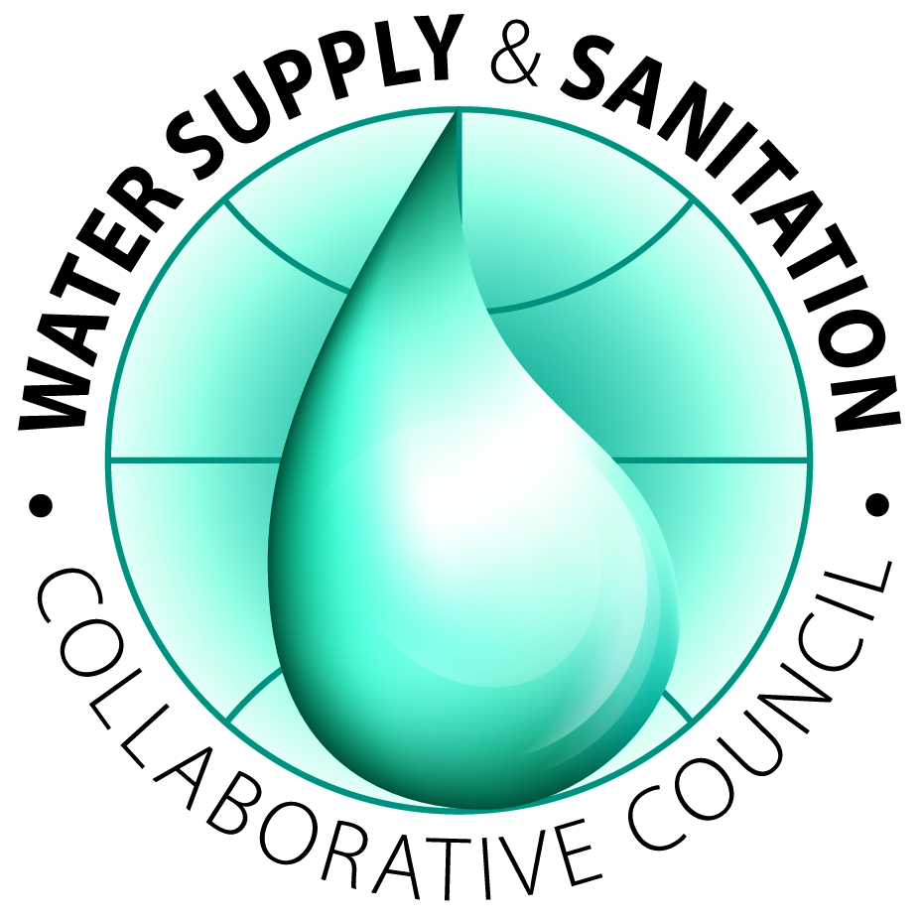

Asia Regional Sanitation and Hygiene Practitioners Workshop

31 Jan – 2 Feb 2012, Dhaka, Bangladesh

Announcement and Call for Abstracts
(250 words maximum)
(Extended) deadline: 29 August 2011
How to achieve universal use of toilets and basic hygiene? What have we learned about moving beyond construction to a focus on sustainable facilities and hygiene behaviours? We talk a lot about equity, but how to reach vulnerable groups in practice? Do we achieve what we aim to achieve? Are our sanitation and hygiene programmes effective and how we do know that?
These are the issues of the third bi-annual practitioners’ workshop in Asia, organized by BRAC, WaterAid, WSSCC and IRC.
The aim of this workshop is to contribute to the evidence base on sanitation and hygiene interventions with sustainable results through documentation and analysis of selected cases. It is set up to support practitioners in practical approaches, steps and lessons for improving their work and to provide an informal setting where participants actively engage and feel confident to question each other and their own assumptions.
To support practitioners before the workshop through a review process to write up their field stories or research and to allow for active learning and participation during the workshop, the maximum number of participants will be 50 participants, including the organisers.

Themes
- Sustainable sanitation services and sustained behaviour change
Capital investment alone will not ensure sustainability.To ensure that the benefits of sanitation and hygiene are enjoyed by all and forever, we need to look beyond the initial construction phase. Facilities need to be managed and maintained over time so that they constantly provide at least a basic level of service. In other words, we need to look beyond the necessary hardware (the pipes, taps and toilets) to the software (hygiene behaviour change, management, maintenance, finance, monitoring). Interventions for sanitation and water supply are effective only if hygienic conditions and practices are achieved and maintained. Understanding how to effectively promote and support safe hygiene behaviours is important and more evidence is needed on which approaches are effective.
Papers could include issues around end of the chain solutions (pit emptying/treatment/ disposal or productive use) or describe factors of success for sustained behaviour change.
- Equity – reaching the poor and vulnerable
A hugely challenging area across South Asia is reaching marginalised groups and individuals. In a regional synthesis paper for SACOSAN IV, Ravi Narayan et al write: “The key question is: is it possible at scale? – to enable all people across the region to practice safe sanitation and hygiene? Mere commitment to action will not work, unless policies, investments and actions are based on the principle of equity, which is essentially the principle of fairness.”
Papers could focus on how to address the institutional, socio-economic, environmental or technological barriers in their own context and describe factors for success.
- Effective monitoring for change and improved planning
Monitoring sanitation and hygiene behaviour is a complex topic, and often only the number of toilets is counted. In a five country study on sustainable sanitation and hygiene for all, SNV and IRC recognise that monitoring of sanitation and hygiene programmes may be one of the weakest areas of our sector. It is a key constraint for improved WASH governance, as the lack of reliable (performance) information limits evidence based decision making especially at local level. Improved performance monitoring is also essential for learning processes at local level.
Papers could focus on how to use or build upon existing monitoring practices in a country; how to allow for comparison and learning across districts within one country and even among countries.
Objectives
- Document field experiences and review progress
- Share with and learn from each other
- Identify lessons, gaps or unanswered questions
- Provide an opportunity to strengthen/ develop a network of sanitation and hygiene practitioners
- Identify and agree on practical follow up actions that will be taken up by workshop participants

Outputs
- Lessons and documented cases that can be disseminated to a wider audience to contribute to learning in the sector, including:
  - Publishing a summary note and key lessons learned
  - Presenting the outcomes in Stockholm Water Week
  - Publishing all presentations, papers and outcomes on the IRC and WSSCC web site
- Practical follow-up action plans

Call for abstracts
You are kindly invited to submit your initial ideas on one of the themes described above that you would like to present during the workshop. Selected authors for a full paper will be guided through a process of writing and independent review.
We seek three types of papers:
- Research papers. These are papers that synthesise research and provide a critical analysis of aspects of sanitation and/or hygiene related to one of the above three themes. The maximum length of these papers is 5000 words.
- Practice papers. These are shorter papers that present practical experiences with the implementation of programmes focusing on one of the above three themes. These are expected to provide a critical look at innovative implementation practices. The maximum length of these papers is 2000 words.
- Photo essays. These are collections of photographs which tell a story. Photo essays should have a maximum of 16 photographs with good captions.
Interested authors can submit abstracts (250 words maximum). The abstract should be in Word format and include the following:
- Type of paper—research or practice
- Proposed title
- Name of author(s), including contact information for lead author
- Abstract of 250 words maximum
Abstracts and full papers will be reviewed by an editorial committee. The format for papers will be provided to authors of selected abstracts.
Further information and submission of abstracts: dhaka2012@irc.nl
Time frame
29 Aug 2011: Extended deadline for submission of abstracts
05 Sep 2011: Authors notified if abstract accepted for development into a paper
30 Sep 2011: Deadline for submission of 1st version full papers / photo essays
31 Oct 2011: Deadline for revised full papers / photo essays
31 Jan – 2 Feb 2012: Asia Regional Sanitation and Hygiene Practitioners Workshop

Equity and inclusion in sanitation and hygiene in South Asia : a regional synthesis paper by WaterAid, WSSCC and Unicef, 2011, http://www.wsscc.org/sites/default/files/publications/wssccunicefwateraid_equity_inclusion_in_sanitation_hygiene_southasia_sacosan_2011.pdf
AusAID funded programme in five countries: Laos, Cambodia, Vietnam, Bhutan and Nepal. Information on the performance monitoring component can be found at http://www.irc.nl/page/63764

