School Sanitation and Hygiene Education
Results from the assessment of a
6-country pilot project

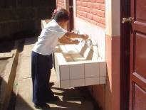

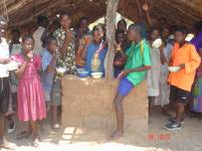
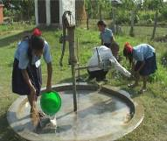

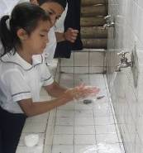
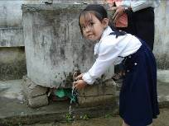
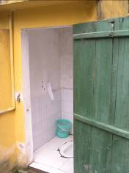

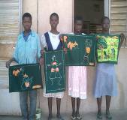

MAY 2006


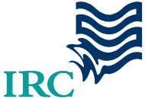

Table of contents
Table of contents 2
List of abbreviations 2
List of abbreviations 2
Acknowledgements 3
Executive summary 4
Conclusions 5
Recommendations 7
Introduction 9
About the pilot project 9
Main implementing partners 10
Design of the pilot interventions 10
Assessment of the pilots 10
The assessment methodology 11
The outcomes 14
Water 14
Handwashing 15
Children 18
Life skills education 20
Gender 21
Effects of SSHE in the home and community 22
Institutional setting and coordination 22
Contacts with the school 23
Scaling up issues: costs and capacity building 24
Annexes 28
Annex I List of UNICEF contact addresses with link to the country reports 29
Annex II Assessment Summary sheets 30
Annex III Conclusions and recommendations from the Nicaraguan study 40
Annex IV List of SSHE education materials produced by the different countries 44

List of abbreviations

IRC IRC International Water and Sanitation Centre
MDGs Millenium Development Goals
NGO Non-Governmental Organisation
SSHE School Sanitation and Hygiene Education
UNICEF United Nations Children’s Fund
WASHE Water, Sanitation, Hygiene Education

Photographs cover:Top left to right: UNICEF Zambia, UNICEF Nicaragua, UNICEF Nepal;
Second row from left to right: UNICEF Colombia, UNICEF Viet Nam, Christine Sijbesma, IRC;
Bottom left: UNICEF Burkina Faso

Acknowledgements
This report provides an assessment of a pilot programme for school water, sanitation and hygiene education, which was implemented in six countries. The UNICEF country offices carried out these programmes and organized the subsequent assessments, also providing considerable professional and financial support throughout. We would like to thank, in particular, the staff from the UNICEF offices: Mr. Soungalo Togola (Burkina Faso), Mr. Francisco Burbano (Colombia), Mr. Namaste Lal Shrestha (Nepal), Ms. Nienke Swagemakers (Nicaragua), Ms. Tran Thi Thu An (Viet Nam) and Mr. Giveson Zulu (Zambia) for their dedicated work and high professional competence over the past four years in this programme (their contact details can be found in annex I). In addition, our most sincere thanks also go to their team members representing various ministries and NGOs.

Mr. Chander Badloe, Chief of UNICEF’s WES-section in Vietnam and his colleague, Ms. Le Anh Lan, senior project assistant in this same section, deserve special mention. Their hospitality and excellent organizational arrangements, coupled with their interesting substantive inputs during the final workshop, have been highly appreciated by everyone involved.

UNICEF New York, through Ms. Lizette Burgers and Mr. Henk van Norden, originally developed the concept and provided subsequent continuing professional and financial support for the pilot programmes and their assessment. In the final workshop, the presence and inputs of the Regional Officers, Mr. Bill Fellows (South Asia) and Mr. Mark Henderson (South East Asia) as well as of the representative of Plan-Vietnam, Mr. John Collet, was appreciated.

All have contributed to this extensive group effort, which has resulted in evidence-based recommendations on the way forward for scaling up school water, sanitation and hygiene education programmes around the world.

Eveline Bolt
Kathleen Shordt
Ingeborg Krukkert
IRC International Water and Sanitation Centre, Delft, the Netherlands
May 2006
Executive summary
Children in school should be able to practice and develop consistent health-promoting behaviours related to water and sanitation. For this, facilities for drinking, handwashing, defecation/urination and often for cooking meals must be present and well-maintained. School water, sanitation and hygiene education programmes work to ensure that hygienic behaviours are linked to clean and operational facilities. These school programmes can be an excellent entry point for improving hygiene behaviours in the home and community, as well as for educational renovation in the school. It was with this in mind that UNICEF decided to implement a pilot to develop and test School Sanitation and Hygiene Education methodologies. This pilot took place in six countries over three continents from 2000 through 2003/4 and was implemented by national UNICEF offices in collaboration with government departments and NGOs. IRC provided technical support. A project assessment of 8 to 64 pilot schools in each country took place in 2005, roughly one to two years after the pilot interventions had ended.

By mid-2005, research teams from the six countries jointly developed an assessment framework and their own country-relevant methodologies and assessment tools. This was followed later in 2005 by field work to collect and analyse data, as well as by sharing the results of the assessment early in 2006. The country assessment reports were the major input in the final workshop held in March 2006, where findings were pulled together and lessons were shared about what we learned and what trends appeared among the country studies

A range of assessment methodologies was used, many of which are described in the often excellent assessment reports drawn up by the country teams. It was found, for example, that triangulation was very useful in cross-checking the validity of the data and that qualitative information obtained using participatory methods could be put to good use particularly when quantified. . The individual reports have been disseminated and discussed at the national level; while this report provides an overview of the results of all the country studies.

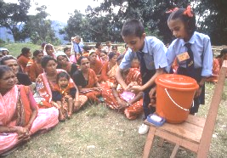
Photo: UNICEF Nepal

Conclusions
The major conclusions from the assessment are briefly noted here.

General
- In all cases where before-and-after comparisons were made, the post-assessment data showed superior performance to the baseline standards. Where the project schools were compared to control schools, the project schools performed better for virtually all indicators. For example, 80% or more of the project schools had toilets and urinals that are well used by children and are kept clean. This was far better than the control schools, providing evidence of the effectiveness of a good SSHE programme, and implying that benefits continue beyond the end of the project period.

The programme at the school level
- Each of the pilot programmes combined hardware (construction) and software (such as training, supervision, life skills education, children’s clubs, outreach activities) inputs. Where this combination is missing or where the intervention is only oriented to construction of facilities, failures occur in terms of overall healthiness of schools and development of children’s hygiene behaviours.

- In 4 out of 5 countries, over 80% of the project schools have child (health) clubs. The country teams attached considerable importance to these clubs.

- Emphasis was put on careful (life skills) training of teachers, supervision and community involvement. While it was not possible to separate the impact of these activities from other aspects of the interventions, these elements were generally considered to be important for achieving behavioural change among children.

- The extent to which children can be involved in cleaning latrines depends largely on local circumstances depending, for example, on the way anal cleansing materials are disposed of.

Enabling students’ behaviour
- Handwashing with soap proved to be far less prevalent than we had expected. This is a very significant challenge for the schools and, we may assume, for scaling up SSHE in general. Although in 2 out of the 5 countries programme schools did better than control schools, less than one-third of the children in the study used soap to wash hands before eating, either because it was absent in the school or because it was not easily accessible in the school.
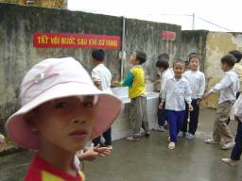
Photo: UNICEF Viet Nam: Children practising handwashing after using toilet in Nguyen Uy primary school in Ha Nam province.
- In this study, the responses were mixed about the availability of anal cleansing materials and their safe disposal, with only 2 of the 5 country studies reporting adequate practice based on our criterion of 80% adherence.

- In all countries the available toilets and urinals were used by students and kept clean.

Technical challenges
- In 4 out of 5 countries our indicator for the existence of toilets was met. In 3 out of 5 countries separate urinals were constructed.

- Several country teams noted that difficulties are experienced at the school level in ensuring adherence to technical specifications for design or construction quality.

- In each country, 80% or more of the project schools had water facilities in working order. However, continued availability of good quality water is a concern in 3 out of the 5 countries.

- The study did not investigate the bacterial and chemical quality of drinking water and stored water. The quality of water deserves further study.

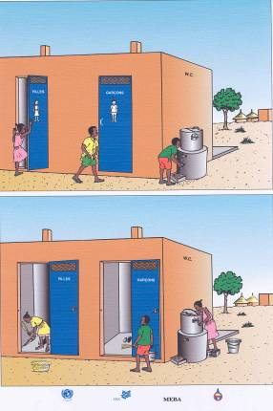
Fig: UNICEF Burkina Faso

Institutional challenges
- Having effective collaboration among the key institutions was seen as a key challenge to scaling up SSHE with quality. In some countries parallel programmes supported by different government departments or donors, operate even in the same schools

- Toilets and urinals were built following the national norms, which vary considerably from 1 toilet/urinal for 25 children up to 1 for more than 100 children. In countries with very large norms, the access of children to the facilities can be difficult.

- Systems for operation and maintenance of facilities have been put in place. In some cases the government or UNICEF appeared to cover operation and maintenance costs, while in other cases this comes entirely from local contributions. ‘In-between’ options also prevail. External donations for operation and maintenance of facilities are probably not sustainable, raising the question of what will happen when these inputs are stopped.

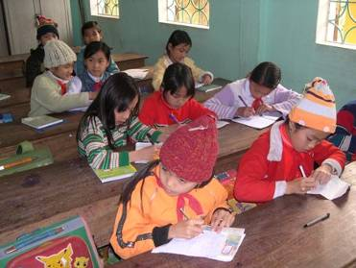
Photo: school children Viet Nam, Christine Sijbesma, IRC

Recommendations

The programme at the school level
- School Sanitation and Hygiene education programmes should combine hardware and software to arrive at sustainable changes.

- Children’s clubs are probably effective in bringing about positive change. However, for singling out the effect of these clubs further research is required.

Enabling children’s behaviour
- Handwashing with soap before eating and after using sanitation facilities deserves priority focus in SSHE programmes. Further practical research, in particular on ensuring students’ access to soap is needed urgently.

- Anal cleansing materials should be readily available in or very near the toilet. In the case of paper, a safe disposal mechanism must be ensured and further investigation into how this could be done is urgently needed.

Technical challenges
- The issue of norms (the average number of children for each facility) deserves to be revisited in countries with very high norms. Norms should be set for facilities so that it easy for children to practice safe hygiene, while at the same time being feasible to implement.

- With respect to hardware, two issues deserve greater attention: the continued availability of water in or nearby the school and adherence to specifications in construction.

- Investigation is needed into bacteriological/chemical quality of (stored) drinking water.

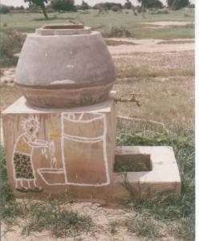
Photo: UNICEF Burkina Faso

Institutional challenges
- Further insight into bringing about effective collaboration among key institutions is required.

- There is a need to determine and adhere to the best and most sustainable option for operation and maintenance of school facilities.

Introduction
Water, Sanitation and Hygiene Education at schools (SSHE) has a high potential to contribute to the achievement of the MDGs. SSHE programmes were launched more than 2 decades ago in many of the countries represented in this study. These were, however, usually small scale efforts that lacked hygiene education inputs. The particular relevance of the SSHE-programme is its additional emphasis on hygiene education and behavioral change. SSHE also exploits the potential of the school to reach into the home and community, motivating families and community members for improved hygiene and sanitation.

UNICEF felt that it would be useful to find out more about effective approaches towards SSHE and it submitted a proposal for a 6-country pilot research project to the Dutch Government. Subsidy was granted and the pilot study, implemented by UNICEF with the support from IRC International Water and Sanitation Centre, took off in 2000 in 6 countries. It lasted till late 2003.

Over the years several progress reports were produced to inform project partners and the donor about the study project. In 0ctober 2004 the final project report was submitted by UNICEF. This final report elaborates the implementation and the results of the study as could be derived from the country reports. It also mentions that an assessment was going to take place. The report you are reading now reflects the outcomes of this assessment.

This report begins with an executive summary and a summary of the lessons learned and some conclusions. After that an overview of the context of the study, followed by descriptions of the assessment methodology and outcomes. In the annexes you will find summary sheets about each of the assessments, a list of contact addresses with links to the full assessment report as well as an elaborate list of materials produced by the various countries.

About the pilot project
The overall objective of the School Sanitation and Hygiene Education (SSHE) pilot project was “to ensure that the present and future health and education of school-aged children improve through better hygiene behaviour and a healthy school environment”. The project was implemented in six countries: Burkina Faso, Colombia, Nepal, Nicaragua, Viet Nam, Zambia, with the following specific objectives:
- To test a methodology for improved SSHE, in at least six countries in three continents.
- To develop and improve country-specific, child-centered teaching programmes utilising the life skills approach.
- To develop capacities to use guidelines for school sanitation and hygiene education.
- To support and sustain initiatives by different stakeholders at community level.
- To document and disseminate experiences of the pilot projects.
- To increase global, regional and national awareness of, and commitment to SSHE.

Main implementing partners
At the global level, the project was supported by UNICEF and IRC. As befits SSHE, a strongly inter-disciplinary programme, there were many implementing agencies working in collaboration with national UNICEF offices in this pilot study:
- Burkina Faso: The Ministry of Basic Education and Literacy and CREPA (Centre Regional d’Eau Potable et d’Assainissement), a sub-regional NGO.
- Colombia: CINARA Institute, at the University of Valle, for Research and Development in WES and Water Resources Education, the Ministry of Education and Local Governments.
- Nepal: The Environmental Sanitation Section of the Department of Water Supply and Sanitation, Nepal Red Cross Society, the Ministries of Education and Health through the Sanitation Steering Committees at the national and the district level.
- Nicaragua: The Ministries of Health, Education, Culture and Sports, and the State-owned Nicaraguan Water and Sewage Company.
- Viet Nam: The Ministry of Education and Training, and the Centre for Rural Water Supply and Sanitation (CERWASS) of the Ministry of Agriculture and Rural Development.
- Zambia: The Ministries of Education, Energy and Water, Local Government and Housing, Health, Community Development, Agriculture, District Water Sanitation and Hygiene Education (D-WASHEs), Village WASHEs and NGOs (including the very local ones).
A list of the present contact addresses is provided as annex I.

Design of the pilot interventions
While there was considerable variation among the original interventions, all had most of these elements:
- mobilisation of groups in and around the school in rural settings;
- collecting baseline data of various types;
- contribution of local government or parents;
- construction or renovation of facilities for drinking water, sanitation and handwashing;
- participation of children, often including activating school clubs or their equivalent;
- life skills education and materials development;
- training and orientation of teachers and in some cases, children, parents, school management councils, head teachers, educational authorities in departments/districts, NGOs.

Assessment of the pilots
In June 2005 preparations for the participatory assessment started. A workshop was organized in the Netherlands, in which 5 out of the 6 project countries participated. UNICEF Nicaragua was already in the process of a mid term assessment of the project and decided not to participate in the workshop. During this workshop the assessment methodology and assessment plan were developed and a start was made with the development of the necessary assessment tools. The workshop proceedings and outcomes are reflected in a report.

The assessment sought to answer the following questions:
- What are the main results of each of the pilot projects?
- What were the major lessons learned (both positive and negative) that may have relevance for SSHE in general?
- What particular experiences, strategies, plans, resources or materials are of sufficient quality that, if appropriately adapted, may be useful in other SSHE and education/WES contexts?
Since the assessment took place two years after implementation of the pilot project, we could also look at the sustainability of the project results.
Upon return to their offices the project staff finalized the assessment tools, trained data collectors, did the field work, and reported on the outcomes.

In March 2006 a final workshop was held, which brought all country teams together, except for the Nicaraguan team for reasons explained above. Using the country reports the outcomes of the assessment were discussed, conclusions were drawn and recommendations formulated. Whereas annex II provides a summary sheet of each of the country reports, the full reports can be obtained from the UNICEF country office or directly downloaded using the web-links given in annex I.

The outcomes of this study improve our understanding of the conditions needed for sustaining and scaling up SSHE programmes. Because many countries are planning or are currently beginning to expand SSHE for nation-wide coverage, this study provides some information about possible strategies and challenges that must be taken into account in the scaling-up effort. Four of the SSHE interventions in the schools had ended between one and two years before this study was undertaken. This also provided an opportunity to examine to what extent hygiene practices and education continue within the school after the intervention, which is a measure of sustainability.

The assessment methodology
When reading this chapter it should be taken into account that in four of the six country studies, the original SSHE intervention was developed as part of a more comprehensive water, sanitation and hygiene intervention which had additional inputs and activities in the communities. In two countries, SSHE was developed as part of a larger educational initiative focusing on the development of child-friendly schools.

Since the Nicaraguan study provides interesting information, the conclusions of its mid-term assessment are given separately in annex III of this report, but are not included in the main assessment on the following pages for reasons explained above.

Data collection
In all studies, information was collected from the key stakeholders: children, teachers and head teachers, parents, school council or management members. In each study, information was also collected, depending on their involvement in the intervention programme, from some of these groups: central, district or sub-district ministry personnel, UNICEF officers, staff of the intervention organisations, NGO personnel, local government and local leaders.

The assessment of an SSHE programme demands a careful study of behaviours such as handwashing with soap, toilet use, protection of water quality. The difficulties of collecting valid information about behaviors by only using questionnaires have become recognised over the years. Thus, a range of tools were used in each study. In one or another country, these were:
- Structured observations of facilities to assess cleanliness, repairs, use in the school and household.
- Observations in full-day school sessions to measure handwashing and toilet use.
- Pocket voting to investigate defecation sites in the home.
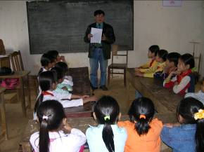
- Demonstrations of handwashing skills by children to measure knowledge, which was accompanied by questions about critical times for handwashing. This also provided information about the availability of soap.
- Group interviews (focus group discussions).
- Individual interviews with questionnaires.
- In-depth, open-ended interviews.
- Protocol where children were given snacks to observe who washed hands before eating.
- Participatory monitoring tools, specifically the Qualitative Information System (QIS) procedures to enable the quantification of qualitative information by asking small groups of participants to rate their experience and observations on rating scales.

Photo: UNICEF Viet Nam: Group discussion with students in Thuong Coc primary school in Lac Son district, Hoa Binh province
Triangulation
In several studies, data was collected from different groups about the same topic, for example, comparing the responses of teachers and children to similar questions. Comparing the information provided about the same thing by different groups of people is one way of checking the accuracy of the information. This can be particularly helpful for behaviours or practices that are difficult to measure directly. A second way of checking or triangulating the data, appeared in some studies where different tools were used to investigate the same topic. For example, data from individual or group interviews were compared to short-term observations of the actual use of facilities.

Data analysis
The analysis, reflected in each of the five reports, was completed by the country teams. In most cases, analysis was done in a straightforward way by totaling the results for each item in the country study. This was considered to be the most valid approach as the samples in most countries were small (less than 100 schools or 200 families), implying that a simple analysis would be most suitable.

In analysing the five country studies, we looked for patterns among the country research data. Thus, for example, where the results of all five studies were similar, it was assumed unlikely that the results were due to chance.

The findings were judged against a set of criteria in two ways. The first is a criterion-referenced approach which measured the extent to which the UNICEF-supported pilot schools in a country study adhered to successful practice, such as having well-used and well-maintained toilets/urinals. The definitions of the indicators, such as well-used or well-maintained toilets, were determined by each country team. The use of definitions that prevailed in the original intervention or commonly prevail in each country was judged to be more realistic and to provide more valid information about the intervention than the use one common definition for all countries. For example, in assessing whether latrine construction adheres to norms, the norms set for the project or for the nation were used. Thus the achievements of each project were judged against its adherence to definitions and standards that are accepted locally.

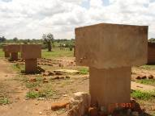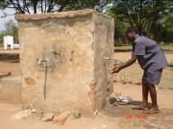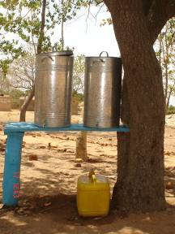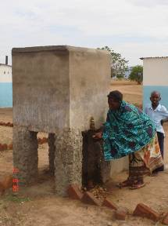
Photo: UNICEF Zambia: various types of handwashing facilities

An indicator was considered to be achieved at an acceptable level when 4 out of 5 schools or 80% of the children (or communities, or teachers…) in a country study adhered to the desired criteria. The relatively high standard of 80% was selected for two reasons. First, because these were pilot projects, it was expected that they would achieve a fairly high level of excellence. Secondly, research shows that in order to have a significant health impact, hygienic practices must be consistently carried out by a large proportion of the population. We find, using this criterion for indicators, for example, that 80% or more of the school water facilities were functioning in all the countries, a considerable achievement one to two years after the end of the project intervention.

The second approach to analyzing the results of the study was to compare the project schools with other, control schools that had no UNICEF-supported intervention. In three countries, some of the control schools were subject to interventions sponsored by other agencies or donors. Nonetheless, the project schools performed better for most indicators. This ‘better performance’ was not significant statistically given the small sizes of the samples. Thus the better performance of the project schools over the control schools in one country can only be viewed as a ‘tendency’, not an established fact. However, where project schools showed closer adherence to an indicator than control schools in all five studies, then this is taken as evidence for the superior performance or sustainability of the intervention programmes. In some cases, the assessment also refers to baseline data.

Sample sizes and implications of the study
The schools assessed in this study were selected in somewhat different ways. In the smallest country study, all the ten schools in the original intervention were assessed. In two countries, the study schools were identified at the district or institutional level on the basis of criteria suggested by UNICEF. In one country, clusters of schools were selected at random. Some of the project schools in each of the studies were also involved in other projects or programmes with the support of the government or other institutions. The selection of control schools also followed somewhat different processes. This was done on the basis of their similarity to the programme schools or a range of types of schools in an area was selected. In other cases they were selected by local institutions, based on given criteria. The assessment compared the situation in schools that benefited from the pilot intervention with the situation in control schools. In some cases it also compared the baseline situation with the situations several years after the pilot intervention had ended.

However, given this diversity in sample selection, it follows that this study can not comment on the status of SSHE within any of the countries involved, nor can it make comparisons between countries. In addition, the original programmes were pilot programmes and thus sample sizes for the study are small, all being less than 100 schools from any one programme supported by UNICEF. Thus, the study is not a general assessment of SSHE in any country and it does not compare SSHE programmes among the countries.

The outcomes
As indicated earlier, links to the full reports are provided in Annex I or can be obtained by contacting the appropriate person from the list of contacts. The outcomes given below are related to the main indicators we identified during the first workshop.

Water
Facilities function: Facilities to provide water were available and in working order in 80% or more of the project schools in each country study. Water facilities were located within the school compound or within 200 meters from the school. Project schools scored higher than control schools in four countries and the same in one country. This provides evidence that the benefits of the SSHE programme can, indeed, be sustained. There was concern expressed by some research groups about the sustainability of the water sources in the future. For example in one country the municipal water system is unreliable In other countries there was concern about the lowering water table and the questionable water quality. These concerns deserve further attention.

Water storage: The storage of drinking water in the school showed considerable variety in the country studies. In all cases it was better than in the control schools. In 4 out of 5 countries 80% of the schools stored drinking water was in a way considered to be adequate. However, no tests were done on the water quality to confirm this. Safe storage of drinking water in the school also deserves some further investigation.

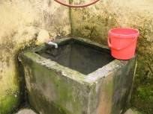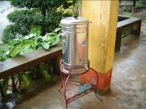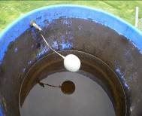
Photographs: UNICEF Viet Nam: Drinking water UNICEF Colombia:
Viet Nam, Christine Sijbesma, IRC for students in Le Ho A primary water storage tank
school, Ha Nam province

Water quality was not tested in this study, except for chemical composition in one country.

Handwashing
Handwashing with soap or ash: In none of the country studies were 80% of the children washing their hands with soap (or ash as appeared in one country program). In fact, less than one-third of the children in the study used soap, either because it was absent in the school or because it was not easily accessible for the children in the school. The research teams noted that current efforts must be acknowledged: handwashing with soap has, in fact, improved, because it was not practiced at all previously. Nonetheless, the current low prevalence is a great cause for concern. If children do not wash their hands with soap and water before eating or after using a toilet, much of the health advantage of the SSHE programme may be lost. Thus, a major recommendation from this study is that far greater emphasis is needed on handwashing with soap before eating and after using the sanitation facilities in schools.
The country reports indicate that addressing the issue of handwashing with soap has complexities. These include:
- How to manage the handwashing: organising the children, ensuring sufficient water points or containers and cups. In one country with a school feeding programme, children were lined up for handwashing before the meal and monitored by older children or the teacher.
- How to manage the soap: quality of the soap, theft and loss of the soap, recurrent cost of the soap, location of the soap. In some countries, recurrent fund systems have been organised for this and for other school-related expenses.
- How to monitor the school about handwashing with soap.

Photo: UNICEF Burkina Faso

Further research on these issues is needed if handwashing with soap is to increase.

Toilets and urinals
Norms for toilets and urinals: In 4 out of 5 countries, toilets and urinals followed national norms about the ratio of children per facility. The project schools performed better than the control schools in this regard in all country studies. However, it should be noted that the norms vary considerably, ranging from one toilet/urinal for 25 boys or girls in one country up to one toilet for more than 100 children in another country. This issue deserves to be revisited in countries with very large norms. The challenge is to set norms for facilities which make it easy for children to practise safe hygiene, while at the same time being feasible to implement. Three out of 5 countries constructed urinals, something which can provide services to more children at lower cost. In the other two countries the launching of urinal construction is now considered.

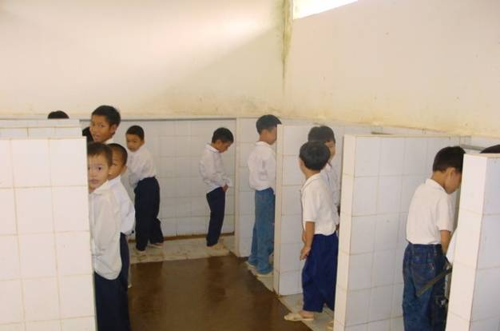
Photo: Viet Nam 2002, Christine Sijbesma, IRC
Design and construction: Three out of 5 studies reported that child-friendly designs were implemented to a satisfactory level for toilets/urinals. Child-friendly features include, in one country or another: separate toilets/urinals for girls and boys; design for sufficient light in the cubical; small toilet bowls for young children; door locks at the height of the children; facilities located near enough to the school. Several country teams noted that difficulties are experienced in ensuring adherence to technical specifications for design or construction quality. In one country, almost one out of 10 latrines collapsed or fell into disuse because of faulty construction.

Use and cleanliness of facilities: In all 5 countries, 80% or more of the project schools had toilets and urinals that are well used by children and are kept clean. This was far better than the control schools. The consistent use and continued cleanliness of toilets provides evidence that an SSHE programme can provide benefits that are sustained beyond the end of the project period. Once good hygiene practices are enabled, they are likely to continue even after the project ends.

Materials and water available for personal cleansing in toilet: Children must be able to clean themselves easily after using the toilet. The custom is that children in most countries clean themselves with water or with paper after defecating and, for girls, after urinating. These materials should be readily available in or very near the toilet. In the case of paper, a safe disposal mechanism must be ensured. In this study, the responses were mixed about the availability of anal cleansing materials and their safe disposal, with only 2 of the 5 country studies reporting adequate practice in more than 80% of the schools. In schools having girls who are menstruating, the availability of cleansing materials and a disposal mechanism even get an added value.

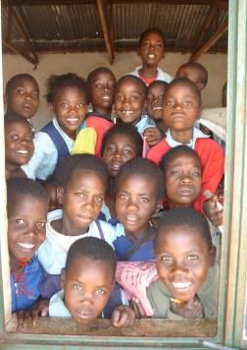
In Zambia the SSHE-programme had contributed to a reduction in diarrhoeal diseases. However, it also brought about other benefits to Malima Basic School. As the teachers state:
- Marked reduction in rates of absenteeism, especially by girl child.
- Big girls no longer shun school as they are assured of comfort and adequate privacy even at times of menstruation.
- Less congestion at latrines.
- Presence and proper use of latrines has encouraged the culture of using the latrines at household level and the community in general. More latrines are being built in the community.
- The presence and proper use of latrines has contributed to the aesthetic beauty of the school.
Photo: UNICEF Zambia

Cleaning of latrines: There was considerable discussion among the research teams about who should clean latrines. It was agreed that each child should be responsible for using the latrine in a clean way, that is, ensuring that faecal waste, anal cleansing
materials and urine are disposed correctly, that water containers are filled and so on. However, in two countries, janitors or caretakers are hired for daily cleaning. In other countries this is the responsibility of children supervised by teachers. The principle rationale for children to clean their facilities was that it increases responsibility, increases participation, is part of education as well as, but not only, because it saves costs. On the other hand, cleaning toilets can be given as a punishment to children or can be inequitable by, for example, being assigned only to poor girls. It was noted that conditions which affect the choice of hiring janitors or not differ in each country and include, for example, the type of material used for anal cleansing, economic levels, and so on. It was concluded that whether or not and to what extent children can be involved in cleaning latrines depends largely on local circumstances and that there are serious pitfalls. However, systems for operation and maintenance need to be in place in each school, something which several countries noted requires further work.

Children
Children’s knowledge: The knowledge of children was tested through questioning and demonstrations. All country studies showed that 80% or more of the children, know how to wash hands and when, for health reasons. The project schools performed better than the control schools in all countries. In general, knowledge about handwashing with soap is greater than practice. This finding appears in other studies as well and it also highlights the point that knowledge alone is not sufficient to improve hygiene behaviours.

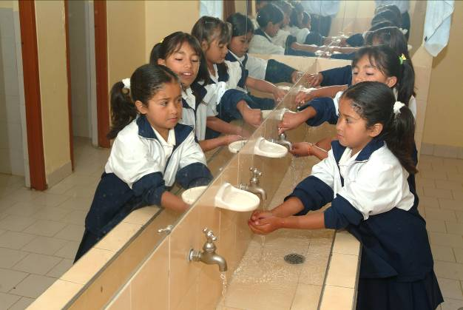
Photo: UNICEF Colombia

Participation of children and children’s clubs: There are many different types of clubs or groups of students active in relation to water, hygiene and sanitation. Four out of 5 country studies showed that most of the project schools (80% or more) have active groups of children and/or child health clubs. The discussion about these in the workshops elicited considerable enthusiasm.

Children were reportedly involved in a wide range of activities that are empowering and stimulate improved hygiene/sanitation in the school and community. Examples given by the research teams included:
- Have input into the design of their facilities.
- Develop studies and monitor the schools, children, use of facilities in schools, and so on.
- Help organise for washing hands before eating.
- Help organise for clean use of facilities and peer teaching for clean use of toilets.
- Perform cleaning tasks in the school and oversee students who clean school, facilities on a rotating basis.
- Study/survey communities to assess hygiene and sanitation needs.
- Reach out to the home and community. Examples of child activities that benefit the community from these studies are: tree planting, setting up and managing a fund for poor children, with information/motivation on sanitation.
- Guard materials for construction and help with some construction work.
In the 4 countries where the project schools have child clubs, the intervention schools performed better than the control schools.

In Nepal 14 year old Sita, who lives in a small village, is member of her school’s child club. She told us the following story: “One evening my cousin Sushma, who lives in Kathmandu visited us. I was delighted to welcome Sushma, since we used to play together during our child-hood. That night Sushma asked the way to the toilet, but unfortunately I could not show it, as there was no toilet built at our house. I decided to take her to the open field for defecation, as it was the only alternative that was available. When Sushma hesitated to follow my advice, I explained that defecation in the open field is a common practice in the village and that there is no reason for shame. Still, Sushma expressed she felt ashamed about defecating there in the open field and told me that she would leave our house early in the morning next day. I was surprised by her words and felt ashamed. I had extremely unpleasant feelings from then on. I felt that my family was unfortunate for not having a latrine. Although I heard a lot about the need to build a toilet from the teacher and classmates, including Child Club members in the school, I was not fully aware that such a heart touching incidence as with my cousin could occur. When I talked to my teacher and friends about my experience, they advised me to convince my family members to build a latrine soon. My classmates also requested me to become a member of the sanitation child club so that we could collectively convince my parents and the other members in the community. I joined the club with a strong zeal to be a role model. Some time later, my family built a latrine. I am now also interested to motivate other community members to build a latrine, so they don’t have to feel ashamed as I did”. With full of confidence and self-esteem, Sita sent a letter to her cousin asking her to visit her house again.
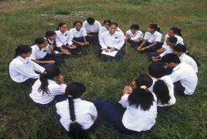
Photo: UNICEF Nepal

Life skills education

The life skills education approach tried to focus on real life situations, involving problem-solving, learning to understand (analyse) situations and negotiating, leading to informed decision-making and action. There appears to be considerable variation in how it is developed among countries, but 3 components are often mentioned: social/interpersonal skills and communication; cognitive skills for problem solving; skills for controlling emotions and feelings.

The participation of children and participatory methods are used in life skills education. All countries noted that life skills and participatory approaches were being developed or attempted. In at least one country, participatory approaches were placed at the centre of programme planning and implementation, with repeated participatory workshops involving educational administrators, municipal government, teachers, parents and children. Only one country study mentioned that some teachers find it difficult to change their teaching methods for participatory life skills education approach. However, it is known from other educational reforms that it can be challenging for teachers to introduce participatory approaches in their pedagogical practices.
Teachers in a mountainous area of Viet Nam, recognizing their particular situation, tried various approaches to help students to improve their health and personal hygiene. Doing so, they not only focused on general knowledge, but also on personal hygiene practice in everyday life. One of them, a teacher from Pu Nhi primary school, in Dien Bien Dong district, said: “Apart from the formal curricular programme, the school organises extra-curricular lessons and collective activities that include elements of health education. The specific thinking behind this is that teaching entirely based on books is not enough. It should be related to the practical situation of the regions by showing the pupils some pictures, drawings, even to TV and radio broadcasts and newspaper cuttings. At times, teachers have to bring combs with them to teach small pupils how to comb their hair”.

Gender
In SSHE ‘gender sensitive’ implies that girls and boys, male and female teachers equally share the responsibilities and benefits as well as having the necessary input into making decisions about things which affect them. In all countries some form of gender specific sanitation facilities were built through the programme. In 2 of the 5 countries children, both boys an girls, had a clear input in the design. Not all country studies report on sharing of water and sanitation related tasks.

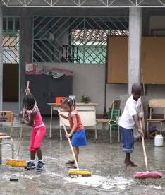
One country study reported that in most schools boys and girls equally share the burden of carrying water, filling water tanks and cleaning latrines and that the interventions schools did better than the control schools. One country reported that girls, who used to be absent during their menstruation period, seem to show improved school attendance. However, hard data was not available. This deserves further study in the future.
Photo: UNICEF Colombia: cleaning of common areas in Yarumales School

With respect to the involvement of male and female teachers, nothing was reported.
The question of whether a man or woman should be the SSHE lead teacher in the schools is relevant for countries that can afford to train one teacher only from each school. Experience shows that women may be more interested in behavioural change and hygiene; while male teachers may tend to be more interested in construction. This is another, almost untouched issue, which deserves further attention in the context of scaling up SSHE.

Effects of SSHE in the home and community
Four of the country reports include a detailed survey of the communities, usually with home visits and discussions with community groups or local officials. These show that many hygiene practices and household sanitation coverage have improved significantly during the period of these SSHE programmes. Furthermore, in 4 of the 5 countries there were school-initiated activities focusing on reaching into the home such as motivating children to share information about hygiene and sanitation with their families. However, the methodological limitations of all such studies make it difficult to say that school programmes alone were responsible for the changes in households or community. Because the SSHE programmes were integrated into community-based water, sanitation and hygiene efforts, it has not been possible to isolate the effects of the particular SSHE effort compared to other programme inputs. Stated simply, parents and community groups can also have been contacted and stimulated about sanitation and hygiene through other programmes. For all of these reasons, it was not possible to state that the SSHE programme caused a particular behavioural change in the homes or community.

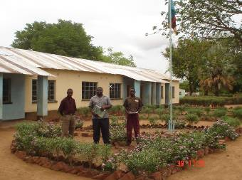
Photo: UNICEF Zambia

The effectiveness of SSHE interventions also had a programming element. In 4 of the countries SSHE is used as an entry point or as a means to initiate community mobilization that leads to improving hygiene and sanitation in the home. As such, it was found that parents and community groups could be mobilised first in the school. The school served as a practical entry point for initial mobilisation launching community groups into community water and sanitation activities.

Institutional setting and coordination
SSHE is the responsibility of a remarkably wide range of different institutions and agencies in the various countries. Colombia had the simplest mix of agencies: the Ministry of Education together with local municipal government. In all other countries, however, at least 3 different government agencies or institutions have responsibility for some aspect of the programme. As would be expected, in all countries, the Ministry of Education has responsibility for the SSHE programme. Still, responsibility is shared, in one country or another, with: Ministries of Water and Sanitation, Physical Works and Planning, Health, Environment, Agriculture and Rural Development, Local Government and Housing. In addition, national and international non-governmental organisations and various donor institutions are also involved. Further complicating the situation are other educational reform programmes being carried out in several countries, with their own organisational structures. Thus, the studies noted that it is possible to find toilets and water points constructed under different programmes and committees for different programmes in one school!

Effective coordination is crucial when carrying out these programmes. Different approaches to coordination of the many stakeholders in SSHE appear in the country studies. In Colombia, SSHE inputs from UNICEF have been organised through the municipal governments. In Zambia, a coordinating mechanism is in place through the WASHE system of local water and sanitation committees, but due to a variety of reasons these are not very effective. In addition, some SSHE functions are simultaneously undertaken through a concurrent programme for School Health and Nutrition, which also has separate committees in some schools, causing confusion and less effectiveness. In Nepal the National and District level SSHE Steering Committees, which bring together all actors involved in SSHE, play an important role in programme development as well as supervision and monitoring.

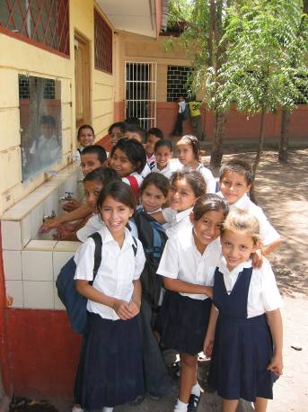
Photo: UNICEF Nicaragua

Contacts with the school
One of the challenges in scaling up SSHE with quality is to ensure that there is effective monitoring and supervision. This implies the need for organising an adequate number of contacts with the school or with school personnel. In this case, among the country pilot projects, the number of contacts with a school during the intervention period varied greatly. For example, in one country, each school was involved in 12 workshops with the participation, at one time or another, of all local stakeholders from the schools, parents, teachers and local government for joint planning, training and so on. In another country, NGO staff paid weekly visits to the schools, which was supplemented by monthly visits by provincial school supervisors. Where visits to schools took place, evidence about the optimum number needed to help ensure programme effectiveness, is not available. This was an innovative programme, and consistent support and monitoring was essential, which makes it difficult to say something meaningful about the necessary number of contacts in relation to the costs involved. The number and organisation of supervisory/monitoring visits or meetings is another area which may deserve further study.

Scaling up issues: costs and capacity building
Capacity building of teachers: Bearing the costs and ensuring the management and delivery of good quality training were viewed as key to the scaling up effort. Teachers were trained in all countries. In one country this was through cascade-training, meaning to say that the programme trained trainers at the national level, leaving training of schoolteachers to them. However, there was concern about the quality of this traditional ‘cascade training’. In one country consideration is being given to having mobile teams of professional trainers in place of the standard cascade model. Some countries emphasized the need for exchange visits by teachers as a way to help them, both the visiting and the visited teacher, learn more about how other schools implement SSHE.

In most countries training was not limited to teachers. In view of potential reinforcement of school efforts, orientation was provided to village chiefs, religious leaders, village health committees, parents, school management committees, municipal staff. No figures are available that show the impact of this particular type of capacity building.

Teacher transfer: Most country studies reported about the frequent transfer of trained teachers, which is considered negative. In one country, for example, about one-third of the teachers in the pilot schools had been transferred from the control schools. Whereas it is probably negative in the short-run, in programmes that seek to intensify to high coverage in a district, the transfer of teachers around a district can be effective, since more schools get trained teachers. Thus, in the long run teacher transfer is supportive of scaling up.

Costs of the SSHE pilot interventions: for scaling up it is crucial to have insight in costs of a programme and costs of SSHE per student. When costs are known we can estimate the budget required for a certain level of coverage. There are two types of costs in SSHE programmes at the school level: recurrent and investment costs. The recurrent costs include cleaning materials, handwashing soap, cups/mugs, repairs to facilities and, hopefully, for additional inputs such as refresher training and replacement of educational and promotional materials.

Investment costs cover construction or rehabilitation of facilities (water, toilet/urinals, handwashing facilities). The second component of investment costs is related to carrying out the intervention: for the implementation period of the SSHE programme, usually called software costs. These costs include training, monitoring and supervision, transportation, baselines, promotion during the start-up period, field work costs, partial salaries of support staff such as drivers who transport supervisors during the intervention period, and so on. Each country group provided an estimate of investment costs per school for hardware and software inputs for SSHE. The hardware costs were broken down by source of payment: (a) UNICEF and government or (b) local contribution from households or local government.

From this, an estimate of investment costs per school was calculated. This information is particularly interesting, because it is so seldom available for SSHE; however, it must be remembered that these costs are for a pilot programme in about 2001-2003 and do not generally reflect the costs of SSHE in the countries which were studied. The cost of the facilities and software (training, monitoring, supervision, baselines, education and promotion materials, field work…) was calculated. The average cost of facilities per school ranged in the 5 countries from $1400 to $14000, a ten-fold difference. The software costs had a smaller range in the 5 countries, from about $835 to $2190 per school. The huge differences can, at least partially, be explained by differences in standards (compare for example schools in urban, industrialized areas in Colombia to schools in rural Nepal), norms (look at the extremely high student/toilet ratio in Vietnam), costs of materials and (skilled) labour. Costs are generally lower in Asia than in Africa and Latin America. In Burkina Faso water supply provision can be extremely expensive as a result of low water tables. However, these factors may not explain the entire variation and this deserves further investigation.

The total cost of all inputs including governmental, donor and local contributions was divided by the number of children in the school, giving a rough investment cost per child that ranged from $4 to $80. However, these investments last longer than one year. Therefore, assuming that the investment in SSHE can last for 5 years, which is an arbitrary and possibly too low number, the rough investment per child over the total 5 year period ranges from about US$ 0.8 – US$ 16.

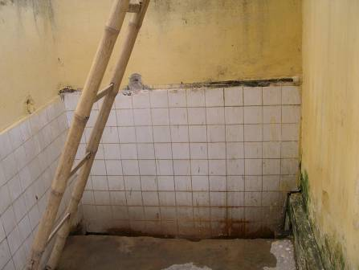
Photo: Christine Sijbesma, IRC
SSHE Programme Support Costs:average costs per school in US$

UNICEF  Programme | Support for toilets, urinals and handwashing facilities |  |  | Support for water supply |  |  | Total Donor/  Gov support  hardware | Support for software for 1 school | Total investment cost per school | Investment cost per student
UNICEF  Programme | Donor + Govt | Local contri  bution | Total | Donor + Govt | Local contri  bution | Total | US$ | US$ | US$ | Per child/ | child/per year
Burkina Faso  (200 children) | 1,775 | 285 | 2,060 | 11,500 | 280 | 11,780 | 13,275 | 2,190 | 16,030 | 80 | 16
Colombia  (200 children) | 6,000 | 6,000 | 12,000 | 750 | 750 | 1,500 | 6,750 | 2,000 | 15,500 | 77 | 15.4
Nepal  (400 children) | 1,500 | 1,500 | 3,000 | 800 | 200 | 1,000 | 2,565 | 835 | 4,835 | 12 | 2.4
Viet Nam  (700 children) in 2001 | 500 | 200 | 700 | 200 | 500 | 700 | 700 | 1,600 | 3,000 | 4 | 0.8
Zambia  (200 children) | 900 | 1,500  material  labour | 2,400 | 5,000 | 500  material  labour | 5,500 | 7,500 | 1,100 | 9,000 | 45 | 9

The average recurrent costs for SSHE, particularly for operation and maintenance of the facilities, are shown in the table below. There is considerable variation in the source of the funding. In some cases the government and UNICEF appear to cover all operation and maintenance costs, while in other cases this comes entirely from local contributions. This issue may deserve further investigation, to determine which options will be most sustainable over the longer term.

Average recurrent costs for operation and maintenance

UNICEF  Pilot Programme | Support for O&M in US$
UNICEF  Pilot Programme | Donor + Govt | Local contri  bution | Total
Burkina Faso  (200 children) | 337 | --- | 337
Colombia  (200 children) | not known | 90/year
Nepal  (400 children) | 65  50% | 65  50% | 130  100%
Viet Nam  (700 children) in 2001 | 0  0 | 200  100% | 200  100%
Zambia  (200 children) | 500 | 500  cash,  material  labour | 1,000

Annexes

Annex I List of UNICEF contact addresses with link to the country reports

# | COUNTRY | NAME OF PARTICIPANT | JOB TITLE | ORG. | EMAIL ADDRESS | URL COUNTRY REPORT
 | Burkina Faso | Mr. Mamadou Bagayoko | Chief (Education) | UNICEF | mbagayoko@unicef.org | http://www.irc.nl/redir/content/download/24643/275940/file/Burkina-Assessment-Report_Mar06.pdf in French [ 1 MB]
 | Burkina Faso | Mr. Soungalo Togola | PO (WES) | UNICEF | stogola@unicef.org
 | Colombia | Mr. Francisco Burbano | Project Officer | UNICEF | fburbano@unicef.org | English: http://www.irc.nl/redir/content/download/24661/276028/file/Colombia-Assessment-Report_2006-English_lowres.pdf [1,3 MB]; Spanish: http://www.irc.nl/redir/content/download/24662/276031/file/Colombia-Assessment-Report_2006-Spanish_lowres.pdf [1,3 MB]
 | Nepal | Mr. Namaste Lal Shrestha | PO (WES) | UNICEF | nlshrestha@unicef.org | http://www.irc.nl/redir/content/download/24663/276034/file/Nepal-Assessment-Report_2005.pdf [1,3 MB]
 | Nicaragua | Ms. Nienke Swagemakers | Assistant Project Officer | UNICEF | nswagemakers@unicef.org | English: http://www.irc.nl/redir/content/download/24666/276043/file/Nicaragua-Assessment-Report_Feb2005_English.pdf ; Spanish: http://www.irc.nl/redir/content/download/24667/276046/file/Nicaragua-Assessment-Report_2005_Spanish.pdf [186 KB]
 | Viet Nam | Mr. Chander Badloe | Chief, WES | UNICEF | cbadloe@unicef.org | http://www.irc.nl/redir/content/download/24664/276037/file/Viet Nam-Assessment-Report_V4Mar-06.pdf [850 KB]
 | Viet Nam | Ms. Tran Thi Thu An | Assistant Project Officer (WES) | UNICEF | ttan@unicef.org
 | Viet Nam | Ms. Le Anh Lan | Senior Project Assistant (WES) | UNICEF | lalan@unicef.org
 | Zambia | Mr. Giveson Zulu | PO (WASHE) | UNICEF | gzulu@unicef.org | http://www.irc.nl/redir/content/download/24665/276040/file/Zambia-Assessment-Report_10March2006.pdf [1,6 MB]

All country reports can be found at http://www.irc.nl/page/28816

Annex II Assessment Summary sheets

BURKINA FASO

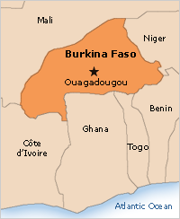
Fig: taken from the UNICEF web site

Original SSHE intervention: The intervention methodology drew upon several methodologies: Hesawa, Life Skills education, FRESH. The project was carried out by the government and the non-governmental organization CREPA working together with UNICEF. For a period of about 6 months, schools were visited by field workers (‘aunts of cleanliness’) each week and included some direct work with children in the class. As with the other projects, this SSHE programme was related to community water and sanitation intervention.

Norms: For rural schools there are no official norms. Norm applied by partners is
40-50 students/cabin.

Data collection:
Data was collected in 26 intervention and 4 control schools.
This was done through the use of:
- Focus group discussions (group interviews).
- Observations.
- Questionnaires.

Information is provided by children, teachers, community groups and parents/householders. To help ensure the validity of the data, triangulation was used, comparing the responses of teachers and children to similar questions.

Key findings:
- Availability of water: Whereas in 96% of the project schools water facilities existed, in 80% of the schools these were also functioning.
- Handwashing with soap: In 17% of the project schools soap is available to students.
- Use and cleanliness of latrines: Over 80% of the project schools have toilets that are being used, clean and maintained.
- Training: Teachers were trained and offered refresher training. They have been provided with modules and educational tools.
- Outreach into the home and community: In 55% of the cases hygiene promotion took place through the SSHE-programme.
- Project vs. control: For each of these indicators project schools did better than control schools.

Special features:
The report included a discussion of challenges for scaling up SSHE: teacher transfers and teacher motivation, efficient fund flow transfers, maintenance by parents, monitoring and supervision of schools. The study provides information about programme costs which were useful to other groups in investigating costs during the final workshop.
COLOMBIA

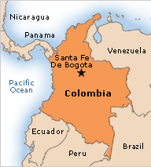
Fig: taken from the UNICEF web site

Original SSHE intervention: SSHE was conceptualized as part of an overall strategy for developing more child-friendly schools. The intervention was carried out by CINARA, an experienced NGO, in collaboration with small-town municipal government.

Norms: 1 toilet/urinal for 25 children, separate facilities for girls and boys

Data collection:
Data was collected in 10 intervention and 3 control schools.
This was a participatory study which used a range of tools:
- Demonstrations of handwashing by children.
- Checking handwashing practices after providing snacks to children. This protocol was not found to valid as children responded to other stimulate such as fear that they would not get enough of the food if they washed hands first.
- Observations of facilities.
- Group and individual interviews with teachers, school directors, children, parents and staff of the original intervention. The Colombian study, unlike others, used tools known as MPA (Method for Participatory Assessment) and the Qualitative Information System. This is an approach to quantifying qualitative data by asking small groups of participants to rate their experience and observations on rating scales.

Key findings:
- Availability of water: In 9 out of 10 schools, the water facilities were functioning. However, 4 out of 10 schools did not have water at the time of the visit, which is due to unreliability of the municipal water system from which the schools draw their water.
- Handwashing with soap: 4 out of 10 schools did not have soap. Children washed hands using soap in 2 out of 10 schools.
- Use and cleanliness of latrines: Over 80% of the schools have used and clean toilets.
- Training: 30% of the teachers are trained for SSHE. Frequent transfer of teaching staff is a problem.
- Outreach into the home and community: 8 out of 10 communities surrounding the schools benefited from hygiene promotion through SSHE.
- Project vs. control: Where this was measured project schools did better than control schools, except for children’s knowledge, which was the same in intervention and control schools.

Special features:
The 4 schools that had more trained teachers (4 or more) also had more hygiene promotion activities outside the school.
Seven out of ten schools were using SSHE materials prepared by CINARA.
Teachers, parents, municipal staff and children were trained.
There was a minimum of 12 contacts with team implementing the pilot and the school.
NEPAL

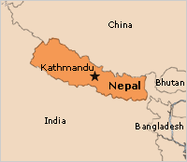
Fig: taken from the UNICEF web site

Original SSHE intervention: The intervention included construction, teacher training, activating school health child clubs and providing follow-up. UNICEF collaborated with the Department of Water Supply and Sanitation, the department of Education and Nepal Red Cross Society. The project was guided by the national and district level Sanitation Steering Committees.

Norms: 1 urinal for 40 students and toilet for about 100 children, separate facilities for girls and boys.

Data collection:
Data was collected in 64 project schools and 7 control schools in 7 districts (4 in the hills and 3 in the plains (Terai)).
This was a participatory study, which used a range of tools:
- Observations of facilities.
- Focus group discussions (group interviews).
- Pocket voting.
- Checking handwashing practices after providing snacks to children.
Data was collected from students, teachers, headteachers, school management committees, village development committees. Data was triangulated to check validity (responses of teachers, responses and pocket voting by children, and the field workers observations).

Key findings:
- Availability of water: in 90% of the schools, the water facilities were functioning.
- Handwashing with soap: about 26% of the project students use soap.
- Use and cleanliness of latrines: some 90% of the school latrines are used and clean.
- Training: Teachers have been trained, but some were transferred to other schools.
- Outreach into the home and community: In 80% of the communities surrounding the schools awareness creation took place as a result of the pilot programma.
- Project vs. control: Where this was measured, project schools did better than the control schools.

Special features:
Interestingly, the results of the study were similar in both the Terai and hill schools, which have different environments and population groups.
The Nepal report included and interesting discussion of challenges in scaling up SSHE, many of which apply to SSHE in other countries. The challenges noted were: transfer of teachers, sufficient district support and monitoring of schools, reaching remote schools, efficient transfer of funds, community commitment. At the same time in had been able to initiate innovative and creative activities for promotion and fundraising by child clubs.
As with some other studies, in Nepal, the household hygiene and sanitation in the areas of the project schools was better than in the control school areas and better than nation averages.
VIET NAM

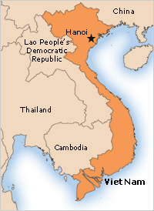
Fig: taken from the UNICEF web site

Original SSHE intervention: The project was completed four to five years before this study (2000-2001). Activities in the project were: national workshops, baseline survey, construction of water and sanitation facilities in 50 schools, development of curriculum materials and a manual, teacher training.

Norms: According to the Ministry of Education: 1 latrine for 100 to 200 children and 1 meter of urinal for 50 children (separate for girls and boys). Presumably more of the schools are running double school sessions each day which allows for a somewhat higher norm than in single session schools, although this norm is far higher than in any of the other countries in the study.

Data collection:
Data was collected in 40 intervention and 14 control schools.
This was a study which used a range of tools:
- Forms and checklists for use together with school management boards.
- In-depth interviews with school leaders, and experts and leaders at the national, provincial and district level.
- Group discussions with teachers and school children.

Key findings:
- Availability of water: more than 90% of the interventions schools have functioning and maintained water points. Availability of water was similar in intervention and control schools. Only 55% of the intervention and 43% of the control schools provided drinking water.
- Handwashing with soap: 62% of the project schools have handwashing facilities for students; however only 1 out of 40 schools had soap for handwashing. Almost two-thirds of the children in control schools and about 1-third in the project schools did not or could not wash hands after urination. All the children who defecated in the project schools were observed to wash their hands afterwards, while this was the case in n1 of the control schools.
- Use and cleanliness of latrines: More than 90% of the latrines in the project schools were well used and maintained, despite the fact that they were built 3 to 5 years before the survey. Water is available for flushing near the latrines. Certain design aspects could be improved in some schools: 2 out of 5 project schools do not have windows for ventilation. Girl students reported that walls are needed in the girls urination areas for privacy.
- Training: Training was organized in a cascade way: first key-trainers of a central mobile training team of the Ministry of Education and Training. In turn they trained teachers. Life-skills were emphasized.
- Outreach into the home and community: Awareness of the project and its implications for the community are high among educational officials.

Special features:
In a mark of good practice, the results of the study in each school were discussed with local stakeholders and included analysing constraints, possible solutions as well as stimulating local authorities to provide further support to the schools.
Over-crowding of facilities may be the reason for nearly half of the control school children and one-fifth of the intervention school children not pouring water to clean the urinals.
ZAMBIA

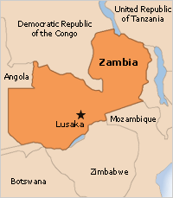
Fig: taken from the UNICEF web site

Original SSHE intervention: SSHE was implemented through the School Health and Nutrition programme. Annual workplans were developed for the schools and the school catchment areas. Focus was on improving water and girl-friendly sanitation facilities as well as on specific hygiene practices. The District WASHE-committee supervised implementation. Parent Teacher Associations worked with Village WASHE committees.

Norms: 1 latrine for 25 girls and 1 for 40 boys, as announced by the Ministry of Education.

Data collection:
Data was collected in 31 project schools and 19 control schools,
Data collections tools were:
- Questionnaires for school administrators, school committees, Village/District WASHE committees, households.
- Interviews.
- Focus Group Discussions with students, teachers and community groups.
- Transect walking.
- Pocket chart.
Secondary data was collected through review of various project documents.

Key findings:
- Availability of water: 90% of the schools has functioning water supply facilities.
- Handwashing with soap: a bit over 1-third of the children in project schools use soap or ash when washing hands.
- Handwashing with running water: in Zambia it is common practice to use a basin for washing hands rather than running water. The use of running water to wash hands instead of a basin, has increased.
- Use and cleanliness of latrines: over 80% of the existing latrine facilities used and kept clean.
- Training: 80% of the project schools had trained teachers and teachers are trained in life skills and PHAST approaches.
- Outreach into the home and community: Outreach is reportedly very high.
- Project vs. control: Where this was measured project schools did better than control schools.

Special features:
Construction quality has in some cases been compromised. Examples, which are not unique to this setting at al1 are, for example, communities attempting to build a larger number of facilities and thus not following specifications or by cementing pipes and taps so that they are difficult to repair.

Interestingly, some of the trained project teachers were transferred to the control schools which have, in this study appeared to perform somewhat better than national average. This may provide insights that can support efforts to scale up SSHE.

Annex III Conclusions and recommendations from the Nicaraguan study

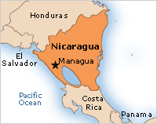
Fig: taken from the UNICEF web site

CONCLUSIONS
- taken from the mid-term evaluation report - February 2005

To what extent have the activities outlined in the project document been
implemented?

In general, the activities outlined in the project document (MPO/UNICEF) have been implemented within the conceptual framework of the FHSI. Sanitary and water facilities have been supplied to schools, teachers have been trained to use instruments that facilitate changes in children’s behavior and coordination has been promoted with other institutions and organisations.

The schools have achieved different levels of development, and have implemented activities to varying degrees. The time required for the different activities depends upon the starting point of each school, since the FHSI’s implementation cycle is adapted to existing conditions and dynamics. Another important factor in the success of the activities is the degree to which the educational community and school principal appropriated their project from the outset.

To what extent have the expected results of the Healthy and Friendly School Initiative’s school sanitation and hygiene education component been achieved?

The SSHE component has contributed to a considerable improvement in the main baseline indicators established for each school. The only exception is the drainage of surface and used water, for which the situation remained negative in all schools. In general, the positive results and changes indicate a clear and sustained trend toward achieving the proposed objective of 80% of school children practicing hygienic behaviors by 2006.

What factors have conditioned the achievement of these results?

The participatory approach has been systematically and consistently applied throughout the project cycle, helping empower both the educational community and the children. Participation is both a means and an end. This evaluation has ascertained that a wide range of mechanisms are now in place that foster children’s participation at all stages of the project cycle. In addition to raising awareness and generating commitment, the participatory approach also fosters changes in habits by allowing children to identify problems and propose their own solutions.

The strategy of combining the provision of sanitary and water facilities with hygiene education and promotion activities helps generate changes in children’s hygiene behavior. This is more effective and efficient than a purely theoretical strategy, as the learning process is speeded up when combined with life skills. Such an approach also guarantees the sustainability of what has been learned.

It should be noted that while the observed progress can be attributed to the effective implementation of the SSHE component, the Friendly and Healthy Schools Initiative’s comprehensive strategy generates synergy among all five components, which has had a notable impact on the overall achievements made to date.

Older children influence not only younger children in the same school, but also their younger sisters and brothers, the rest of the family, their neighbors and their communities. In this way, the school becomes an arena for the transmission of new knowledge, attitudes and practices related to hygiene and environmental sanitation.

The use of communication and promotion materials has helped schools to identify more strongly with the initiative. The school communities increase their selfesteem and want their efforts to overcome obstacles to be recognized, which in turn leads them to seek certification as a Friendly and Healthy School.

All school intervention proposals are consistent with the logic of the FHSI. Different actors making different contributions form part of a broad-based partnership that shares resources, methodologies and materials. This makes the FHSI attractive not only to schools, children, families and communities, but also to other actors interested in taking part. One such example is the extensive use of the SDCproduced “Juanita y la Gotita” materials.

The process of negotiation between the building contractors and the school authorities that takes place during the project stage is one of the most innovative phases of the project cycle. The builders learn to respect and value the opinions of the educational community, while the educational community assumes responsibility for decisions related to the construction process and also develops the ability to judge the quality of the construction work.

The evaluation identified one of the model’s greatest strengths as its flexibility and ability to adapt to different local conditions. The institutions involved have learned to design and build different types of school sanitary facilities with the participation of all right holders and duty bearers. Construction plans, designs and costing have been systematized, which will make it much easier to extend this model on a larger scale.

RECOMMENDATIONS
- taken from the mid-term evaluation report - February 2005

Coming at the halfway point of the 2002-2006 Country Program cycle, the results of this mid-term evaluation allow us to make certain recommendations that could help strengthen the component’s implementation during the remaining period:

The FHSI has had a decisive influence on the development of MEDC’S Educational Centers for Learning and Progress (CAP) initiative, which has been incorporated into national educational policies. As this would be the most viable vehicle for assuring the sustainability and universalization of this strategy, it is recommended that specific indicators related to water, school hygiene and environmental sanitation be defined for the CAP initiative.

The costs of installing or rehabilitating sanitary and water infrastructure are reasonable compared to other interventions. Nonetheless, water and sanitary facilities should be included in initial school infrastructure designs and norms, as it is more costly to incorporate such facilities later on. It is therefore recommended to develop national primary school infrastructure norms.

The life skills approach, particularly the use of the “Juanita y la Gotita” materials, is a strategy that generates sustainable changes in behavior and should therefore be strengthened. New active methodologies that are relevant to the children’s socioeconomic environments should be rapidly developed and then incorporated into MEDC’s curricular reforms. These new learning methods and tools would help children to assess and improve their own hygiene practices. Activities that reach out to families and communities should also be encouraged to ensure that the children’s home and community environments improve in line with their healthy school environment.

Indigenous communities should be invited to participate in the proposal of an intercultural adaptation of the FHSI so that the SSHE component can be extended to rural primary schools in the North and South Atlantic Autonomous Regions (RAAN and RAAS).

The monitoring of the component’s actions should provide information that is above all useful to the school. Such information should be produced by school and for the use of the school and the local community. Children and the community must therefore be effectively involved in a monitoring process that uses simple instruments. The systematisation of experiences should be considered part of the project cycle.

The monitoring of operation and maintenance plans for sanitary and water facilities should be incorporated into the supervisory and technical assistance activities of the national-, departmental- and municipal-level technical committees.

The FHSI and its SSHE component have developed very good monitoring instruments and mechanisms, but there has been no time to systematize the information generated and use it as the basis for an ongoing improvement of the strategy. The systematisation of the SSHE component is therefore recommended.

Annex IV List of SSHE education materials produced by the different countries

Burkina Faso

Title | Intended use | Produced by | Languague | Year of publication | Electronically available?
Cartoon | Promotion of latrine utilization for schools | UNICEF | French | 2003 | N
Sets of three posters | Promotion of hygiene education in schools | UNICEF | French | 2002 | N
SARAR tools adapted | Promotion of hygiene education by teachers | UNICEF | French | 2001 | N
Documentary film | Project process | UNICEF | French | 2002 | N
Flyers | For advocacy on the pilot project | UNICEF | French | 2001 | N
Utilisons bien les latrines |  | UNICEF | French
Module de la Session de Formation des Enseignants du Gazourgou |  | Jean Claude Somda, EHAE, CREPA | French
Guide Pédagogique pour l’Education à l’Hygiene dans les Ecoles Primaires |  | ONEA, I.P.B., CREPA | French
Guide Pédagogique d’Utilisation de la Bande Dessinée pour la Promotion de l’Hygiene et de l’Assainissement |  | DAO Bayé, KABORE Sibiri Luc, SANOU Ouri, YOUL/DA Lucie, Ministere de L’Enseignement de Base et de l’Alphabétisation, UNICEF | French
Modules Portant sur les Thèmes d’Eau d’Hygiene et de Protection de l’Environnement |  | UNICEF | French

Colombia

Title | Intended use | Produced by | Languague | Year of publication | Electronically available?
School sanitation and hygiene education, based on the life-skills approach | Working guidelines for teachers of primary education | UNICEF  CINARA | Spanish | 2003
Basic sanitation at school | Guideline for use operation and maintenance and follow-up of school sanitary infrastructure | UNICEF  CINARA | Spanish | 2003
Songs for hygiene and school sanitation | 9 songs for facilitating the understanding of school sanitation and hygiene education | UNICEF  CINARA | Spanish | 2003
How to improve school sanitation and hygiene education. Participatory diagnosis and design of school facilities in Colombia |  |  | English

Nepal

Title | Intended use | Produced by | Language | Year of publication | Electronically available?
SSHE Guideline | Program planning, implementation and follow up | UNICEF/DWSS | English/ Nepal | 2000 | Y
Teachers' Training Package | TOT | UNICEF/DWSS | English/ Nepali | 2000
Posters, Flip Chart, Pocket Chart, Flannel Graph, Sticker, Danglers, Cards, Flax etc. | Promotion/  Campaign | UNICEF/DWSS | Nepali | 2000 -2005
Instant Illustration | Aware School Children | UNICEF | Nepali | 2000
Children's Poem | Awareness | DWSS/UNICEF | Nepali | 2000
Pocket Calendar | Awareness | DWSS/UNICEF | Nepali | 2001 -2005
Baseline and Monitoring Formats | Self-monitoring and update study | DWSS/UNICEF | English/ Nepali | 2001 | Y
Meena Three Wishes | Awareness | UNICEF | English/ Nepali | 2001/2003
School Latrine Designs and Drawings | Latrine construction and cost estimation | UNICEF | English | 2000 and 2005
Annual Reports | Progress Review and Planning | DWSS/UNICEF | English | 2000, 2001, 2002, 2003, 2005 | Y
Life Skills-based Hygiene Education Manual and Reports | Guideline for Trainers/Teachers | DWSS/UNICEF | English | 2002 and 2005/6 | Y
Baseline Study Report | Guideline for implementors | DWSS/UNICEF | English | 2003 | Y
National Hygiene and Sanitation Guideline | Policy makers, Planners, Implementers and uniformity and standardisation. | DWSS/UNICEF | English | 2005 | Y
Youth Participation Workshop Report | Guideline for implementers and youths | DWSS/UNICEF | English | 2005 | Y
School Led Total Sanitation  Guideline | Guideline for implementers | DWSS/UNICEF | English | 2005 | Y
UNICEF Assisted Information Education Communication and Training Materials User-Friendly Catalogue on Water and Sanitation, |  | WES/UNICEF, CHRDU/DWSS/  MHPP
10 points for Model School Concept
Street Drama Guideline
Note: Nepal also produced: Newsletters (Private Sector) and Case Studies/Success Stories (UNICEF/DWSS); T- Shirt, Cap, Badge, Meena Audio/Video Cassette etc., (UNICEF); Trainers Kit Bag, (DWSS/UNICEF)

Nicaragua

Title | Intended use | Produced by | Languague | Year of publication | Electronically available?
Iniciativa de Escuelas Amigas y Saludables: Guía para la Aplicación del Componente de Higiene Escolar y Saneamiento Ambiental, Escuela Miguel larreynaga, Yalaguina |  | Argentina Vela Suárez | Spanish
Guía para el Monitoreo/Seguimiento Efectivo de Saneamiento Escolar y la Educación en Higiene en el marco de la Iniciativa de Escuelas Amigas y Saludables |  | UNICEF, Instituto Cinara Universidad del Valle Cali-Colombia | Spanish | 2002
Juanita y la Gotita | Basic sanitation manual and stories for primary school teachers | Nicaraguan Water and Sewage Company (ENAA) | Spanish | No date
Systematization of activities of the Friendly and Healthy Schools Initiative’s school sanitation and hygiene education component |  | Gareth Richards, UNICEF | English | 2005

Viet Nam

Title | Intended use | Produced by | Languague | Year of publication | Electronically available?
Textbook on SSHE and life skills x2x5 =10 titles | Grade 1 |  | Vietnamese | 2000-2002
Teachers Guidebook on SSHE and life skills =5 | Grade 5 |  | Vietnamese | 2000-2002
Workbooks on SSHE and life skills = 5 |  |  | Vietnamese | 2000-2002
Reference materials on SSHE and life skills |  |  | Vietnamese | 2000-2002

Zambia

Title | Intended use | Produced by | Languague | Year of publication | Electronically available?
Latrine construction : how to construct a double pit latrine for schools |  | DAPP / UNICEF | English | 2004 | Y

Hygiene, sanitation and water supply at schools; accelerated efforts towards girls’ education. Final Report for the Government of the Netherlands. UNICEF, October 2004, http://www.irc.nl/page/28817
Report of the workshop to prepare for the assessment of the SSHE-6 country programme. May 31 – June 3, 2005. IRC, Delft, the Netherlands, http://www.irc.nl/page/28817
This protocol was found to be less valid or useful in Colombia than in Nepal.
See, for example, Bateman, O. Massee and Shelley Smith. December 1991. A Comparison of the Health Effects of Water Supply and Sanitation in Urban and Rural Guatemala. WASH Field Report No. 352. Esrey SA, Feachem R, Hughes JM (1985). Interventions for the control of diarrhoeal diseases among young children: improving water supplies and excreta disposal facilities. Bulletin of the World Health Organization, 63(4):757–772. http://www.ncbi.nlm.nih.gov/entrez/query.fcgi?cmd=Retrieve&db=PubMed&list_uids=3878742&dopt=Abstract
For more on child-friendly facilities: Zomerplaag, J. and Mooijman, A. (2005). Child-friendly hygiene and sanitation facilities in schools. IRC/UNICEF (downloadable from http://www.irc.nl/page/5985).
No data were available that would allow us to separate out donor and government support.
Software includes training, monitoring, baseline update, promotion, educational materials, transportation of staff, supervision…..
This column shows the sum of total support, both government/donor and local contribution, for toilets, urinals, handwashing facilities and water supply, plus software support.
Investment cost per child per year is calculated on the assumption that the inputs will last for 5 years, in other words, the investment costs can be pro-rated over a five-year period.
Current costs as of 2006 averages to US $ 3,600 for toilets and handwashing facilities for one school
This figure, which is high compared to the other countries, led to considerable discussion, but no obvious reasons were identified.
These maps do not reflect a position by UNICEF on the legal status of any country or territory or the delimitation of any frontiers.

